

January 2018

**A great way to start the new year** is by watching the Lord establish a local Independent Baptist church! **The Get Acquainted Meetings for Lighthouse Baptist Church will take place January 21-25 in Hartford, AL** with Pastor Aaron Pack. The reproducing church is Grace Baptist Church in Ozark, AL, under the leadership of Pastor Doug Crosby. **Over twenty-five churches are involved with this plant and are cooperating together to assist in every way possible. Please pray for a healthy birth to this new church and for the Lord to be glorified through these efforts.**

**We are just seven months away from BCPM’s 25th anniversary service** and we are excited for this historic occasion. **We will be recognizing all the church planters and reproducing pastors who have used BCPM**. We will thank the Lord for how he has blessed the ministry in the past and also share what we believe the Lord will do in the future. It will be held at **7pm** **on** **July 31 at South Haven Baptist Church in Springfield, TN.**

**We are truly thankful for the opportunity to partner with you.** A new year will bring new opportunities, obstacles, and victories. Advancing the light of the gospel in dark places is never easy and that is why we covet your prayers and financial support. **Thank you and may the Lord continue to give fruit for your investment in BCPM.**

After the passing of Dr. Jessup last year, it was needful to move the US headquarters to South Haven Baptist Church in Springfield, TN with Pastor Frank Gagliano. This is the church where I have been basing out of for over seven years. Dr. Jessup advised me that this would be a great location as it is centrally located and South Haven Baptist is a very solid ministry that loves BCPM and church planting. This has been a very good move for the ministry and I am thankful for God’s leading in it. **Please make note of the new mailing address for BCPM. All US support and mail should be mailed to our new mailing address at PO Box 387 Greenbrier, TN 37073.**

Advancing in Christ,

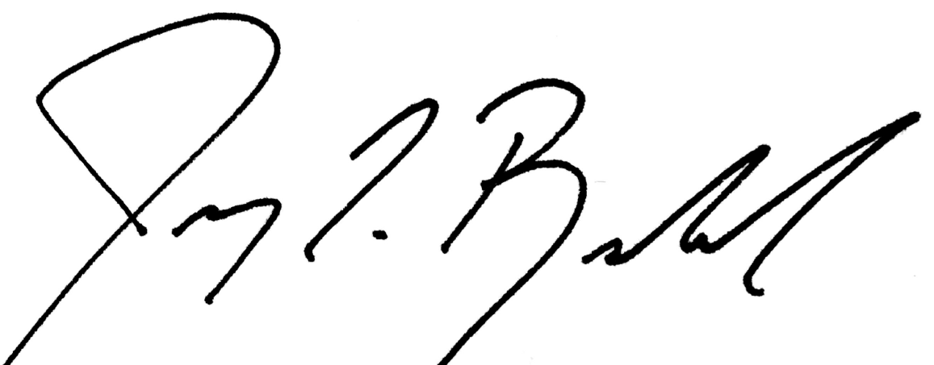

Jeremy Rowland,

General Director