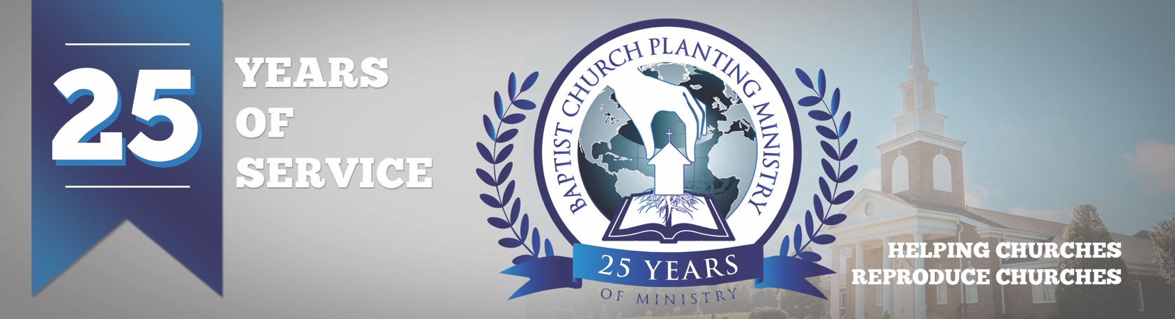

May 2018

We continue to receive healthy reports from the young church plants we have recently assisted. Bible Baptist Church in Naples, Florida recently had their first baptismal service, Lighthouse Baptist Church in Hartford, AL, continues to see guests from the community, and Bible Baptist Church in Big Timber, MT, is finishing the remodeling of their building. Each of these baby churches is advancing the gospel and seeing the hand of God upon their ministries.

We are just three months away from BCPM's 25th-anniversary service and we have had a wonderful response from pastors who plan to attend. We will be recognizing all the church planters and reproducing pastors who have used BCPM. We will also thank the Lord for what He has done and prayerfully will do through our efforts. The special event will be held at 7 pm on July 31 at South Haven Baptist Church in Springfield, TN. We would love to see you there so please email one of our staff or sign up online.

We are excited to host our first “Pre-plant Conference” on August 1 and 2 in conjunction with the 25th-anniversary in Springfield, TN. The "Pre-plant Conference" will be a time of instruction and encouragement and is designed to help the church planter and his wife prepare for the uniquenesses of church planting. All church planters are invited to attend.

Thank you so much for partnering with BCPM! Your prayer and financial commitment are encouraging. May the Lord bless you as you help impact the world through church planting.

Advancing in Christ,

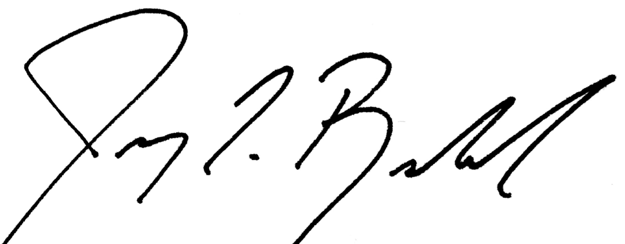

Jeremy Rowland,
General Director

