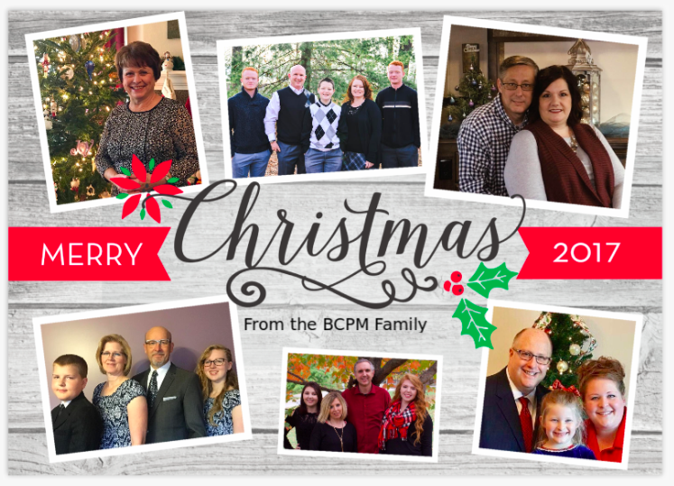

Our staff family at BCPM would like to wish you and your family a very merry Christmas! Not only is Christ “the reason for the season,” but He is also the reason our ministry exists. As we help churches reproduce churches, our goal is to glorify Christ and praise Him for what He does in each church plant. The Lord has been good to our ministry and in 2017, He lead us to assist church plants in Cranbrook, British Columbia; Wilmington Delaware; Charlotte, NC; and Jerez, Mexico. Please pray that the Lord will protect and provide for these young churches and that He will give us wisdom as we assist with the projects scheduled for 2018.

Several have contacted us about the 25th anniversary celebration offering. Some are taking up a special Christmas offerings while others are designating a whole month of special offerings. More information, including info on the anniversary service, is located on our website at bcpm.org.

As 2017 comes to a close, we are thankful for the opportunity to work for our Savior to reach needy areas by establishing local Independent Baptist churches. We are thankful for a staff that is unified and committed to the purpose of helping churches reproduce churches. We are also thankful for faithful supporters that the Lord uses to help us fulfill the ministry. We are thankful for what the Lord has done in 2017 and we are anxious to see what the Lord has in store for 2018!

Advancing in Christ,



Jeremy Rowland, General Director