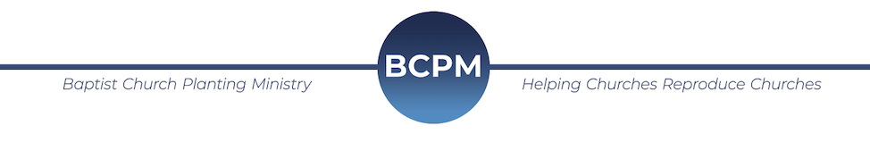April 2020

I pray you are well during these unique days! Here are a few updates and prayer requests:

Updates
1. Church Plants - The two church plants (East Cleveland, OH, and Welch, WV) scheduled for this spring have been moved to the fall. This means, among the other conferences and preplanned meetings, we will be involved with five church plants within seven weeks.
2. Meetings – Even though most of the meetings for myself, Rick and Brian, have been canceled through the end of May, we have been able to join churches “live” online. Please let us know if you would like us to join your services to give an update and/or a brief challenge.
3. Connect - We have been spending this time to connect with most of the church planters, praying with them and offering help. We have also been hosting online GoToMeetings with groups of pastors to help strengthen the church plants. The church planters have enjoyed these meetings, and we will continue to be "close" to these men and their families. I am reminded of 1 Cor. 11:28 when Paul stated, "that which cometh upon me daily, the care of all the churches."
4. BCPMSource - We have also been using this time to build out the “Resources” on BCPMSource. We’ve been asking the church planters to help with this as well. Please check it out at resources.html. Although we are not finished, these resources have already been a help to church planters and the young church plants.
5. Seed Bank Offering - Although the announcement of our “Seed Bank Offering” and video went out just as this crisis hysteria began, we have already seen $6000 come in! We praise the Lord for churches that are giving during times like these.

Prayer Requests
1. The young church plants - to remain strong enough to make it through this time. Many have no financial reserve and are struggling.
2. Our ministry - to endure this financially. We have not seen a drop in support, but this may happen over the next few months. We are already going to see a drop in income because of the canceled meetings.
3. For churches - not to lose their focus on the greater need of spreading the gospel and planting churches.
4. For God to be glorified – and to accomplish His purpose through all of this.

Thank you for praying for, and supporting, BCPM! You are a blessing as we advance the gospel and church planting during these challenging days.
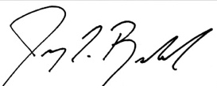
Jeremy Rowland
General Director

