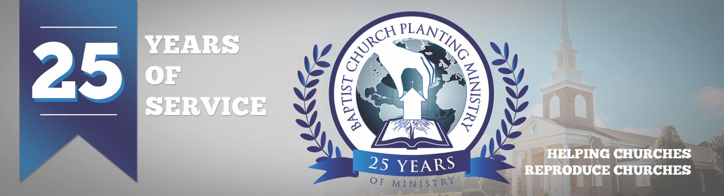

September 2018

Please pray for the next church plant we will be assisting with in Castelo Branco, Portugal. We will be taking a group from South Haven Baptist in Springfield, TN with us to help with the distribution of John and Romans. The Get Acquainted Meetings are set for October 10-12. It has been a joy to help Brother Mark Pereira with this church plant, and we are asking the Lord to do a great work and establish a solid church in this needy area. We are working on several church plant projects that are listed below.

• Castelo Branco, Portugal – Oct. 10-12

• Glendale, AZ – Feb. 17-21, 2019

• Reggio Emillia, Italy – March 3-4

• NW Dayton, OH – Mar. 31 – April 4

• Shrewsbury, MA – May 5-9

Pray for each of these church plants and several more we are working on that are in the preliminary stages. Pray that the Lord opens doors for meeting places, that every household in the area gets evangelized, for other churches to join in and help, for all the financial needs to be met, and for the Lord to be glorified!

Please pray also for Assistant Director Rick Rust and Canadian Representative Brian Thiessen as they raise their financial support. It is imperative that these men raise full support as they are needed to help carry the load of the ministry.

Time is short and we have so much to do to further the gospel through church planting. We covet your prayer and financial support as we work to advance the cause of Christ.

Advancing in Christ,

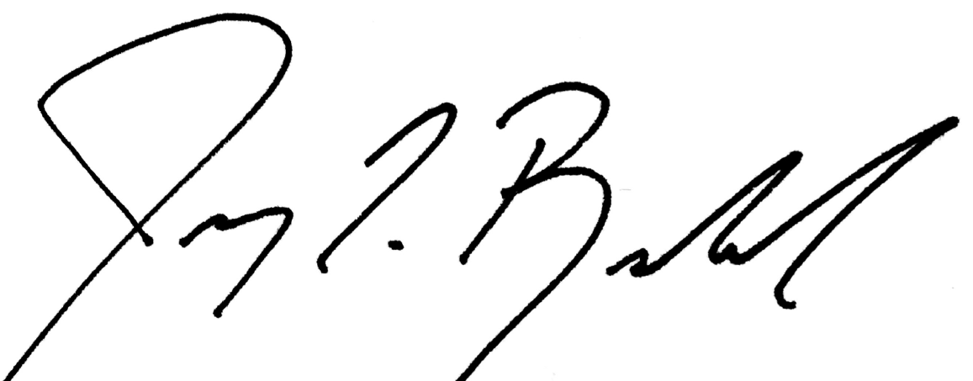

Jeremy Rowland,

General Director