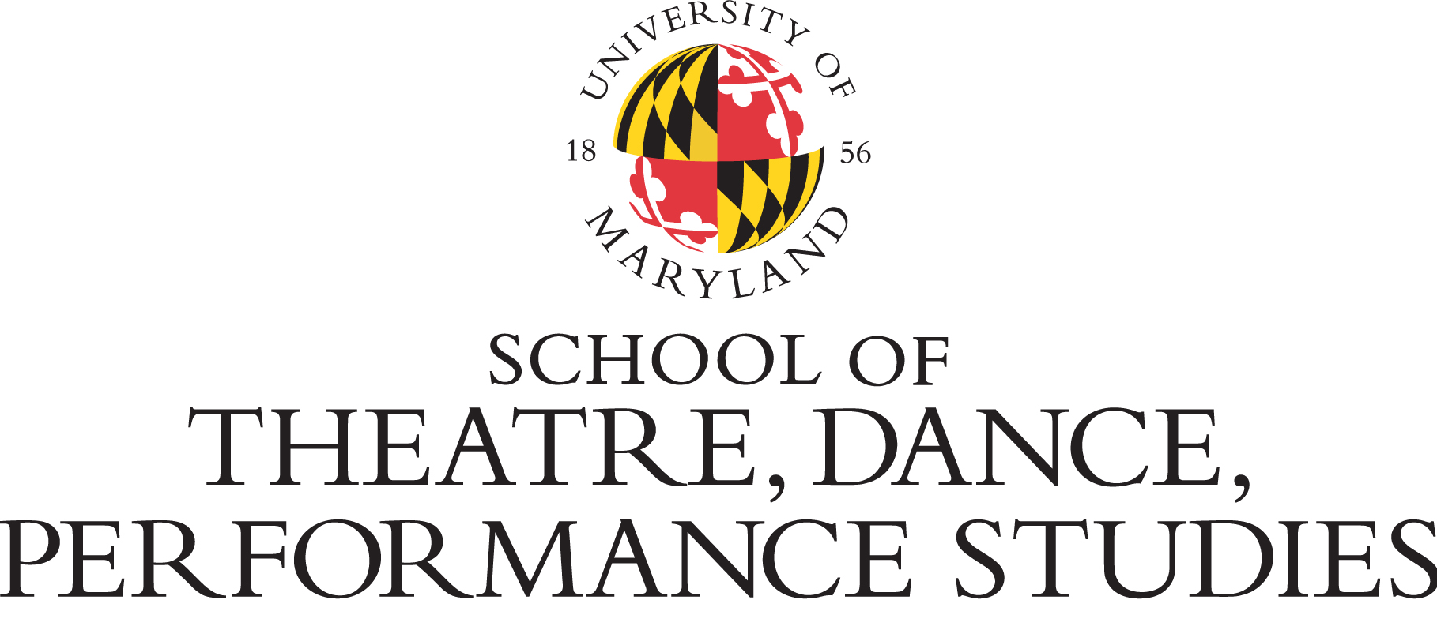

Guidelines for Board of Visitors Undergraduate Student Award

The Board of Visitors Student Award was established by the School of Theatre, Dance, and Performance Studies Board of Visitors.

Up to three (3) awards up to $2,500 each will be offered to undergraduate and graduate students in the School of Theatre, Dance, and Performance Studies. Undergraduate students must be declared Dance or Theatre majors, at a sophomore or junior standing, with a minimum of a 3.00 cumulative GPA.

The award is merit based and may be used to fund projects supporting career training and choices with respect to the performing arts or entertainment industries Summer 2021 including, but not limited to:
- Performance, design, choreography, or research
- Study Abroad
- Unpaid Internships

Students who wish to apply for the prestigious award must meet the following guidelines:
- Be a current School of Theatre, Dance, and Performance Studies undergraduate or graduate student and declared as a dance or theatre major as of September 2020;
- Enrolled as a fulltime student (minimum 12 credits);

- Must have completed at least two or three (2-3) semesters of the dance or theatre major here at UMD or at another institution (preference will be given to students who will be returning Fall 2021);
- Must have a cumulative minimum GPA of 3.00 or higher;

- Complete the attached application form;

- Supply a list of project support materials (if applicable), such as video, research papers/projects, renderings, recordings, etc.;

- Supply itemized project budget;

- Attach a CV or resume;

Selection Process and Criteria:
- Applications must be submitted to Susan Miller via email by 5pm on Friday, December 18, 2020
- Applications will go through three rounds of review;
- All applicants will receive an award decision by March 15, 2021
- Recipients will be required to present a report to the Board of Visitors at a meeting in Fall 2021

Board of Visitors Student Award Application Form

Name:

Phone Number:

UID# UMD Email address:

Check One: Sophomore ____ Junior ____ Senior ______ Major:

Expected Graduation Date:

Cumulative GPA:

Describe Your Project (350 words max):

Why is it important and relevant to your future studies/artistic growth (250 words max):

What will be the long-term impact for you and your career aspirations and/or your field of study/discipline? (250 words max):

How will you complete your project within timeframe and budget?

I certify that I am a current TDPS student. To the best of my knowledge, the information provided on this application is true and accurate.

Signature: Date:

Please submit complete application packets to Susan Miller via email only at smille13@umd.edu by 5pm on Friday, December 18, 2020

