Second Sunday after the Epiphany
Sunday, January 17 at 9am

Church of the Holy Nativity, Honolulu, HI
5286 Kalaniana’ole Highway Honolulu, HI 96821
www.holynativityhawaii.org

We welcome everyone to in-person and on-line worship! For safety reasons, those worshipping in person at the church please make all spoken responses quietly. We look forward to “making a joyful noise unto the Lord” together whenever it is deemed safe for us to do so!

Gathering Music Lorraine Yamamoto
“Break Forth, O Beauteous Heavenly Light,” Arranged by Robert Lau

The Liturgy of the Word
Opening Acclamation

The people stand in body or in spirit as the Officiant says

Celebrant: Blessed be God: Father, Son, and Holy Spirit.
People: And blessed be God’s kingdom, now and for ever. Amen.

The Celebrant says

Almighty God, to you all hearts are open, all desires known, and from you no secrets are hid: Cleanse the thoughts of our hearts by the inspiration of your Holy Spirit, that we may perfectly love you, and worthily magnify your holy Name; through Christ our Lord. Amen.

Hymn of Praise: #126, “The People Who in Darkness Walked”
Those appointed will bring the three kings to the creche at the front of the church.
The in-person congregation may sing along quietly to the hymn; those at home, please sing out!

The people who in darkness walked have seen a glorious light;
On them broke forth the heavenly dawn who dwelt in death and night.

To hail thy rising, Sun of life, the gathering nations come,
Joyous as when the reapers bear their harvest treasures home.

To us the promised Child is born, to us the Son is given;
Him shall the tribes of earth obey, and all the hosts of heaven.

His name shall be the Prince of Peace for evermore adored,
The Wonderful, the Counselor, the mighty God and Lord.

His power increasing still shall spread, his reign no end shall know;
Justice shall guard his throne above, and peace abound below.

The Collect

Celebrant The Lord be with you.
People And also with you.
Celebrant Let us pray.

Almighty God, whose Son our Savior Jesus Christ is the light of the world: Grant that your people, illumined by your Word and Sacraments, may shine with the radiance of Christ's glory, that he may be known, worshipped, and obeyed to the ends of the earth; through Jesus Christ our Lord, who with you and the Holy Spirit lives and reigns, one God, now and for ever. Amen.

The First Lesson: 1 Samuel 3:1-10

Now the boy Samuel was ministering to the Lord under Eli. The word of the Lord was rare in those days; visions were not widespread.
At that time Eli, whose eyesight had begun to grow dim so that he could not see, was lying down in his room; the lamp of God had not yet gone out, and Samuel was lying down in the temple of the Lord, where the ark of God was. Then the Lord called, “Samuel! Samuel!” and he said, “Here I am!” and ran to Eli, and said, “Here I am, for you called me.” But he said, “I did not call; lie down again.” So he went and lay down. The Lord called again, “Samuel!” Samuel got up and went to Eli, and said, “Here I am, for you called me.” But he said, “I did not call, my son; lie down again.” Now Samuel did not yet know the Lord, and the word of the Lord had not yet been revealed to him. The Lord called Samuel again, a third time. And he got up and went to Eli, and said, “Here I am, for you called me.” Then Eli perceived that the Lord was calling the boy. Therefore Eli said to Samuel, “Go, lie down; and if he calls you, you shall say, ‘Speak, Lord, for your servant is listening.’” So Samuel went and lay down in his place.
Now the Lord came and stood there, calling as before, “Samuel! Samuel!” And Samuel said, “Speak, for your servant is listening.”

The Psalm: 139: 1-5, 12-17
Reader Please join me in reading the psalm in unison

1 Lord, you have searched me out and known me; *
you know my sitting down and my rising up;
you discern my thoughts from afar.
2 You trace my journeys and my resting-places *
and are acquainted with all my ways.
3 Indeed, there is not a word on my lips, *
but you, O Lord, know it altogether.
4 You press upon me behind and before *
and lay your hand upon me.
5 Such knowledge is too wonderful for me; *
it is so high that I cannot attain to it.
12 For you yourself created my inmost parts; *
you knit me together in my mother's womb.
13 I will thank you because I am marvelously made; *
your works are wonderful, and I know it well.
14 My body was not hidden from you, *
while I was being made in secret
and woven in the depths of the earth.
15 Your eyes beheld my limbs, yet unfinished in the womb;
all of them were written in your book; *
they were fashioned day by day,
when as yet there was none of them.
16 How deep I find your thoughts, O God! *
how great is the sum of them!
17 If I were to count them, they would be more in number than the sand; *
to count them all, my life span would need to be like yours.

The Second Lesson: 1 Corinthians 6:12-20

“All things are lawful for me,” but not all things are beneficial. “All things are lawful for me,” but I will not be dominated by anything. “Food is meant for the stomach and the stomach for food,” and God will destroy both one and the other. The body is meant not for fornication but for the Lord, and the Lord for the body. And God raised the Lord and will also raise us by his power. Do you not know that your bodies are members of Christ? Should I therefore take the members of Christ and make them members of a prostitute? Never! Do you not know that whoever is united to a prostitute becomes one body with her? For it is said, “The two shall be one flesh.” But anyone united to the Lord becomes one spirit with him. Shun fornication! Every sin that a person commits is outside the body; but the fornicator sins against the body itself. Or do you not know that your body is a temple of the Holy Spirit within you, which you have from God, and that you are not your own? For you were bought with a price; therefore glorify God in your body.

The Gospel: Josh 1:43-51 The Rev. Libby Berman

Jesus decided to go to Galilee. He found Philip and said to him, “Follow me.” Now Philip was from Bethsaida, the city of Andrew and Peter. Philip found Nathanael and said to him, “We have found him about whom Moses in the law and also the prophets wrote, Jesus son of Joseph from Nazareth.” Nathanael said to him, “Can anything good come out of Nazareth?” Philip said to him, “Come and see.” When Jesus saw Nathanael coming toward him, he said of him, “Here is truly an Israelite in whom there is no deceit!” Nathanael asked him, “Where did you get to know me?” Jesus answered, “I saw you under the fig tree before Philip called you.” Nathanael replied, “Rabbi, you are the Son of God! You are the King of Israel!” Jesus answered, “Do you believe because I told you that I saw you under the fig tree? You will see greater things than these.” And he said to him, “Very truly, I tell you, you will see heaven opened and the angels of God ascending and descending upon the Son of Man.”

The Homily The Rev. Dr. Robert Steele

The Nicene Creed ICET 1988 Text
The Celebrant begins. The people join in.

We believe in one God, the Father, the Almighty,
maker of heaven and earth, of all that is, seen and unseen.

We believe in one Lord, Jesus Christ, the only Son of God,
eternally begotten of the Father, God from God, Light from Light, true God from true God,
begotten, not made, of one Being with the Father. Through him all things were made.
For us and for our salvation he came down from heaven,
was incarnate of the Holy Spirit and the Virgin Mary, and became truly human.
For our sake he was crucified under Pontius Pilate; he suffered death and was buried.
On the third day he rose again in accordance with the Scriptures;
he ascended into heaven and is seated at the right hand of the Father.
He will come again in glory to judge the living and the dead, and his kingdom will have no end.

We believe in the Holy Spirit, the Lord, the giver of life, who proceeds from the Father,
who with the Father and the Son is worshiped and glorified.
who has spoken through the Prophets.
We believe in one holy catholic and apostolic Church.
We acknowledge one baptism for the forgiveness of sins.
We look for the resurrection of the dead, and the life of the world to come. Amen.

Prayers of the People: Form II (Book of Common Prayer, p. 385)
In the course of the silence after each bidding, the People offer their own prayers, either silently or aloud.

I ask your prayers for God’s people throughout the world; for our Bishop; for this gathering; and for all ministers and people. Pray for the Church.

Silence

I ask your prayers for peace; for goodwill among nations; and for the well‑being of all people.
We pray especially today, for our nation, as we anticipate the Inauguration of a new President. Help us to go forward in our country with a shared unity of values and purpose.
Pray for justice and peace.

Silence

I ask your prayers for the poor, the sick, the hungry, the oppressed, and those in prison.
Pray for those in any need or trouble. We pray for those on our parish prayer list, especially Kelly, Hanohano, Chris, Lola, Sylvia, Heidi, Wayne, Guthrie, Ronny, Heather, and Deedie. We pray for all those who have the Corona virus and all caregivers. We pray for those facing unemployment.

Silence

I ask your prayers for all who seek God, or a deeper knowledge of God. Pray that they may find and be found by God.

Silence

I ask your prayers for the departed. Pray for those who have died.

Silence

We give thanks for the witness of the Rev. Dr. Martin Luther King, Jr. May we follow his lead in claiming the equality of and creating equal opportunity for all people.

Silence

Praise God for those in every generation in whom Christ has been honored. Pray that we may have grace to glorify Christ in our own day.

Silence

The Celebrant adds a concluding Collect.

The Confession of Sin

The Celebrant says

Let us confess our sins against God and our neighbor.

Silence may be kept.

Minister and People

Most merciful God, we confess that we have sinned against you in thought, word, and deed,
by what we have done, and by what we have left undone.
We have not loved you with our whole heart; we have not loved our neighbors as ourselves.
We are truly sorry and we humbly repent.
For the sake of your Son Jesus Christ, have mercy on us and forgive us; that we may delight in your will, and walk in your ways, to the glory of your Name. Amen.

The Priest stands and says

Almighty God have mercy on you, forgive you all your sins through our Lord Jesus Christ, strengthen you in all goodness, and by the power of the Holy Spirit keep you in eternal life. Amen.

The Peace
The Celebrant offers the greeting of peace to the congregation. Those worshipping at the church please offer greetings to one another from a distance; feel free to wave, bow, offer shakas, or take other joyful actions of greeting. Those worshipping in person and at home, please remember one another, as we are one!

Celebrant The peace of the Lord be always with you!
People And also with you!

Offertory by Lorraine Yamamoto, organist
“I Want to be a Christian,” Arranged by Mary McDonald

For those worshipping in person in the church, please note that there is a koa bowl at the rear of the church into which you are encouraged to place your offerings. For those worshipping at home, please continue to support Holy Nativity with your pledges and financial gifts by sending checks to Church of the Holy Nativity, 5286 Kalaniana’ole Hwy, Honolulu, HI 96821. Thank you to all those who have responded generously during this challenging time!

The Hawaiian Doxology (Hymn #380 in the 1982 Hymnal)
The choir has recorded this hymn from their homes. Please join in the singing, either in person or from home

Ho’o - na-ni i ka Ma-ku-a,
Ke Kei-ki me ka ‘U-ha-ne no,
Ke-A-ku-a mau Ho-’o-mai-ka-’i pu
Ko kei-ia ao, ko ke-la ao. A-me-ne.

The Holy Communion

The Great Thanksgiving: Eucharistic Prayer B

The people remain standing. The Celebrant, whether bishop or priest, faces them and says

The Lord be with you.
People And also with you.
Celebrant Lift up your hearts.
People We lift them to the Lord.
Celebrant Let us give thanks to the Lord our God.
People It is right to give him thanks and praise.

Then, facing the Holy Table, the Celebrant proceeds

It is right, and a good and joyful thing, always and everywhere to give thanks to you, Father Almighty, Creator of heaven and earth. Because in the mystery of the Word made flesh, you have caused a new light to shine in our hearts, to give the knowledge of your glory in the face of your Son Jesus Christ our Lord.

Therefore we praise you, joining our voices with Angels and Archangels and with all the company of heaven, who for ever sing this hymn to proclaim the glory of your Name:

The Sanctus
Sung by Kip & Jan Jones; please join them in singing quietly.

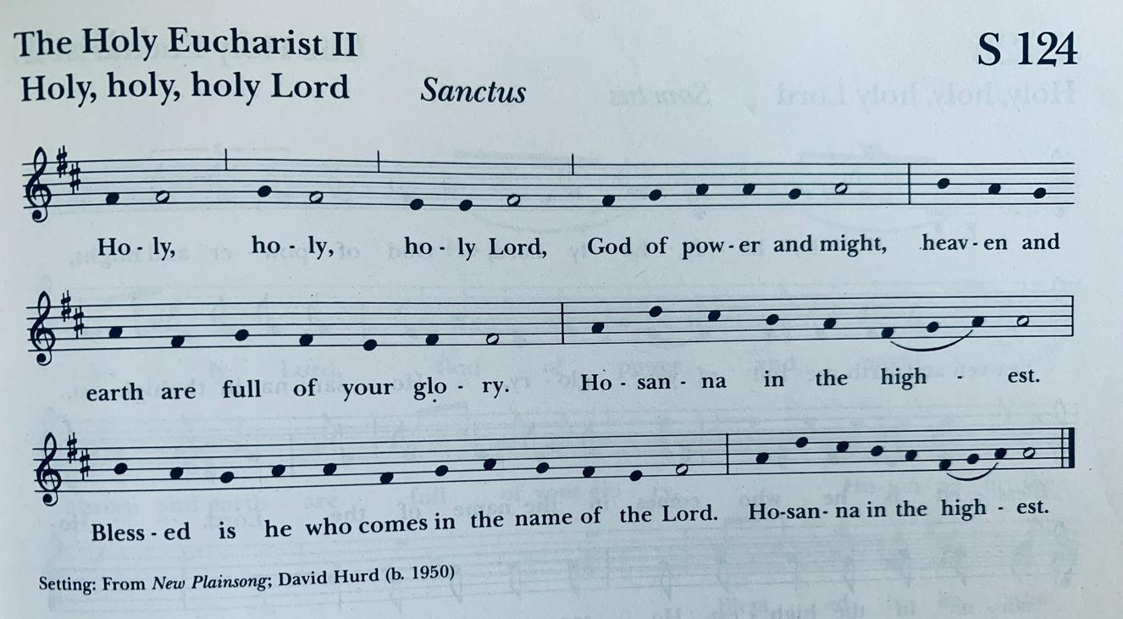

Then the Celebrant continues

We give thanks to you, O God, for the goodness and love which you have made known to us in creation; in the calling of Israel to be your people; in your Word spoken through the prophets; and above all in the Word made flesh, Jesus, your Son. For in these last days you sent him to be incarnate from the Virgin Mary, to be the Savior and Redeemer of the world. In him, you have delivered us from evil, and made us worthy to stand before you. In him, you have brought us out of error into truth, out of sin into righteousness, out of death into life.

At the following words concerning the bread, the Celebrant is to hold it, or lay a hand upon it; and at the words concerning the cup, to hold or place a hand upon the cup and any other vessel containing wine to be consecrated.

On the night before he died for us, our Lord Jesus Christ took bread; and when he had given thanks to you, he broke it, and gave it to his disciples, and said, “Take, eat: This is my Body, which is given for you. Do this for the remembrance of me.”

After supper he took the cup of wine; and when he had given thanks, he gave it to them, and said, “Drink this, all of you: This is my Blood of the new Covenant, which is shed for you and for many for the forgiveness of sins. Whenever you drink it, do this for the remembrance of me.”

Therefore, according to his command, O Father,

Celebrant and People

We remember his death,
We proclaim his resurrection,
We await his coming in glory;

The Celebrant continues

And we offer our sacrifice of praise and thanksgiving to you, O Lord of all; presenting to you, from your creation, this bread and this wine.

We pray you, gracious God, to send your Holy Spirit upon these gifts that they may be the Sacrament of the Body of Christ and his Blood of the new Covenant. Unite us to your Son in his sacrifice, that we may be acceptable through him, being sanctified by the Holy Spirit. In the fullness of time, put all things under your Christ, and bring us to that heavenly country where, with all your saints, we may enter the everlasting heritage of your sons and daughters; through Jesus Christ our Lord, the firstborn of all creation, the head of the Church, and the author of our salvation.

By him, and with him, and in him, in the unity of the Holy Spirit all honor and glory is yours, Almighty Father, now and for ever. AMEN.

And now, as our Savior
Christ has taught us,
we are bold to say,
People and Celebrant

Our Father, who art in heaven,
hallowed be thy Name,
thy kingdom come,
thy will be done,
on earth as it is in heaven.
Give us this day our daily bread.
And forgive us our trespasses,
as we forgive those
who trespass against us.
And lead us not into temptation,
but deliver us from evil.
For thine is the kingdom,
and the power, and the glory,
for ever and ever. Amen.

The Breaking of the Bread
The Celebrant breaks the consecrated Bread. A period of silence is kept.

Celebrant Alleluia. Christ our Passover is sacrificed for us;
People Therefore let us keep the feast. Alleluia.

The Fraction Anthem
Led by members of the Choir; please join them in singing quietly.

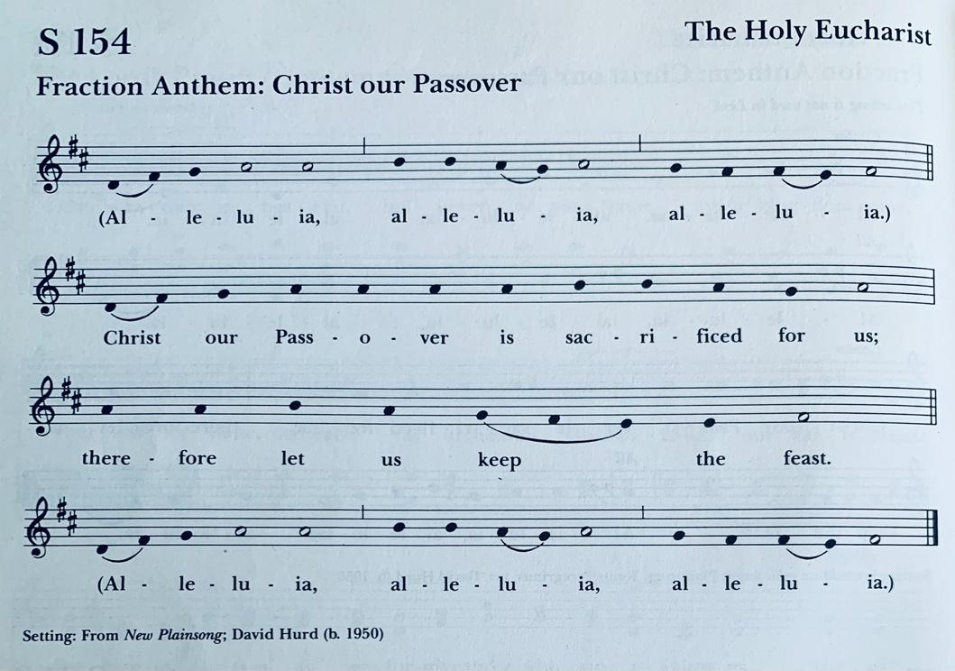

Facing the people, the Celebrant says the following Invitation

The Gifts of God for the People of God. Take them in remembrance that Christ died for
you, and feed on him in your hearts by faith, with thanksgiving.

The ministers deliver the Bread to the people at the station at the bottom of the chancel area. Please follow the ushers and the verbal instructions given. When you have received the sacrament, please return to your seat to consume it. Receiving the sacrament “in one kind only,” as we are doing today, is considered by the Church to be a full communion. (Please note that we are delivering the sacrament to those continuing to worship at home who request it.)

After Communion, the Celebrant says
Let us pray.

Celebrant and People Eternal God, heavenly Father, you have graciously accepted us as living members of your Son our Savior Jesus Christ, and you have fed us with spiritual food in the Sacrament of his Body and Blood. Send us now into the world in peace, and grant us strength and courage to love and serve you with gladness and singleness of heart; through Christ our Lord. Amen.

Announcements

The Blessing The Rev. Libby Berman

The Final Hymn: #181, “Amazing Grace”
The in-person congregation may sing along quietly; those at home, please sing out loud!

Amazing grace! how sweet the sound
That saved a wretch like me!
I once was lost, but now I am found
Was blind, but now I see

'Twas grace that taught my heart to fear
And grace my fears relieved
How precious did that grace appear
The hour I first believed!

The Lord hath promised good to me
His word my hope secures
He will my shield and portion be
As long as life endures

Through many dangers, toils and snares
We have already come
'Tis grace has brought us safe thus far
And grace will lead me home

When we've been there ten thousand years
Bright shining as the sun
We've no less days to sing God's praise
Than when we've first begun

The Dismissal

Deacon Let us go forth into the world, rejoicing in the power of the Spirit!
People Thanks be to God!

The Postlude Lorraine Yamamoto
“Praise Him with the Sound of the Trumpet,” Composed by Robert Lau

Ministry Team for Today’s Service: thank you!
Celebrant: The Rev. Libby Berman
Deacon and Preacher: The Rev. Robert Steele
Musicians: Lorraine Yamamoto & the HNC Choir
Readers: Justin Donahue & Lila Johnson
Intercessor: Frank Condello
Eucharistic Minister & Acolyte: Kim Garner

Staff
Music Director (Chris Suzuki): hncmusic1@gmail.com
Student for Formation for Ordination: Frank Condello
Office (Punahele Coldwell): hncparish@gmail.com
Operations Manager (Kathy Kia): hncoperationsmanager@gmail.com
Thrift Shop (Peggy Budlong): hntsmgr@gmail.com

JOIN US NEXT SUNDAY FOR THE THIRD SUNDAY AFTER THE EPIPHANY
SUNDAY, JANUARY 24 at 9AM (in person & on Zoom)

ANNUAL MEETING TO FOLLOW THE 9AM SERVICE on
JANUARY 31, 2021

