Third Sunday in Lent
Sunday, March 7 at 9am

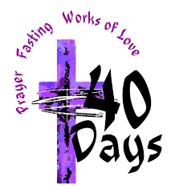

Church of the Holy Nativity, Honolulu, HI
5286 Kalaniana’ole Highway Honolulu, HI 96821
www.holynativityhawaii.org

We welcome everyone to worship today! For safety reasons, those worshipping in person at the church please make all spoken responses quietly. We look forward to “making a joyful noise unto the Lord” together whenever it is deemed safe for us to do so!

Gathering Music Lorraine Yamamoto
“Herzliebster Jesu,” by Johannes Brahms

The Processional: Hymn # 149, “Eternal God of Love”
led by the choir

Eternal Lord of love, behold your Church
Walking once more the pilgrim way of Lent,
Led by your cloud by day, by night your fire,
Moved by your love and toward your presence bent:
Far off yet here the goal of all desire.

So daily dying to the way of self,
So daily living to your way of love,
We walk the road, Lord Jesus, that you trod,
Knowing ourselves baptized into your death:
So we are dead and live with you in God.

If dead in you, so in you we arise,
You the firstborn of all the faithful dead;
And as through stony ground the green shoots break,
Glorious in springtime dress of leaf and flower,
So in the Father’s glory shall we wake.

The Liturgy of the Word

The Penitential Order

In Lent and on other penitential occasions, the people stand in body or in spirit as the Officiant says

Bless the Lord who forgives all our sins.
People His mercy endures for ever.

The Celebrant reads the following sentence

Jesus said, “The first commandment is this: Hear, O Israel: The Lord our God is the only Lord. Love the Lord your God with all your heart, with all your soul, with all your mind, and with all your strength. The second is this: Love your neighbor as yourself. There is no other commandment greater than these.” Mark 12:29‑31

If we say that we have no sin, we deceive ourselves, and the truth is not in us. But if we confess our sins, God, who is faithful and just, will forgive our sins and cleanse us from all unrighteousness. 1 John 1:8,9

The Confession and Absolution
The Deacon or Celebrant then says

Let us confess our sins against God and our neighbor.

Silence may be kept.

Minister and People

Most merciful God,
we confess that we have sinned against you in thought, word, and deed,
by what we have done, and by what we have left undone.
We have not loved you with our whole heart; we have not loved our neighbors as ourselves.
We are truly sorry and we humbly repent.
For the sake of your Son Jesus Christ, have mercy on us and forgive us;
that we may delight in your will, and walk in your ways,
to the glory of your Name. Amen.

The Bishop when present, or the Priest, stands and says

Almighty God have mercy on you, forgive you all your sins through our Lord Jesus Christ, strengthen you in all goodness, and by the power of the Holy Spirit keep you in eternal life. Amen.

Queen Lili’uokalani’s Prayer
The choir will lead this hymn; the congregation may join in.

‘O kou a-lo-ha no, A-i-a i ka la-ni, A ‘o kou’oi-a-i-‘o, he he-mo-le-le ho-‘i.

Ko’u no-ho mi-hi ‘a-na a pa’-a-h-o ‘i-a, ‘O ‘o-e ku-’u la-ma, kou na-ni ko-’u ko-‘o.

Mai na-na ‘i-no-‘i-no. Na he-wa o ka-na-ka, A-ka, e hu-i-ka-la, A ma-‘e ma-’e no.

No lai-la e ka ha-ku, Ma la-lo kou e-he-u, Ko ma-kou ma-lu hi-a, A mauloa a-ku no. ‘A-me-ne.

(“Your loving mercy is as high as heaven and your truth so perfect.
I live imprisoned in sorrow; you are my light; your glory, my support.
Behold not with malevolence the sins of mankind, but forgive and cleanse.
And so, O Lord, protect us beneath your wings and let peace be our portion
now and forever more. Amen.”)
--prayer and tune by Queen Lili’uokalani

The Kyrie
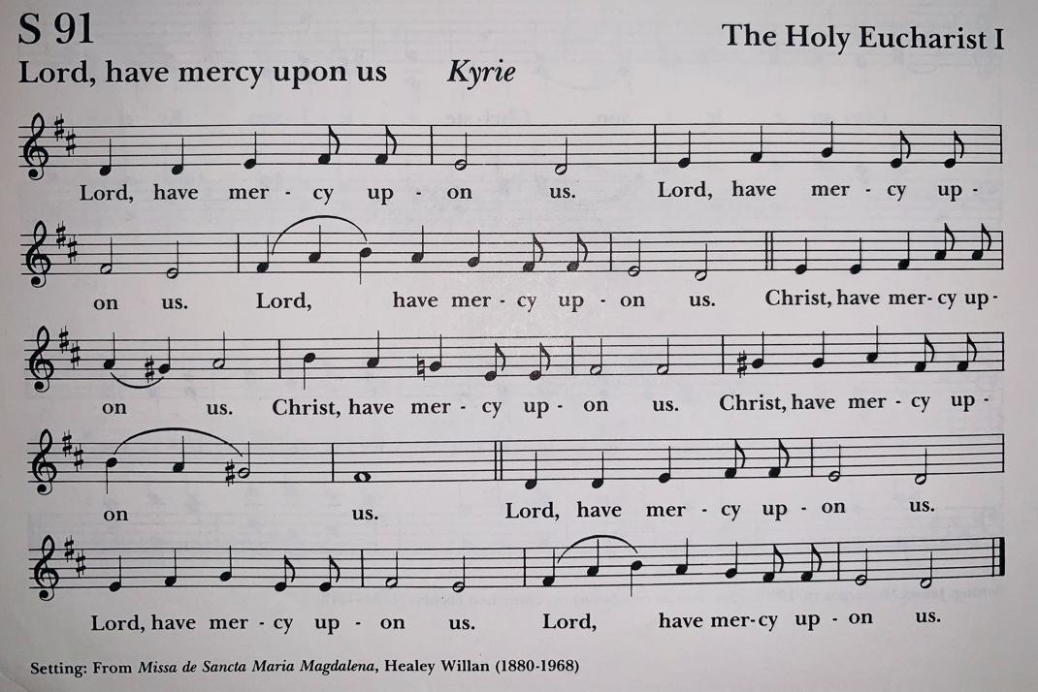

The Collect

Celebrant The Lord be with you.
People And also with you.
Celebrant Let us pray.

Almighty God, you know that we have no power in ourselves to help ourselves: Keep us both outwardly in our bodies and inwardly in our souls, that we may be defended from all adversities which may happen to the body, and from all evil thoughts which may assault and hurt the soul; through Jesus Christ our Lord, who lives and reigns with you and the Holy Spirit, one God, for ever and ever. Amen.

The First Lesson: Exodus 20:1-17

Then God spoke all these words: I am the Lord your God, who brought you out of the land of Egypt, out of the house of slavery; you shall have no other gods before me.

You shall not make for yourself an idol, whether in the form of anything that is in heaven above, or that is on the earth beneath, or that is in the water under the earth. You shall not bow down to them or worship them; for I the Lord your God am a jealous God, punishing children for the iniquity of parents, to the third and the fourth generation of those who reject me, but showing steadfast love to the thousandth generation of those who love me and keep my commandments.

You shall not make wrongful use of the name of the Lord your God, for the Lord will not acquit anyone who misuses his name. Remember the sabbath day, and keep it holy. For six days you shall labour and do all your work. But the seventh day is a sabbath to the Lord your God; you shall not do any work—you, your son or your daughter, your male or female slave, your livestock, or the alien resident in your towns. For in six days the Lord made heaven and earth, the sea, and all that is in them, but rested the seventh day; therefore the Lord blessed the sabbath day and consecrated it.

Honor your father and your mother, so that your days may be long in the land that the Lord your God is giving you.

You shall not murder. You shall not commit adultery. You shall not steal. You shall not bear false witness against your neighbor. You shall not covet your neighbor’s house; you shall not covet your neighbor’s wife, or male or female slave, or ox, or donkey, or anything that belongs to your neighbor.

Reader The Word of the Lord.
People Thanks be to God.

The Psalm: 19
Reader Please join me in praying Psalm 19

1 The heavens declare the glory of God, *
and the firmament shows his handiwork.
2 One day tells its tale to another, *
and one night imparts knowledge to another.
3 Although they have no words or language, *
and their voices are not heard,
4 Their sound has gone out into all lands, *
and their message to the ends of the world.
5 In the deep has he set a pavilion for the sun; *
it comes forth like a bridegroom out of his chamber;
it rejoices like a champion to run its course.
6 It goes forth from the uttermost edge of the heavens
and runs about to the end of it again; *
nothing is hidden from its burning heat.
7 The law of the Lord is perfect
and revives the soul; *
the testimony of the Lord is sure
and gives wisdom to the innocent.
8 The statutes of the Lord are just
and rejoice the heart; *
the commandment of the Lord is clear
and gives light to the eyes.
9 The fear of the Lord is clean
and endures for ever; *
the judgments of the Lord are true
and righteous altogether.
10 More to be desired are they than gold,
more than much fine gold, *
sweeter far than honey,
than honey in the comb.
11 By them also is your servant enlightened, *
and in keeping them there is great reward.
12 Who can tell how often he offends? *
cleanse me from my secret faults.
13 Above all, keep your servant from presumptuous sins;
let them not get dominion over me; *
then shall I be whole and sound,
and innocent of a great offense.
14 Let the words of my mouth and the meditation of my
heart be acceptable in your sight, *
O Lord, my strength and my redeemer.

The Second Lesson: 1 Corinthians 1:18-25

The message about the cross is foolishness to those who are perishing, but to us who are being saved it is the power of God. For it is written, “I will destroy the wisdom of the wise, and the discernment of the discerning I will thwart.”
Where is the one who is wise? Where is the scribe? Where is the debater of this age? Has not God made foolish the wisdom of the world? For since, in the wisdom of God, the world did not know God through wisdom, God decided, through the foolishness of our proclamation, to save those who believe. For Jews demand signs and Greeks desire wisdom, but we proclaim Christ crucified, a stumbling block to Jews and foolishness to Gentiles, but to those who are the called, both Jews and Greeks, Christ the power of God and the wisdom of God. For God’s foolishness is wiser than human wisdom, and God’s weakness is stronger than human strength.

Reader The Word of the Lord.
People Thanks be to God.

The Gospel: John 2:13-22 The Rev. Bob Steele

Deacon or Priest The Holy Gospel according to our Lord Jesus Christ according to John.
People Glory to you, Lord Christ.

The Passover of the Jews was near, and Jesus went up to Jerusalem. In the temple he found people selling cattle, sheep, and doves, and the money changers seated at their tables. Making a whip of cords, he drove all of them out of the temple, both the sheep and the cattle. He also poured out the coins of the money changers and overturned their tables. He told those who were selling the doves, “Take these things out of here! Stop making my Father’s house a marketplace!” His disciples remembered that it was written, “Zeal for your house will consume me.” The Jews then said to him, “What sign can you show us for doing this?” Jesus answered them, “Destroy this temple, and in three days I will raise it up.” The Jews then said, “This temple has been under construction for forty-six years, and will you raise it up in three days?” But he was speaking of the temple of his body. After he was raised from the dead, his disciples remembered that he had said this; and they believed the scripture and the word that Jesus had spoken.

Deacon or Priest The Gospel of the Lord.
People Praise to you, Lord Christ.

The Homily The Rev. Libby Berman

The Nicene Creed ICET 1988 Text
The Celebrant begins. The people join in.

We believe in one God, the Father, the Almighty,
maker of heaven and earth, of all that is, seen and unseen.

We believe in one Lord, Jesus Christ, the only Son of God,
eternally begotten of the Father, God from God, Light from Light, true God from true God,
begotten, not made, of one Being with the Father. Through him all things were made.
For us and for our salvation he came down from heaven,
was incarnate of the Holy Spirit and the Virgin Mary, and became truly human.
For our sake he was crucified under Pontius Pilate; he suffered death and was buried.
On the third day he rose again in accordance with the Scriptures;
he ascended into heaven and is seated at the right hand of the Father.
He will come again in glory to judge the living and the dead, and his kingdom will have no end.

We believe in the Holy Spirit, the Lord, the giver of life, who proceeds from the Father,
who with the Father and the Son is worshiped and glorified.
who has spoken through the Prophets.
We believe in one holy catholic and apostolic Church.
We acknowledge one baptism for the forgiveness of sins.
We look for the resurrection of the dead, and the life of the world to come. Amen.

Prayers of the People:
(adapted from the Church of England’s “Times and Seasons”)
After each bidding, the People respond with the words, “in your mercy hear us” and offer their own prayers silently.

With confidence and trust let us pray to God.
For the one holy catholic and apostolic Church, let us pray to God. Lord of compassion,
in your mercy hear us.
For the mission of the Church, that in faithful witness it may preach the gospel
to the ends of the earth, let us pray to God.
Lord of compassion,
in your mercy hear us.
For those preparing for baptism and confirmation, and for our students at Holy Nativity School, who are invited to come closer to you in chapel each week, and for their teachers and mentors, let us pray to God.
Lord of compassion,
in your mercy hear us.
For peace in the world, that a spirit of respect and reconciliation may grow among nations and peoples, let us pray to God.
Lord of compassion,
in your mercy hear us.
For the poor, the persecuted, the sick, and all who suffer, for refugees, prisoners, and all in danger; that they may be relieved and protected. We pray for those our parish prayer list: Kelly, Hanohano, Chris, Lola, Sylvia, Heidi, Wayne, Coco, Ronny, Heather, Deedie, June, Susan, Julian, Jerome, and Beverly. We pray for all those who have the Corona virus, all caregivers, and for those facing unemployment.

Lord of compassion,
in your mercy hear us.
For those whom we have injured or offended, let us pray to God.
Lord of compassion,
in your mercy hear us.
For grace to amend our lives and to further the reign of God, let us pray to God.
Lord of compassion,
in your mercy hear us.
In communion with all those who have walked in the way of holiness in this life, let us pray to God. Lord of compassion,
in your mercy hear us.
Gracious God, in your love and goodness you have taught us to come close to you in penitence with prayer, fasting and generosity; accept our Lenten discipline, and when we fall by our weakness, raise us up by your unfailing mercy; through Jesus Christ our Lord.
Amen.
The congregation keeps a moment of silence.

The Peace
The Celebrant offers the greeting of peace to the congregation. Those worshipping at the church please offer greetings to one another from a distance; feel free to wave, bow, offer shakas, or take other joyful actions of greeting. Those worshipping in person and at home, please remember one another, as we are one!

Celebrant The peace of the Lord be always with you!
People And also with you!

Offertory Anthem offered by Amie Lawyer

For those worshipping in person in the church, please note that there is a koa bowl at the rear of the church into which you are encouraged to place your offerings. For those worshipping at home, please continue to support Holy Nativity with your pledges and financial gifts by sending checks to Church of the Holy Nativity, 5286 Kalaniana’ole Hwy, Honolulu, HI 96821. Thank you to all those who have responded generously during this challenging time!

The Holy Communion

The Great Thanksgiving: Eucharistic Prayer A

The people remain standing. The Celebrant, whether bishop or priest, faces them and says

The Lord be with you.
People And also with you.
Celebrant Lift up your hearts.
People We lift them to the Lord.
Celebrant Let us give thanks to the Lord our God.
People It is right to give God thanks and praise.

Then, facing the Holy Table, the Celebrant proceeds

It is right, and a good and joyful thing, always and everywhere to give thanks to you, Father Almighty, Creator of heaven and earth. Through Jesus Christ our Lord, who was tempted in every way as we are, yet did not sin. By his grace we are able to triumph over evil, and to live no longer for ourselves alone, but for him who died for us and rose again.

Therefore we praise you, joining our voices with Angels and Archangels and with all the company of heaven, who for ever sing this hymn to proclaim the glory of your Name:

Celebrant and People, speaking together

Holy, holy, holy Lord, God of power and might,
heaven and earth are full of your glory.
Hosanna in the highest.
Blessed is he who comes in the name of the Lord.
Hosanna in the highest.

The people stand, sit, or kneel, as is most comfortable for each, in continuing prayer. The Celebrant continues

Holy and gracious God: In your infinite love you made us for yourself; and, when we had fallen into sin and become subject to evil and death, you, in your mercy, sent Jesus Christ, your only and eternal Son, to share our human nature, to live and die as one of us, to reconcile us to you, the God and Father of all.

He stretched out his arms upon the cross, and offered himself, in obedience to your will, a perfect sacrifice for the whole world.

On the night he was handed over to suffering and death, our Lord Jesus Christ took bread; and when he had given thanks to you, he broke it, and gave it to his disciples, and said, “Take, eat: This is my Body, which is given for you. Do this for the remembrance of me.”
After supper he took the cup of wine; and when he had given thanks, he gave it to them, and said, “Drink this, all of you: This is my Blood of the new Covenant, which is shed for you and for all for the forgiveness of sins. Whenever you drink it, do this for the remembrance of me.”

Therefore we proclaim the mystery of faith:

Celebrant and People

Christ has died.
Christ is risen.
Christ will come again.

The Celebrant continues

We celebrate the memorial of our redemption, O Father, in this sacrifice of praise and thanksgiving. Recalling his death, resurrection, and ascension, we offer you these gifts.

Sanctify them by your Holy Spirit to be for your people the Body and Blood of your Son, the holy food and drink of new and unending life in him. Sanctify us also that we may faithfully receive this holy Sacrament, and serve you in unity, constancy, and peace; and at the last day bring us with all your saints into the joy of your eternal kingdom.

All this we ask through your Son Jesus Christ. By him, and with him, and in him, in the unity of the Holy Spirit all honor and glory is yours, Almighty Father, now and for ever. AMEN.

And now, as our Savior
Christ has taught us,
we are bold to say,
People and Celebrant

Our Father, who art in heaven,
hallowed be thy Name,
thy kingdom come,
thy will be done,
on earth as it is in heaven.
Give us this day our daily bread.
And forgive us our trespasses,
as we forgive those
who trespass against us.
And lead us not into temptation,
but deliver us from evil.
For thine is the kingdom,
and the power, and the glory,
for ever and ever. Amen.

The Breaking of the Bread
The Celebrant breaks the consecrated Bread. A period of silence is kept.

Celebrant Christ our Passover is sacrificed for us;
People Therefore let us keep the feast.

Facing the people, the Celebrant says the following Invitation

The Gifts of God for the People of God. Take them in remembrance that Christ died for
you, and feed on him in your hearts by faith, with thanksgiving.

The ministers deliver the Bread to the people at the station at the bottom of the chancel area, keeping social distancing guidelines. When you have received the sacrament, please return to your seat to consume it. Receiving the sacrament “in one kind only,” as we are doing today, is considered by the Church to be a full communion.

The Post-Communion Prayer
After Communion, the Celebrant says

Let us pray.

Almighty and everliving God, we thank you for feeding us with the spiritual food of the most precious Body and Blood of your Son our Savior Jesus Christ; and for assuring us in these holy mysteries that we are living members of the Body of your Son, and heirs of your eternal kingdom.
And now, Father, send us out to do the work you have given us to do, to love and serve you as faithful witnesses of Christ our Lord. To him, to you, and to the Holy Spirit, be honor and glory, now and for ever. Amen.

Announcements The Rev. Libby Berman

Closing Hymn: : “Angus Dei,” by Mariano Garau
The hymn will be led by members of the choir.

Agnus Dei, qui tollis peccata mundi, miserere nobis.
Agnus Dei, qui tollis peccata mundi, miserere nobis.
Agnus Dei, qui tollis peccata mundi, dona nobis pacem.

translation:

Lamb of God, who takes away the sins of the world, have mercy upon us.
Lamb of God, who takes away the sins of the world, have mercy upon us.
Lamb of God, who takes away the sins of the world, grant us peace.

The Lenten Prayer for the People The Rev. Libby Berman

The Dismissal

Deacon Let us go forth into the world, rejoicing in the power of the Spirit!
People Thanks be to God!

The Postlude Lorraine Yamamoto
“Thanks be to God Who Reigns, “ by John Barr

Ministry Team for Today’s Service: thank you!
Celebrant and Preacher: The Rev. Libby Berman
Deacon: The Rev. Robert Steele
Musicians: Lorraine Yamamoto & the HNC Choir
Readers: Alison Kittle & Jean Steele
Intercessor: Julia Yamaguchi
Eucharistic Minister & Acolyte: Kim Garner
Usher: Ed Moore

Staff
Music Director (Chris Suzuki): hncmusic1@gmail.com
Student for Formation for Ordination: Frank Condello
Office (Punahele Coldwell): hncparish@gmail.com
Operations Manager (Kathy Kia): hncoperationsmanager@gmail.com
Thrift Shop (Peggy Budlong): hntsmgr@gmail.com

JOIN US NEXT SUNDAY FOR THE FOURTH SUNDAY IN LENT
SUNDAY, MARCH 14 at 9AM (in person & on Zoom)

Join us on Wednesday evenings in Lent for our series, “Becoming the Beloved Community.” 6-7pm on Zoom; link is on the front of the website: www.holynativityhawaii.org

LILLIES FOR EASTER

Please consider contributing to the Holy Nativity Flower Fund to decorate our nave on Easter Sunday. For $10.00, you can purchase a potted Easter Lily. You may make a dedication to be noted with your name in the church bulletin. After Easter you can take the lily home to plant.

----------------------------------------------------------

I wish to contribute $___________ for _____ a potted Easter Lily

Name ____________________________________________________

Dedication: ____________________________________________________________________

Thank you from the Altar Guild

