First Sunday after the Epiphany
Sunday, January 10 at 9am

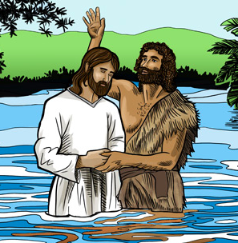

Church of the Holy Nativity, Honolulu, HI
5286 Kalaniana’ole Highway Honolulu, HI 96821
www.holynativityhawaii.org

We welcome everyone to in-person and on-line worship! For safety reasons, those worshipping in person at the church please make all spoken responses quietly. We look forward to “making a joyful noise unto the Lord” together whenever it is deemed safe for us to do so!

Gathering Music Lorraine Yamamoto

The Liturgy of the Word
Opening Acclamation

The people stand in body or in spirit as the Officiant says

Celebrant: Blessed be God: Father, Son, and Holy Spirit.
People: And blessed be God’s kingdom, now and for ever. Amen.

The Celebrant says

Almighty God, to you all hearts are open, all desires known, and from you no secrets are hid: Cleanse the thoughts of our hearts by the inspiration of your Holy Spirit, that we may perfectly love you, and worthily magnify your holy Name; through Christ our Lord. Amen.

Hymn of Praise: #128, “We Three Kings”
Those appointed will bring the three kings to the creche at the front of the church.
The in-person congregation may sing along quietly to the hymn; those at home, please sing out!

We three kings of Orient are, bearing
Gifts we traverse afar, field and fountain,
Moor and mountain, following yonder star.

Born a King on Bethlehem’s plain, gold I
Bring to crown him again, King forever,
Ceasing never over us all to reign.

Myrrh is mine; its bitter perfume breathes a
Life of gathering gloom; sorrowing, sighing,
Bleeding, dying, sealed in the stonecold tomb.

Glorious now behold him arise, King and
God and Sacrifice; heaven sings alleluia:
Alleluia the earth replies.

The Collect

Celebrant The Lord be with you.
People And also with you.
Celebrant Let us pray.

Father in heaven, who at the baptism of Jesus in the River Jordan proclaimed him your beloved Son and anointed him with the Holy Spirit: Grant that all who are baptized into his Name may keep the covenant they have made, and boldly confess him as Lord and Savior; who with you and the Holy Spirit lives and reigns, one God, in glory everlasting. Amen.

The First Lesson: Genesis 1:1-5 Alison Kittle

In the beginning when God created the heavens and the earth, the earth was a formless void and darkness covered the face of the deep, while a wind from God swept over the face of the waters. Then God said, “Let there be light”; and there was light. And God saw that the light was good; and God separated the light from the darkness. God called the light Day, and the darkness he called Night. And there was evening and there was morning, the first day.

The Psalm: 29
Reader Please join me in reading the psalm in unison Alison Kittle

1 Ascribe to the Lord, you gods, *
ascribe to the Lord glory and strength.
2 Ascribe to the Lord the glory due his Name; *
worship the Lord in the beauty of holiness.
3 The voice of the Lord is upon the waters;
the God of glory thunders; *
the Lord is upon the mighty waters.
4 The voice of the Lord is a powerful voice; *
the voice of the Lord is a voice of splendor.
5 The voice of the Lord breaks the cedar trees; *
the Lord breaks the cedars of Lebanon;
6 He makes Lebanon skip like a calf, *
and Mount Hermon like a young wild ox.
7 The voice of the Lord splits the flames of fire;
the voice of the Lord shakes the wilderness; *
the Lord shakes the wilderness of Kadesh.
8 The voice of the Lord makes the oak trees writhe *
and strips the forests bare.
9 And in the temple of the Lord *
all are crying, "Glory!"
10 The Lord sits enthroned above the flood; *
the Lord sits enthroned as King for evermore.
11 The Lord shall give strength to his people; *
the Lord shall give his people the blessing of peace.

The Second Lesson: Acts 19:1-7 Lila Johnson

While Apollos was in Corinth, Paul passed through the interior regions and came to Ephesus, where he found some disciples. He said to them, “Did you receive the Holy Spirit when you became believers?” They replied, “No, we have not even heard that there is a Holy Spirit.” Then he said, “Into what then were you baptized?” They answered, “Into John’s baptism.” Paul said, “John baptized with the baptism of repentance, telling the people to believe in the one who was to come after him, that is, in Jesus.” On hearing this, they were baptized in the name of the Lord Jesus. When Paul had laid his hands on them, the Holy Spirit came upon them, and they spoke in tongues and prophesied— altogether there were about twelve of them.

The Gospel: Mark 1:4-11 The Rev. Bob Steele

John the baptizer appeared in the wilderness, proclaiming a baptism of repentance for the forgiveness of sins. And people from the whole Judean countryside and all the people of Jerusalem were going out to him, and were baptized by him in the river Jordan, confessing their sins. Now John was clothed with camel’s hair, with a leather belt around his waist, and he ate locusts and wild honey. He proclaimed, “The one who is more powerful than I is coming after me; I am not worthy to stoop down and untie the thong of his sandals. I have baptized you with water; but he will baptize you with the Holy Spirit.”
In those days Jesus came from Nazareth of Galilee and was baptized by John in the Jordan. And just as he was coming up out of the water, he saw the heavens torn apart and the Spirit descending like a dove on him. And a voice came from heaven, “You are my Son, the Beloved; with you I am well pleased.”
The Homily The Rev. Alison Dingley

The Nicene Creed ICET 1988 Text
The Celebrant begins. The people join in.

We believe in one God, the Father, the Almighty,
maker of heaven and earth, of all that is, seen and unseen.

We believe in one Lord, Jesus Christ, the only Son of God,
eternally begotten of the Father, God from God, Light from Light, true God from true God,
begotten, not made, of one Being with the Father. Through him all things were made.
For us and for our salvation he came down from heaven,
was incarnate of the Holy Spirit and the Virgin Mary, and became truly human.
For our sake he was crucified under Pontius Pilate; he suffered death and was buried.
On the third day he rose again in accordance with the Scriptures;
he ascended into heaven and is seated at the right hand of the Father.
He will come again in glory to judge the living and the dead, and his kingdom will have no end.

We believe in the Holy Spirit, the Lord, the giver of life, who proceeds from the Father,
who with the Father and the Son is worshiped and glorified.
who has spoken through the Prophets.
We believe in one holy catholic and apostolic Church.
We acknowledge one baptism for the forgiveness of sins.
We look for the resurrection of the dead, and the life of the world to come. Amen.

Prayers of the People: Form II (Book of Common Prayer, p. 385)
In the course of the silence after each bidding, the People offer their own prayers, either silently or aloud.

I ask your prayers for God’s people throughout the world; for our Bishop; for this gathering; and for all ministers and people. Pray for the Church.

Silence

I ask your prayers for peace; for goodwill among nations; and for the well‑being of all people.
Pray for justice and peace.

Silence

I ask your prayers for the poor, the sick, the hungry, the oppressed, and those in prison.
Pray for those in any need or trouble. We pray for those on our parish prayer list, especially Kelly, Hanohano, Chris, Lola, Sylvia, Heidi, Wayne, Guthrie, Ronny, Heather, and Deedie. We pray for all those who have the Corona virus, caregivers, and for those who are working toward a vaccine or other measures of relief. We pray for those currently facing unemployment.

Silence

I ask your prayers for all who seek God, or a deeper knowledge of God. Pray that they may find and be found by God.

Silence

I ask your prayers for the departed. Pray for those who have died.

Silence

We give thanks for the new year and pray that we may have the courage and energy to meet the challenges and opportunities before us.

Silence

Praise God for those in every generation in whom Christ has been honored. Pray that we may have grace to glorify Christ in our own day.

Silence

The Celebrant adds a concluding Collect.

The Peace
The Celebrant offers the greeting of peace to the congregation. Those worshipping at the church please offer greetings to one another from a distance; feel free to wave, bow, offer shakas, or take other joyful actions of greeting. Those worshipping in person and at home, please remember one another, as we are one!

Celebrant The peace of the Lord be always with you!
People And also with you!

Offertory: #118, “Spirit Song”

Oh let the Son of God enfold you,
with His Spirit and His love,
Let Him fill your heart and satisfy your soul.
Oh, let Him have the things that hold you,
and His Spirit like a dove,
Will descend upon your life and make you whole.

Refrain: Jesus. Oh Jesus, come and fill your lambs.
Jesus, Oh Jesus, come and fill your lambs.

Oh, come and sing this song with gladness,
as your hearts are filled with joy,
Lift your hands in sweet surrender to His name.
Oh, give Him all your tears and sadness,
give Him all your years of pain,
And you’ll enter into life in Jesus’ name.

Refrain

For those worshipping in person in the church, please note that there is a koa bowl at the rear of the church into which you are encouraged to place your offerings. For those worshipping at home, please continue to support Holy Nativity with your pledges and financial gifts by sending checks to Church of the Holy Nativity, 5286 Kalaniana’ole Hwy, Honolulu, HI 96821. Thank you to all those who have responded generously during this challenging time!

The Hawaiian Doxology (Hymn #380 in the 1982 Hymnal)
The choir has recorded this hymn from their homes. Please join in the singing, either in person or from home

Ho’o - na-ni i ka Ma-ku-a,
Ke Kei-ki me ka ‘U-ha-ne no,
Ke-A-ku-a mau Ho-’o-mai-ka-’i pu
Ko kei-ia ao, ko ke-la ao. A-me-ne.

The Holy Communion

The Great Thanksgiving: Eucharistic Prayer B

The people remain standing. The Celebrant, whether bishop or priest, faces them and says

The Lord be with you.
People And also with you.
Celebrant Lift up your hearts.
People We lift them to the Lord.
Celebrant Let us give thanks to the Lord our God.
People It is right to give him thanks and praise.

Then, facing the Holy Table, the Celebrant proceeds

It is right, and a good and joyful thing, always and everywhere to give thanks to you, Father Almighty, Creator of heaven and earth. Because in the mystery of the Word made flesh, you have caused a new light to shine in our hearts, to give the knowledge of your glory in the face of your Son Jesus Christ our Lord.

Therefore we praise you, joining our voices with Angels and Archangels and with all the company of heaven, who for ever sing this hymn to proclaim the glory of your Name:

Celebrant and People

S-124—Holy, Holy, Holy Lord Sung by Kip/Jan Jones
Recorded and Played here by our Tech Team
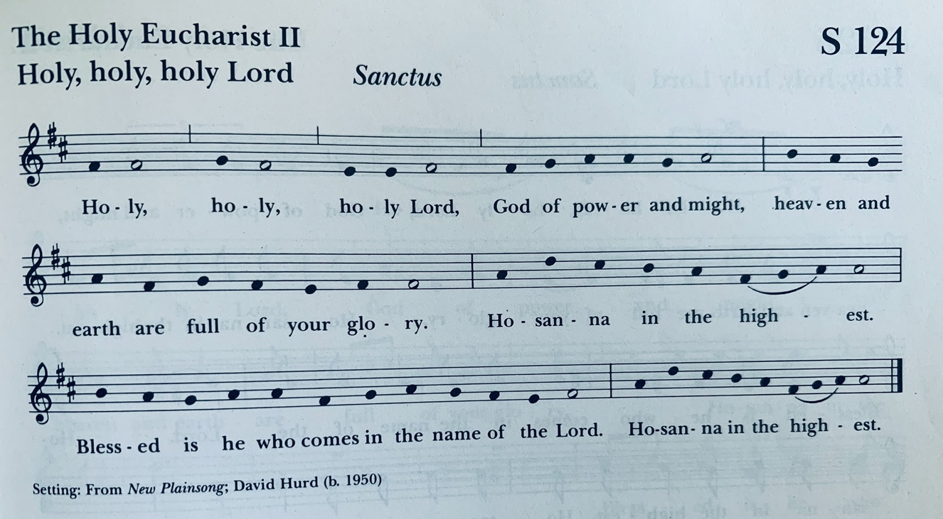
The people stand or kneel.

Then the Celebrant continues

We give thanks to you, O God, for the goodness and love which you have made known to us in creation; in the calling of Israel to be your people; in your Word spoken through the prophets; and above all in the Word made flesh, Jesus, your Son. For in these last days you sent him to be incarnate from the Virgin Mary, to be the Savior and Redeemer of the world. In him, you have delivered us from evil, and made us worthy to stand before you. In him, you have brought us out of error into truth, out of sin into righteousness, out of death into life.

At the following words concerning the bread, the Celebrant is to hold it, or lay a hand upon it; and at the words concerning the cup, to hold or place a hand upon the cup and any other vessel containing wine to be consecrated.

On the night before he died for us, our Lord Jesus Christ took bread; and when he had given thanks to you, he broke it, and gave it to his disciples, and said, “Take, eat: This is my Body, which is given for you. Do this for the remembrance of me.”

After supper he took the cup of wine; and when he had given thanks, he gave it to them, and said, “Drink this, all of you: This is my Blood of the new Covenant, which is shed for you and for many for the forgiveness of sins. Whenever you drink it, do this for the remembrance of me.”

Therefore, according to his command, O Father,

Celebrant and People

We remember his death,
We proclaim his resurrection,
We await his coming in glory;

The Celebrant continues

And we offer our sacrifice of praise and thanksgiving to you, O Lord of all; presenting to you, from your creation, this bread and this wine.

We pray you, gracious God, to send your Holy Spirit upon these gifts that they may be the Sacrament of the Body of Christ and his Blood of the new Covenant. Unite us to your Son in his sacrifice, that we may be acceptable through him, being sanctified by the Holy Spirit. In the fullness of time, put all things in subjection under your Christ, and bring us to that heavenly country where, with all your saints, we may enter the everlasting heritage of your sons and daughters; through Jesus Christ our Lord, the firstborn of all creation, the head of the Church, and the author of our salvation.

By him, and with him, and in him, in the unity of the Holy Spirit all honor and glory is yours, Almighty Father, now and for ever. AMEN.

And now, as our Savior
Christ has taught us,
we are bold to say,
People and Celebrant

Our Father, who art in heaven,
hallowed be thy Name,
thy kingdom come,
thy will be done,
on earth as it is in heaven.
Give us this day our daily bread.
And forgive us our trespasses,
as we forgive those
who trespass against us.
And lead us not into temptation,
but deliver us from evil.
For thine is the kingdom,
and the power, and the glory,
for ever and ever. Amen.

The Breaking of the Bread
The Celebrant breaks the consecrated Bread. A period of silence is kept.

Celebrant Alleluia. Christ our Passover is sacrificed for us;
People Therefore let us keep the feast. Alleluia.

S-154—Fraction Anthem: Christ our Passover Sung by members of the Choir
Recorded and played here by our Tech Team

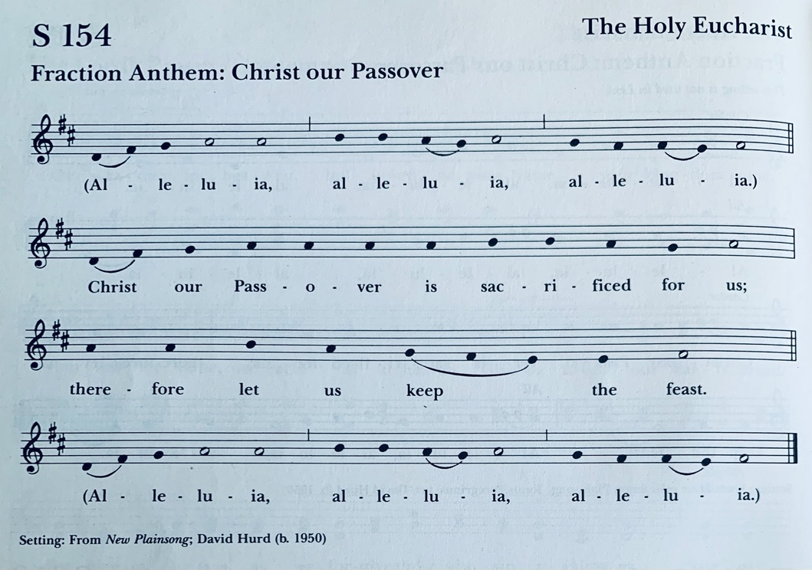

Facing the people, the Celebrant says the following Invitation

The Gifts of God for the People of God. Take them in remembrance that Christ died for
you, and feed on him in your hearts by faith, with thanksgiving.

The ministers deliver the Bread to the people at the station at the bottom of the chancel area. Please follow the ushers and the verbal instructions given, so that the bread can be distributed as safely as possible. When you have received the sacrament, please return to your seat to consume it. Receiving the sacrament “in one kind only,” as we are doing today, is considered by the Church to be a full communion. (Please note that the members of our online congregation are aware of the distribution of communion; we are making efforts to deliver the sacrament to the homes of those in our community who request it.)

After Communion, the Celebrant says
Let us pray.

Celebrant and People Eternal God, heavenly Father, you have graciously accepted us as living members of your Son our Savior Jesus Christ, and you have fed us with spiritual food in the Sacrament of his Body and Blood. Send us now into the world in peace, and grant us strength and courage to love and serve you with gladness and singleness of heart; through Christ our Lord. Amen.

Announcements

The Blessing The Rev. Alison Dingley

The Final Hymn: #135, “Songs of Thankfulness and Praise”
The in-person congregation may sing along quietly; those at home, please sing outloud!

Songs of thankfulness and praise, Jesus, Lord, to thee we raise,
Manifested by the star to the sages from afar;
Branch of royal David’s stem in thy birth at Bethlehem;
Anthems be to thee addressed, God in man made manifest.

Manifest at Jordan’s stream, Prophet, Priest, and King supreme;
And at Cana, wedding guest, in thy Godhead manifest;
Manifest in power divine, changing water into wine;
Anthems be to thee addressed, God in man made manifest.

Manifest in making whole palsied limbs and fainting soul;
Manifest in valiant fight, quelling all the devil’s might;
Manifest in gracious will, ever bringing good from ill;
Anthems be to thee addressed, God in man made manifest.

Manifest on mountain height, shining in resplendent light,
Where disciples filled with awe thy transfigured glory saw.
When from there thou leddest them steadfast to Jerusalem,
Cross and Easter Day attest God in manmade manifest.

The Dismissal

Deacon Let us go forth into the world, rejoicing in the power of the Spirit! Alleluia! Alleluia!
People Thanks be to God! Alleluia! Alleluia!

The Postlude Lorraine Yamamoto
“O Dieu de clemence, Viens par ta presence,” by Jean Romary (Rene) Grosjean

Flower Dedications
In dedication of Family & Friends by Doug & Alison Kittle
In honor of Elizabeth Atmore by Rosemary Domecki
In honor of Irene Domecki by Rosemary Domecki
In honor of Michael Domecki by Rosemary Domecki
In honor of Rita Wasilewska by Rosemary Domecki
In honor of Alina Zeranski by Rosemary Domecki
In honor of Ludwig Zeranski by Rosemary Domecki
In honor of Maria Rawicz-Szcerbo by Rosemary Domecki
In honor of Waldemar Rawicz-Szcerbo by Rosemary Domecki
In memory of Richard Christian Jones by Jan & Kip Jones
In memory of Stephen Cross & Shirley LaForest by Ed & Delia Moore
Dedication by by Lila Johnson
In dedication of James Braham by Sandra Braham
In memory of Karen & Clarence Tom by Vivian Tom
Dedication by by Lila Rae Johnson
In memory of Alfred Dreyer by Wyn Aubrey-Child
In dedication of Anne Sutton by Beverly Toomey

The staff at Holy Nativity Church is grateful for your patience and grace, as we seemed to have been a bit delayed in recognizing all who have donated. Your servant hearts do not go unnoticed!

Ministry Team for Today’s Service: thank you!
Celebrant and Preacher: The Rev. Alison Dingley
Deacon: The Rev. Robert Steele
Musicians: Lorraine Yamamoto
Readers: Alison Kittle & Kim Garner
Intercessor: Julia Yamaguchi
Eucharistic Minister & Acolyte: Sandra Braham

Staff
Music Director (Chris Suzuki): hncmusic1@gmail.com
Student for Formation for Ordination: Frank Condello
Office (Punahele Coldwell): hncparish@gmail.com
Operations Manager (Kathy Kia): hncoperationsmanager@gmail.com
Thrift Shop (Peggy Budlong): hntsmgr@gmail.com

JOIN US NEXT SUNDAY FOR THE SECOND SUNDAY AFTER THE EPIPHANY
SUNDAY, JANUARY 17 at 9AM (in person & on Zoom)

