Three Administrators Added to Logistics Team
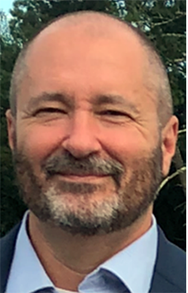
New aircraft maintenance coordinator Bill Kendrick’s interest in aviation began in 2002 when he began courses to earn his Airframe and Powerplant certification. From there, he went on to receive his inspection authorization, and he also holds a private pilot’s certificate.
He ran a successful aircraft rental and maintenance business from 2014-2023 just outside San Antonio. Kendrick worked as director of maintenance for a privately owned aviation maintenance company in the San Antonio area before moving to the role of quality assurance director of maintenance for the Air Force Services’ Aero Club program.
Kendrick worked in the IT field for 15 years at Electronic Data Systems and spent almost 20 years working in the oil and gas industry on an offshore platform in the Gulf of Mexico.
Originally from south Mississippi, Kendrick has lived the last 35 years in Texas, where he and his wife of 27 years have raised their two sons, 22 and 24.


Jennifer “Jen” Bellflower is CAP’s new supply and real property program manager.

Bellflower has been on CAP staff for six years, formerly in Logistics and Mission Resources as a maintenance coordinator and most recently as the aircraft parts and engine lead.
She has 16 years of combined experience in parts and equipment procurement, sales, and warehousing, complemented by hands-on experience in quality control and process improvement.

She’s eager to bring a blend of professional acumen and personal dedication to a new challenge, where she can contribute and grow.

Bellflower was born and raised in Montgomery, Alabama, home of CAP National Headquarters, and resides in nearby Prattville. A dedicated wife and mother, she has a 21-year-old son and two beloved dogs.

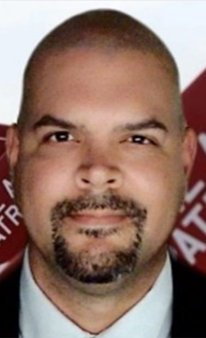
Enrique “Rico” Vázquez is CAP’s new director for logistics and mission resources.

In May, he relinquished command of a special operations planning unit and, after serving in the enlisted and officer ranks, retired from the military after seven years in the U.S. Marine Corps and 20 years in the U.S. Air Force.
He performed in heavy equipment operation, administration, finance, contracting, aircraft maintenance (avionics), logistics, and communications as an IT specialist for the Defense Logistics Agency for four years and staff officer at the Pentagon and Special Operations Command South. His go-to phrase is “Attack, Attack, Attack!”

He is establishing roots in Parrish, Florida, about 45 minutes from Tampa. Born and raised in Bayamon, Puerto Rico, he’s married to Sami, and they have a 20-year-old son, Jorge; a 14-year-old daughter, Gianna; and a 2-year-old golden retriever, Eclipse.

