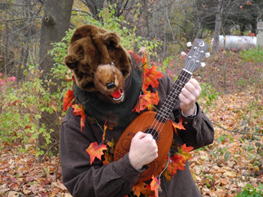

Halloween Uke Party!!!!
UKULELE PLAYSHOP, CONCERT & SINGALONG with Amy Conley, M.Ed.
Fri, Oct 29, 6:00-7:30 PM,
at Kingston Rec, 24 Main Street
Call 603-531-3337 to register, ukuleles available to borrow.
Kingston Recreation Department, 24 Main Street
6:00 Beginner Lesson (ages 8 yrs.-adult, ukuleles available for first 12 people who request them)
6:45 Concert and Singalong for all ages, chords will be provided for ukuleles/guitars/etc.
Costumes Optional! $20 per person – NEED 15 people to register to have this event.

