2019 OUACHITA WRESTLING CLUB – TECHNIQUE CAMP
JUNE 19th 20th, and 21st 2019
OUACHITA BAPTIST UNIVERSITY – HATCHER WRESTLING COMPLEX
9:00 AM – 12:00 PM – TECHNIQUE 1:00 PM – 4:00 PM TECHNIQUE
6:30 PM – 8:00 PM LIVE MATCHES – DUAL FORMAT AND TOURNAMENT FORMAT
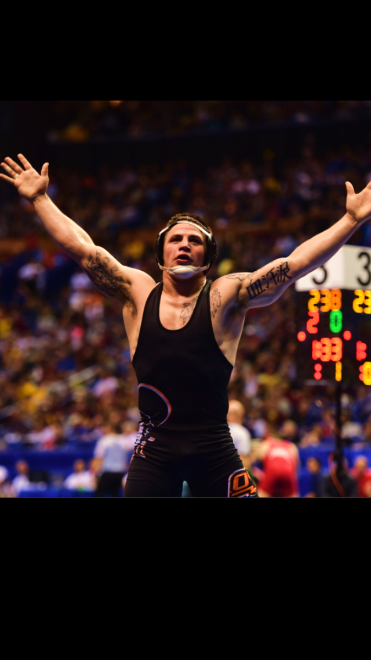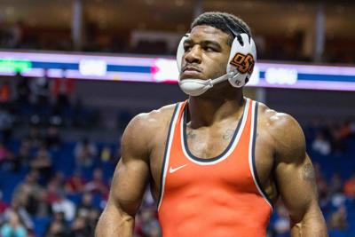

Campers Registration Time: June 19th 2018 – 8:30 am – Campers Pick up Time June 21st 3:00 pm
Hatcher Wrestling Complex – 410 Ouachita St., Arkadelphia AR, 71998
Contact: Kevin Crutchmer - Head Wrestling Coach – 918-728-0430 / crutchmerk@obu.edu
MAKE CHECKS PAYABLE TO: OUACHITA WRESTLING CLUB
CAMP COST:
$325.00 FOR NON COMMUTER
+ T Shirt
$275.00 FOR COMMUTER
+ T Shirt
INCLUDES: lodging, 3 meals a day excluding breakfast on the 19th and dinner on the 21st.
10:1 ratio camper to coach,
Snacks and drinks available to purchase, and
Entertainment before lights Out.

FULL TIME ATHLETIC TRAINER ON SITE – DURING CAMP
FOCUS OF CAMP:
BASIC, MEDIUM & HIGH LEVEL TECHNIQUE
HIGH PERCENTAGE SCORING
MENTAL TOUGHNESS TRAINING
MATCH PREPERATION AND PLANNING

WHAT TO BRING?
6 CHANGES OF WORKOUT GEAR
WRESTLING AND RUNNING SHOES
2 TOWELS
PERSONAL HYGIENE ITEMS
MONEY FOR SNACKS
ONE SLEEPING BAG AND PILLOW
Kyle Crutchmer – Oklahoma State University Jacobe Smith – Oklahoma State University
- 2X Oklahoma 6A State Champion 2018 NCAA Div 1 All American
- 1X Fargo Junior National Champion 2X NJCAA National Champion - NEO
- 2X NCAA Div 1 All American 2X Big 12 Champion
- 2X Big 12 Champion 2X Oklahoma 6A State Champion

