
 | FOR IMMEDIATE RELEASE  January 18, 2024
  Contact | Jamin Johnson
  Telephone
  Cell | Jamin—320-295-0326
  Email | Jamin.johnson@fairview.org
  Website | https://www.ebenezercares.org/eicr

The Fountains Hires Fitch

Lakeville, MN, January 18, 2024–
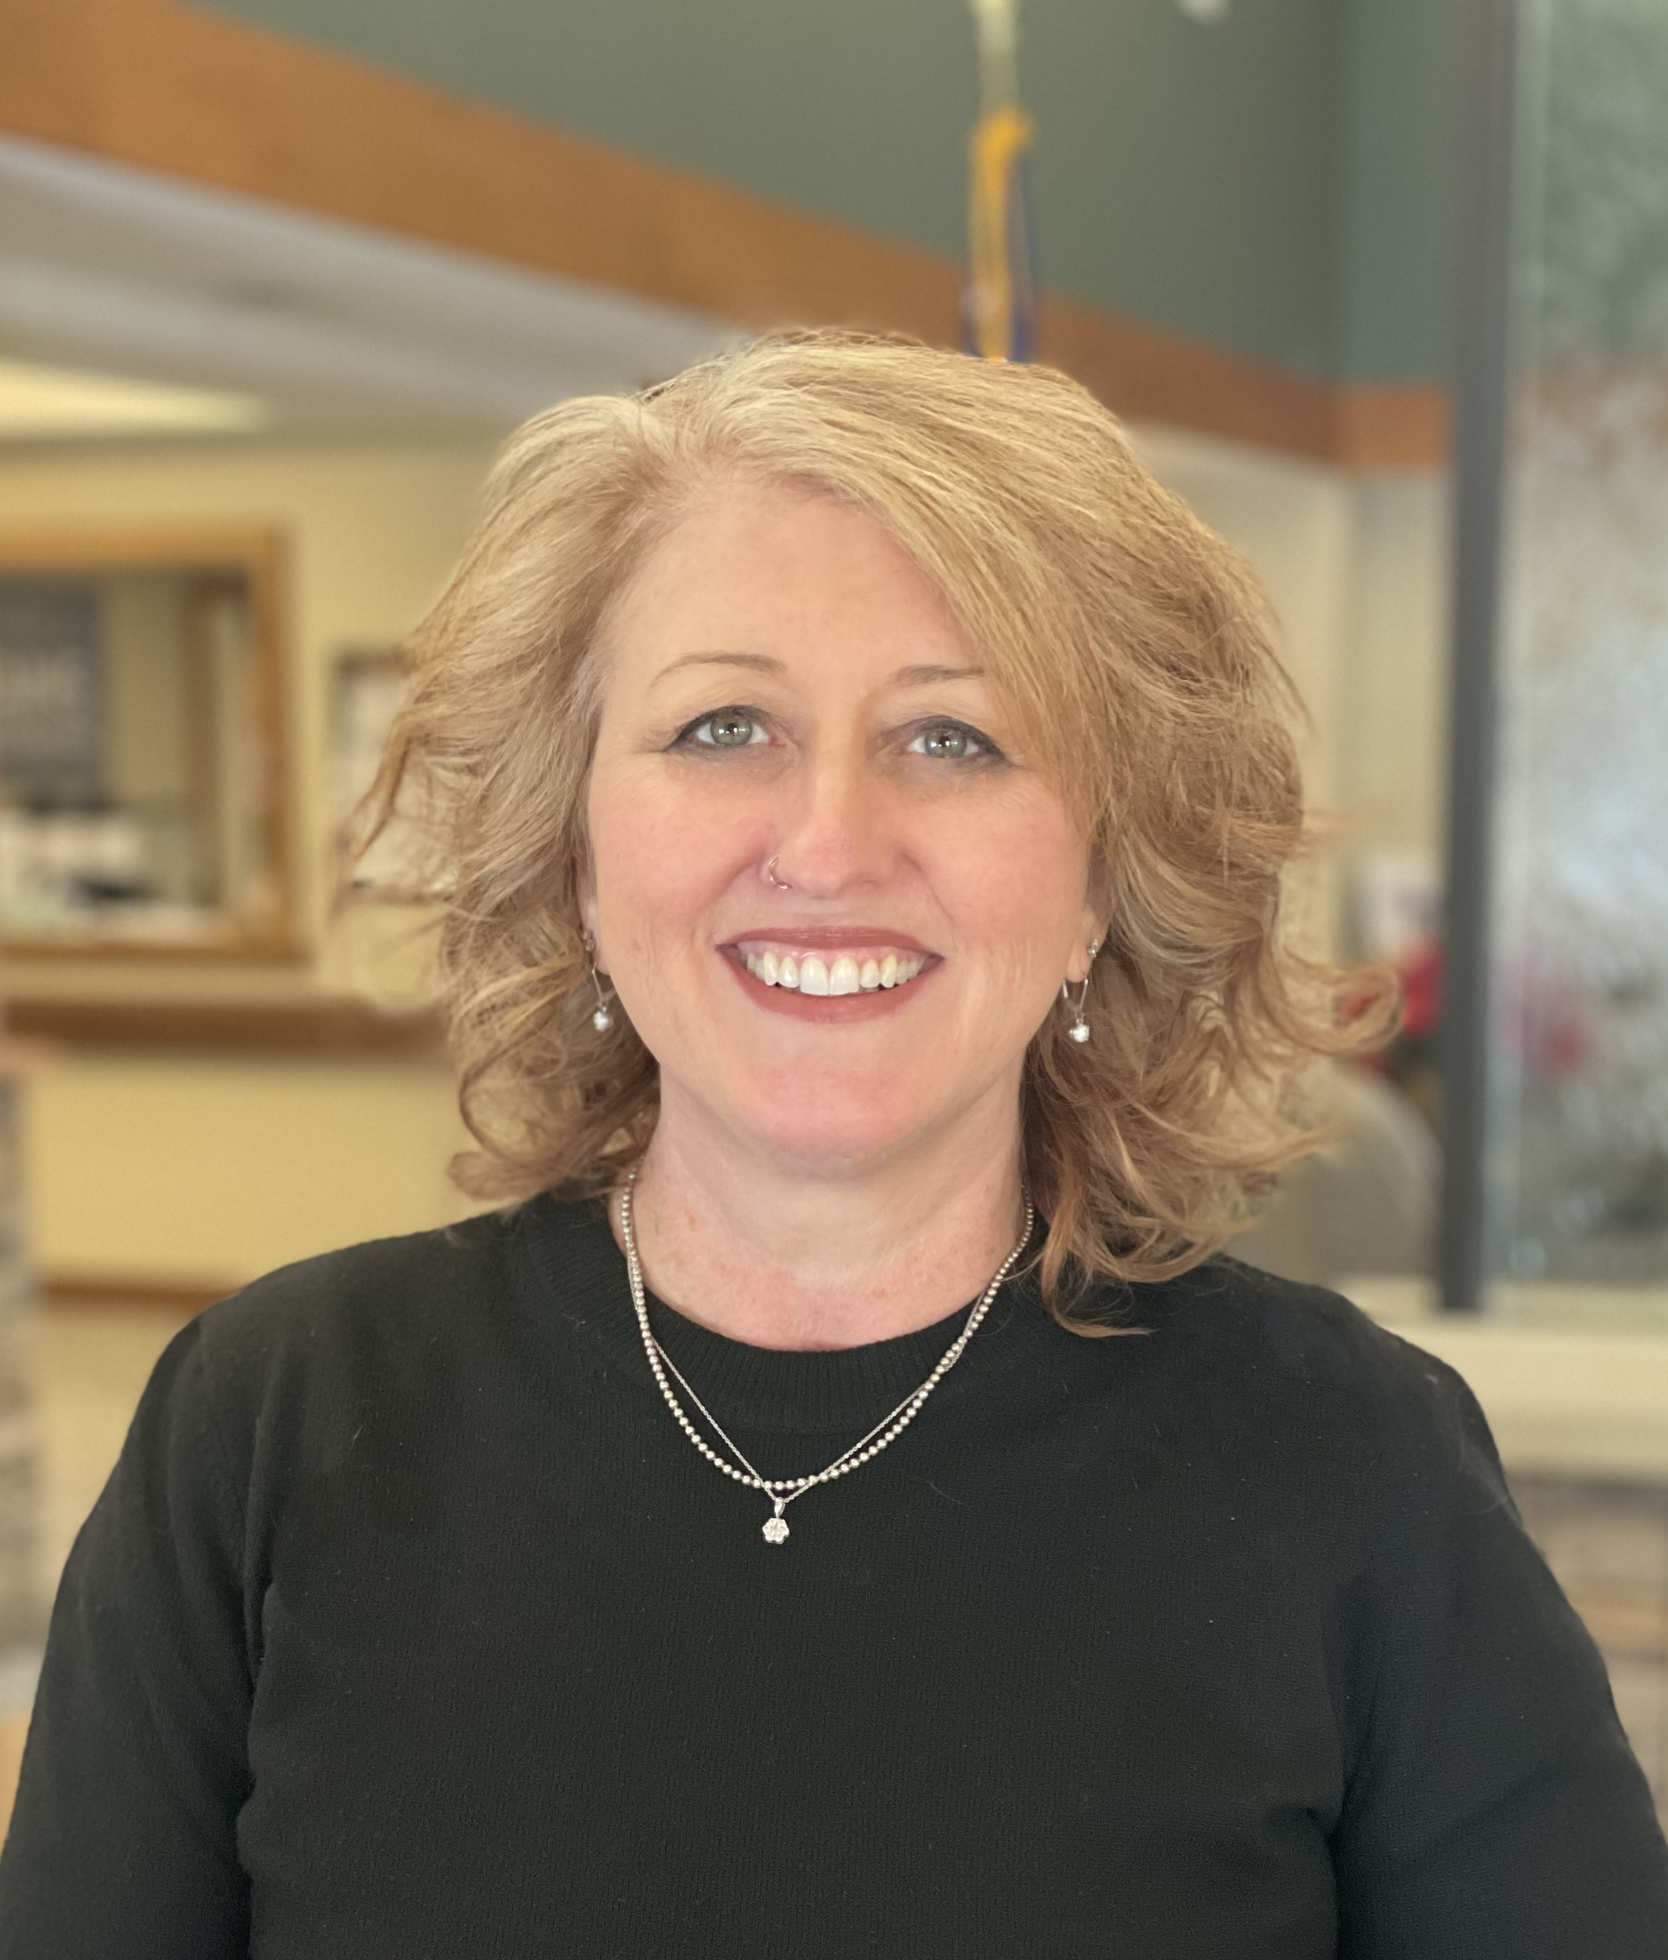
Ebenezer is proud to announce the hiring of Brandi Fitch as their new Executive Director of The Fountains at Hosanna Senior Living. With the move of Julie Walton to Ebenezer’s Amira Choice Senior Living in Sarasota, Florida, The Fountains at Hosanna looked for a new talented and knowledgeable leader. After extensive interviews, they hired Brandi Fitch as their new Executive Director.
“I’ve worked in senior housing for 15 years – with 9 of them here at The Fountains. I am passionate about making sure seniors live their best lives every day,” shared Fitch, “I’m excited to continue the great work that has been going here at The Fountains! I love our senior community!”
When not at work, Fitch enjoys time with her husband, Rob, and 4 adult sons
The Fountains at Hosanna is part of Ebenezer Management Services (EMS). Ebenezer is a multi-award-winning company with recognitions for their senior living, rehab, adult day and childcare from The Star Tribune, Minnesota Real Estate Journal, Readers’ Choice Awards, and U.S. News and World Reports.

