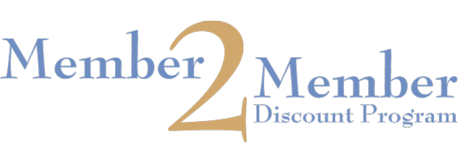
The Chamber encourages members to take advantage of two ways to obtain or provide discounts to other members. These discounts offer you great exposure and are a free service open only to members of The City of Waukegan Chamber of Commerce.
Hot Deals
Do you have a special sale coming up? Do you want to promote a month long special? As a member you can post “hot deals” to the Chamber’s web site and Facebook page expanding your advertising presence in the community. If you are interested in offering a hot deal email info@waukeganchamber.org with details on your promotion.
Member-to-Member Discounts
Take advantage of the Chamber’s Member-to-Member Discount Program and discover savings throughout the community that will help enhance Waukegan’s overall economy. The Member-to-Member Discount Program offers member businesses and their employee’s discounts on products or services from other Chamber members. Chamber members can use this service by offering a discount and/or taking advantage of these discounts. If you are interested in offering a discount, or if you need additional member discount cards for your employees, please contact the Chamber at info@waukeganchamber.org. The discounts are subject to change without notice and not all discounts are advertised on this listing. Always present your Members-to-Member Discount card when requesting the Chamber discount.

Member – to – Member Discount Application

Company Name:
Company Contact:
Discount/ Sale offered:

Discount expiration Date:

By Signing this agreement, you agree to offer the stated discount for the listed period to all City of Waukegan Chamber of Commerce Members.
Signature:
Date:

Offer will be posted to our website at www.waukeganchamber.org. Members must present card at time of purchase to receive discount. Discounts can be changed, updated or removed at any time. Please contact info@waukeganchamber.org with any changes that need to be made.

