Color vision deficiency is the inability to distinguish certain shades of color. The term "color blindness" is also used to describe this visual condition, but very few people are completely color blind.
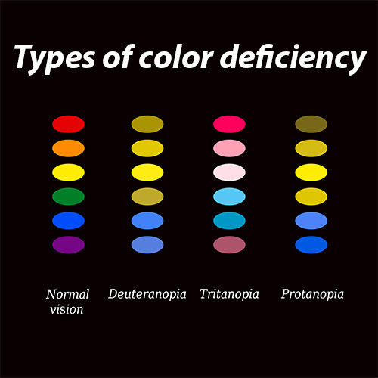
Most people with color vision deficiency can see colors, but they have difficulty differentiating between the following colors:
- particular shades of reds and greens (most common)
- blues and yellows (less common)
People who are totally color blind, a condition called achromatopsia, can only see things as black and white or in shades of gray.

Color vision deficiency can range from mild to severe, depending on the cause. It affects both eyes if it is inherited and usually just one if it is caused by injury or illness.

Color vision is possible due to photoreceptors in the retina of the eye known as cones. These cones have light-sensitive pigments that enable us to recognize color. Found in the macula (the central part of the retina), each cone is sensitive to either red, green or blue light. The cones recognize these lights based on their wavelengths.

Normally, the pigments inside the cones register different colors and send that information through the optic nerve to the brain. This enables you to distinguish countless shades of color. But if the cones don't have one or more light-sensitive pigments, you will be unable to see one or more of the three primary colors.

The most common form of color deficiency is red-green. This does not mean that people with this deficiency cannot see these colors at all. They simply have a harder time differentiating between them, which can depend on the darkness or lightness of the colors.

Another form of color deficiency is blue-yellow. This is a rarer and more severe form of color vision loss than red-green, because people with blue-yellow deficiency frequently have red-green blindness too.

The prevalence of CVD is 8% for males and 0.5% for females.

There are more than 100 distinguished jobs/careers that are off-limits to those with a color vision deficiency.

My research is based on providing everyday materials for color vision testing. We hope to prove that classroom teachers and other non-optometric professionals can test for color vision deficiencies and make accommodations without making sizeable investments in optometry equipment. I will be testing subjects age 18-59, with or without a color vision deficiency. There are four assessments and the time needed for testing is around 35 mins.

