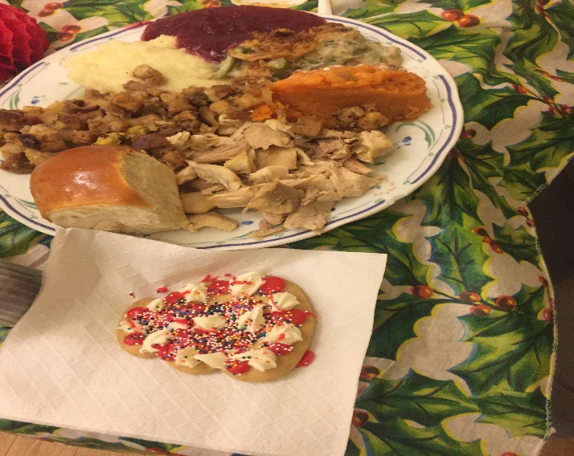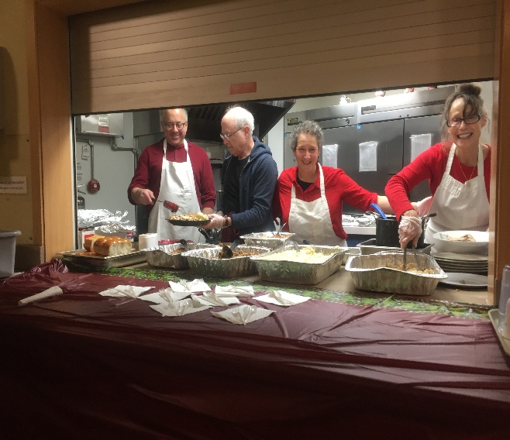

HOLIDAY VOLUNTEER OPPORTUNITY FOR
BIC MEMBERS
PRE-CHRISTMAS DINNER AT
SAFE HAVEN HOMELESS SHELTER
MONDAY, DECEMBER 23rd -2:30-6:30 pm
Please help BIC provide a festive pre-Christmas dinner for residents of Porchlight’s Safe Haven shelter for homeless with serious, chronic mental illness
For more information : please contact dinner coordinators Merle (at 608-298-7537 or 914-316-5171) or Corliss (at 608-831-6521 or 608-770-6521)
Help is needed cooking dishes in advance such as: turkey, mashed potatoes, sweet potatoes, green beans, & stuffing; purchasing other food items in advance, working in the Safe Haven kitchen on December 23rd serving and clean up.

You may also help the homeless by donating warm socks, gloves, hats and other warm clothing to Porchlight. Bins for collection will be outside the downstairs BIC office.

Safe Haven kitchen staff is in need of a Kitchen Aide. If you have a used one in good condition that you wish to donate please contact us.

