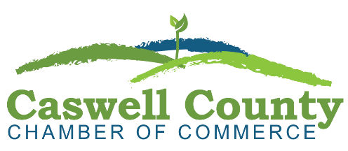
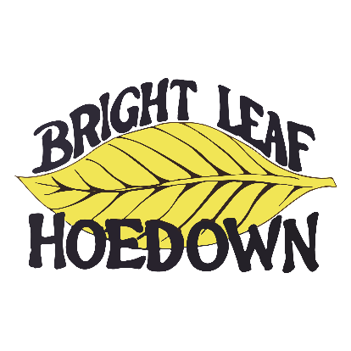

CORPORATE HOEDOWN SPONSORSHIPS
Title Sponsorship - Sold OUT!
__________________________________________

$5,500

- Logo promotion on large banners entering into Yanceyville beginning Sept. 5
- Recognition via news story and ad in the special ‘Bright Leaf Hoedown’ insert
- Social Media recognition
- Logo recognition on the Chamber’s website
- Logo recognition on the program/map event day
- Acknowledgement on radio spots promoting the Hoedown
- Recognition by emcee during the event and opportunity to speak if desired
- Promotion in Chamber of Commerce monthly
- Exhibit booth; choice of location

Hoedown Gold Sponsorship
_________________________________________

$3,500

- Logo promotion on ‘Gold Sponsors Banner’
- Recognition via advertorial and ad in the special “Bright Leaf Hoedown’ insert
- Social Media recognition
- Logo recognition on the Chamber’s website
- Logo recognition on the program/map event day
- Recognition by emcee during the event
- Promotion in Chamber of Commerce monthly
- Exhibit booth

Hoedown Silver Sponsorship
_________________________________________

$2,500
- Logo promotion on sponsor’s banner
- Recognition via advertorial and ad in the special “Bright Leaf Hoedown’ insert
- Social Media recognition
- Logo recognition on the Chamber’s website
- Logo recognition on the program/map event day
- Promotion in Chamber of Commerce monthly and quarterly publications
- Exhibit booth

Hoedown Bronze Sponsorship
_________________________________________

$1,750
- Logo promotion on sponsor’s banner
- Logo recognition on the Chamber’s website
- Social Media recognition
- Logo recognition on the program/map event day
- Exhibit booth and ad in ‘Bright Leaf Hoedown’ insert

Hoedown Patron Sponsorship
_________________________________________

$550
- Logo promotion on sponsors banner
- Logo recognition on the program/map event day
- Social Media recognition
- Exhibit booth
- Logo recognition on the Chamber’s website

Customized Hoedown Event Sponsorship
_________________________________________
Custom packages based on interests of the sponsor beginning at $1000

May include sponsorship of selected areas of the event:
“Hoedown Entertainment”
“Hoedown Arts & Crafts”
“Hoedown Kids Kountry”
“Hoedown Foodcourt”
“Service Caswell” (nonprofits and services for Caswell)
Other customized and creative options can be developed

INDIVIDUAL SPONSORSHIPS
__________________________________________
The Caswell County and surrounding community citizens have been a key factor in the Hoedown being alive for all these years and for that we say, Thank You!

Individual and small business donations/sponsors are welcome.
The annual letters/cards to the community will be sent via US mail by August 31.
Please contact the Chamber with any questions.

Sponsorship info will be live and payable online at CaswellChamber.org beginning June 1. If you’d like to mail in a donation/sponsorshi, please make check payable to:

Caswell County Chamber of Commerce
PO Box 29
Yanceyville NC 27379

