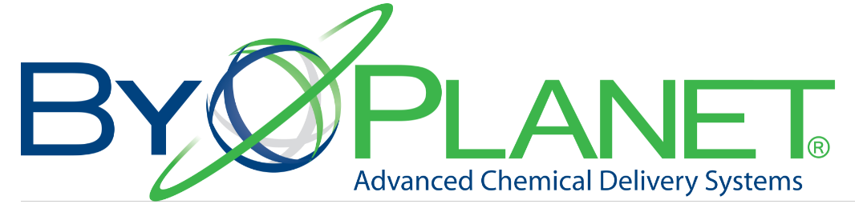

ByoPlanet International would like to give you and your small business the opportunity to be operating back at full capacity. ByoPlanet has been working with the Classic Center, Burton & Burton, UGA Athletics, North Georgia Foodbank, and local churches to enable a return to more normal times, and we would like to offer this opportunity to our fellow members of the Athens Chamber of Commerce and local businesses.
Our industry-leading Electrostatic disinfection sprayers have been developed and are produced in Athens and when combined with a proven protocol and chemistry will help you to have both your staff and customers feeling safe during the current pandemic. ByoPlanet Internationals’ electrostatic technology delivers maximum disinfection productivity with minimum wasted effort or expense.
ByoPlanet’s Electrostatic sprayers:
- Enable rapid and easy disinfection treatment in any facility, large and small
- Convert pressurized liquid- air flow mixture into an atomized spray plume of small droplets and apply a negative charge that then allows the droplets to adhere to a surface with superior coverage
- Provide 360 degree wrap with small particles covering over , under, and around surfaces, that are usually missed with traditional pump spray systems
- Enable the elimination of cold and flu viruses and numerous bacteria, MRSA, Norovirus, H1N1, E. coli, Listeria, Salmonella, and Covid-19 (to name a few)
- Provide coverage far superior to conventional tools like pump- sprayers and foggers
- Save time, money, and labor
ByoPlanet International wants to help the people of Athens feel safe and give back to the small business community of Athens. This service includes a one-time complimentary spray as well as a tutorial on how to use the product and where and how to purchase.
If you are interested in learning more about Electrostatic Disinfecting and our complimentary disinfecting service, please contact Deborah Krause at dkrause@byoplanet.com
