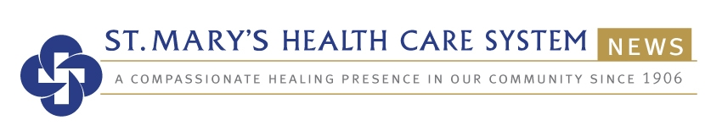
A Member of Trinity Health

St. Mary’s receives 11th Gold-Plus Award for stroke care

American Heart Association Award recognizes hospital for commitment to quality

Contact: Mark Ralston
706.296.6717 ⏐ mralston@stmarysathens.org
September 8, 2020

FOR IMMEDIATE RELEASE

ATHENS, Ga. – St. Mary’s Health Care System has received the American Heart Association/American Stroke Association’s Get With The Guidelines®-Stroke Gold Plus Quality Achievement Award. The award recognizes the hospital’s commitment to ensuring stroke patients receive the most appropriate treatment according to nationally recognized, research-based guidelines that are based on the latest scientific evidence.

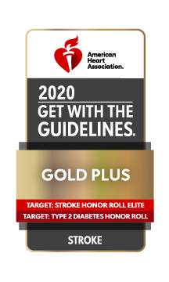
St. Mary’s has received the Stroke Gold-Plus quality achievement award 11 years in a row and has been named to the Target: Stroke Honor Roll nine years in a row, elevating its achievement to Honor Roll Elite for the first time.

St. Mary’s earned the awards by meeting specific quality achievement measures for the diagnosis and treatment of stroke patients at a set level for a designated period. These measures include evaluation of the proper use of medications and other stroke treatments aligned with the most up-to-date, evidence-based guidelines with the goal of speeding recovery and reducing death and disability for stroke patients. Before discharge, patients should also receive education on managing their health, get a follow-up visit scheduled, as well as other care transition interventions

“St. Mary’s is dedicated to improving the quality of care for our stroke patients through our ongoing implementation of the American Heart Association’s Get With The Guidelines-Stroke initiative,” said Montez Carter, St. Mary’s President and CEO. “The tools and resources provided help us track and measure our success in meeting evidenced-based clinical guidelines developed to improve patient outcomes.”

At the same time, St. Mary’s received the Association’s Target: StrokeSM Elite recognition. To qualify for this honor roll, hospitals must meet quality measures developed to reduce the time between the patient’s arrival at the hospital and treatment with the clot-buster tissue plasminogen activator, or tPA, the only drug approved by the U.S. Food and Drug Administration to treat ischemic stroke. Ischemic stroke is the most common kind of stroke, affecting about 80 percent of stroke patients. It happens when a blood vessel in the brain becomes blocked, interrupting blood flow to brain tissue. Up to 2 million brain cells can die each minute unless blood flow can be restored with clot-busting medication or mechanical thrombectomy, a procedure that physically removes clots from large blood vessels, that is available at St. Mary’s in conjunction with neurosurgeon Neil Woodall, MD.

St. Mary’s additionally received the Association’s Target: Type 2 Honor Roll award. To qualify for this recognition, hospitals must meet quality measures developed with more than 90 percent of compliance for 12 consecutive months for the “Overall Diabetes Cardiovascular Initiative Composite Score.” Diabetes is a common condition that can damage blood vessels if not well managed, leading to complications such as heart attack and stroke.

St. Mary’s has also met specific scientific guidelines as a Primary Stroke Center, featuring a comprehensive system for rapid diagnosis and treatment of stroke patients admitted to the emergency department.

“We are pleased to recognize St. Mary’s Health Care System for their commitment to stroke care,” said Lee H. Schwamm, M.D., national chairperson of the Quality Oversight Committee and Executive Vice Chair of Neurology, Director of Acute Stroke Services, Massachusetts General Hospital, Boston, Massachusetts. “Research has shown that hospitals adhering to clinical measures through the Get With The Guidelines quality improvement initiative can often see fewer readmissions and lower mortality rates.”

According to the American Heart Association/American Stroke Association, stroke is the No. 5 cause of death and a leading cause of adult disability in the United States. On average, someone in the U.S. suffers a stroke every 40 seconds and nearly 795,000 people suffer a new or recurrent stroke each year.

###

About St. Mary’s
St. Mary’s Health Care System is a faith-based, not-for-profit health care ministry whose mission is to be a compassionate and transforming healing presence in the communities it serves. Part of Trinity Health, St. Mary’s puts special focus on neurosciences, cardiac care, orthopedics, general medicine, general surgery, women’s and children’s health, and care for older adults. St. Mary's includes hospitals in Athens, Lavonia and Greensboro, as well as a multi-practice medical group, a retirement community, outpatient care facilities, graduate medical education, and a region-wide home health care/hospice service. St. Mary’s Hospital in Athens is a certified chest pain center, a gold-plus hospital for stroke care, and was named Georgia's Large Hospital of the Year in 2006, 2010, 2015 and 2018 For more information, visit St. Mary’s website at www.stmaryshealthcaresystem.org.

About Get With The Guidelines®
Get With The Guidelines® is the American Heart Association/American Stroke Association’s Get With The Guidelines® is the American Heart Association/American Stroke Association’s hospital-based quality improvement program that provides hospitals with tools and resources to increase adherence to the latest research-based guidelines. Developed with the goal of saving lives and hastening recovery, Get With The Guidelines has touched the lives of more than 9 million patients since 2001. For more information, visit heart.org/quality.

