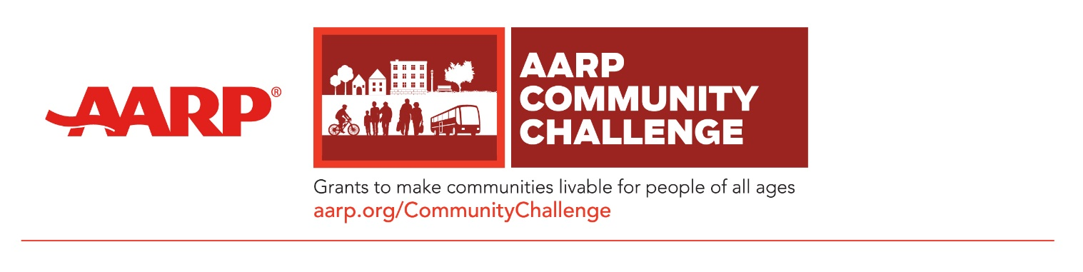

FOR IMMEDIATE RELEASE
March 30, 2021

MEDIA CONTACT:
Alisa Jackson | atjackson@aarp.org

AARP Community Challenge Grant Program Now Accepting 2021 Applications
The program funds quick-action projects; Application Deadline is April 14, 2021

Atlanta, GA — AARP Georgia invites community organizations and local governments across the state to apply for the 2021 Community Challenge grant program, now through April 14. Grants fund quick-action projects that can range from several hundred dollars for small, short-term activities to several thousand or tens of thousands for larger projects. Now in its fifth year, the grant program is part of AARP’s nationwide Livable Communities initiative, which supports the efforts of cities, towns, neighborhoods and rural areas to become great places to live for people of all ages.

“We are thrilled to bring this grant opportunity back to Georgia in 2021 and we encourage all eligible organizations to apply,” said Debra Tyler-Horton, AARP Georgia State Director. “We’ve seen great results from the Community Challenge grant program in communities across Georgia, and this year we are increasing our support for projects that focus on diversity and inclusion and aid in local recovery from the coronavirus pandemic.”

Since 2017, AARP has awarded 560 grants through the Community Challenge to nonprofit organizations and government entities in all 50 states, the District of Columbia, Puerto Rico and the U.S. Virgin Islands. The program provides direct support to all community types, with nearly 40% of past projects benefitting rural communities, 20% going to suburban locations and 40% improving urban places. Granted projects have demonstrated an ability to help garner additional funds or support from public and private funders, encourage replication and overcome local policy barriers, and receive greater overall awareness and engagement.

AARP will prioritize projects that deliver inclusive solutions that meet the needs of diverse populations, as well as those that directly engage volunteers through permanent or temporary solutions that aim to achieve one or more of the following outcomes:
- Create vibrant public places that improve open spaces, parks and access to other amenities.
- Deliver a range of transportation and mobility options that increase connectivity, walkability, bikeability, wayfinding, access to transportation options and roadway improvements.
- Support a range of housing options that increase the availability of accessible and affordable options.
- Increase civic engagement and demonstrate the tangible value of “Smart Cities” with innovative and tangible projects that bring residents and local leaders together to address challenges and facilitate a greater sense of inclusion.
- Support local recovery from the coronavirus pandemic with an emphasis on economic development, improvements to public spaces, and transportation services.
- Ensure a focus on diversity and inclusion while improving the built and social environment of a community.
- Other community improvements. In addition, AARP wants to hear about local needs and new, innovative ideas for addressing them.

The Community Challenge is open to 501(c)(3), 501(c)(4) and 501(c)(6) nonprofits and government entities. Other types of organizations will be considered on a case-by-case basis.

The application deadline is 8:00 p.m. ET, April 14, 2021, and all projects must be completed by November 10, 2021. To apply and view past grantees, visit www.AARP.org/CommunityChallenge.

AARP Georgia works in collaboration with communities across the state, bringing people together, and providing resources and expertise to help make Georgia’s counties, towns and cities great places to live for people of all ages.

###

About AARP
AARP is the nation’s largest nonprofit, nonpartisan organization dedicated to empowering people 50 and older to choose how they live as they age. With a nationwide presence and nearly 38 million members, AARP strengthens communities and advocates for what matters most to families: health security, financial stability and personal fulfillment. AARP also produces the nation's largest circulation publications: AARP The Magazine and AARP Bulletin. To learn more, visit www.aarp.org, www.aarp.org/espanol or follow @AARP, @AARPenEspanol and @AARPadvocates, @AliadosAdelante on social media.​

