Proud to be named Georgia's 2018 Large Hospital of the Year

St. Mary's partners with statewide
collaborative to maximize maternal safety

Contact: Mark Ralston
706.389.3897 ⏐ mralston@stmarysathens.org
February 6, 2020

FOR IMMEDIATE RELEASE

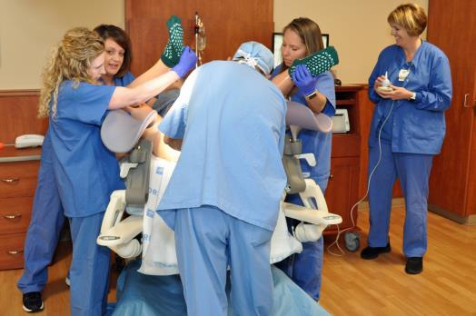
Athens, Ga. – St. Mary's Family Birth Center is part of a statewide collaborative that is working to improve Georgia's maternal death rate, currently ranked as one of the worst in the United States.
Members of St. Mary's Family Birth Center staff and Dr. Kaushik Shah use a mannequin to practice safely delivering a baby whose shoulder is stuck inside the birth canal.

"The safety of mothers is vitally important to us," said Jackie Iley, director of St. Mary's Family Birth Center. "Our birth center is an extremely safe place to have your baby, but as good as we are, we know we can always improve. We want to do everything possible to remain in the forefront for maternal and baby safety. Every mother who delivers here deserves the best evidence-based care available."

According to the World Health Organization, almost 850 women worldwide die every day from preventable causes related to pregnancy and childbirth. Some 99 percent of those deaths happen in developing nations, but the U.S. is not the safest place in the world to have a baby and is the only industrialized nation with a rising maternal mortality rate.

Georgia's 2019 maternal mortality rate ranked No. 43 in the nation with 7.4 deaths per 1,000 births, according to America's Health Rankings (www.americashealthrankings.org). By comparison, the highest-ranked state, Massachusetts, reported 3.8 maternal deaths per 1,000 births. The lowest-ranked state, Mississippi, reported 8.6 maternal deaths per 1,000 births, and the U.S. average was 5.8.

"Georgia is making progress, and we are proud to be part of the solution," said Tabby Bonner, St. Mary's perinatal clinical educator. "That's why we're taking action to stay in the forefront of safety and working to help our state improve those statistics."

Since 2017, St. Mary's Family Birth Center has partnered with the Georgia Perinatal Quality Collaborative (GaPQC). The collaborative focuses on developing evidence-based practices to improve health outcomes for mothers and babies across the state.

"The collaborative is part of a national, data-driven quality improvement joint effort with the Alliance for Innovation on Maternal Health," Bonner said. "Together, they provide free maternal patient safety bundles for hospitals to use to reduce maternal morbidity and mortality."

Education in progress

St. Mary's Family Birth Center already has completed two educational bundles and is working on a third. The first bundle focused on obstetrical hemorrhage – excessive bleeding after birth, which is the leading cause of maternal death in Georgia. The second bundle focused on acute hypertensive emergencies, which is when the mother's blood pressure becomes dangerously high, a symptom of conditions that can lead to seizures, strokes or other life-threatening emergencies. The bundle now in progress teaches ways to reduce primary cesarean sections.

"These bundles focus heavily on unit readiness, recognition of the problem, prevention, and rapid and proper response," Bonner said. "They are incredibly well researched and very thorough. Plus, they feature a hands-on style of learning, including staff drills, that is practical and effective.

"In addition to intensive staff training, we also use two OB hemorrhage carts paid for by donations to St. Mary's Foundation," Bonner noted. "The carts are fully stocked and ready at all times if a mom is having a serious problem with bleeding."

Completing drills gives nurses and medical staff an opportunity to learn best practices, fine-tune skills and enhance communication in a low-pressure environment, Bonner said. "This way, when a true emergency arises, our staff and physicians know how to respond to changing situations and are confident in their plan to safely take care of patients."

Hands-on learning

Recently, for example, Family Birth Center nurses drilled with Athens obstetrician and gynecologist Kaushik Shah, MD, on shoulder dystocia. Shoulder dystocia is when the baby's shoulder becomes stuck against the mother's pubic bone, preventing the baby from moving through the birth canal.

Using St. Mary's sophisticated Noelle birthing mannequin, the team ran the drill once to review techniques and procedures. They then reviewed their performance and ran the drill a second time.

"It's very helpful to the nurses," said Bonner, who helped Dr. Shah coach the staff during the training session. "They get to learn not only what to do but why we do it. They also get to practice new skills in a safe, relaxed environment dedicated entirely to learning."

Next up will be a bundle focusing on venous thromboembolism, in which a blood clot forms deep in a vein and then moves to the lungs.

For more information about the national effort to reduce maternal mortality, visit the Council on Patient Safety in Women's Health Care at www.safehealthcareforeverywoman.org. For more information about St. Mary's Family Birth Center, visit www.stmarysathens.org.

# # #

