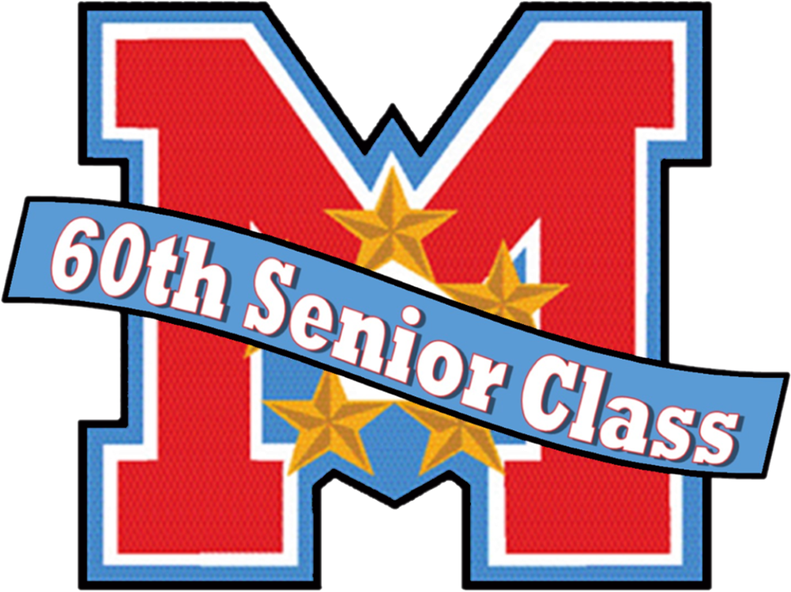
GEORGE C. MARSHALL HIGH SCHOOL
CLASS OF 2023 | SILENT AUCTION | MARCH 2023

We invite you to support George C. Marshall High School’s Class of 2023 Senior Year and All Night Graduation Celebration Silent Auction and help keep our seniors safe the night they graduate.
George C. Marshall High School
George C. Marshall High School is the community high school of Tysons Corner and the surrounding areas of Vienna, Falls Church, McLean, Merrifield and Dunn Loring. Marshall’s International Baccalaureate (IB) diploma, certificate classes, and the Marshall Academy attract students from across Fairfax County. It is likely that our 2050 outstanding students and their families not only have patronized your company but also work in this business community.
Senior Year and All Night Graduation Celebration (ANGC)
At Marshall, the Senior Year Celebration Committee works with GCM administration, counselors and students to plans events designed to provide information, build community, and celebrate our seniors. Senior year culminates with an All Night Graduation Celebration (ANGC) the night our seniors graduate. ANGC was created by FCPS in 1987 to provide students with an alcohol and drug-free graduation celebration which includes food, games, and entertainment. To help make the evening affordable for all graduates and sponsor those in need, the Class hosts fundraisers, including our March silent auction.
March Silent Auction Donation and Sponsorship Opportunities
Our biggest fundraiser for ANGC is the March Silent Auction which is planned for March 17th – 19th, 2023.
We invite your support by:
● Donating an item, gift certificate or service for our online auction fundraiser in March
● Pledging a cash contribution to sponsor the ANGC event
● Providing an in-kind donation for the ANGC celebration
Additionally, by supporting the Class of 2022 ANGC Silent Auction with your donation, you would be given the diverse marketing audience of our 2050 students, including 520 seniors, and their families.
Class of 2023: A Philanthropic Legacy
As part of the Class of 2023’s ANGC fundraising, the class sold pink t-shirts for a “Pink Out” at the October 22nd football game, and the proceeds of which will benefit Susan G. Komen. Also, the class will hold a “Stock the Market” event to collect food donations to help stock the George C. Marshall Food Pantry for our population of food insecure students. With 22.25% of the Marshall students identified as economically disadvantaged, our class legacy will help to support future Marshall students’ success.
If you have questions, or to make arrangements for donation pick-up, please contact:
Joanna Baltes, Chair: 571-344-3913, gcm2023silentauction@gmail.com; or Tara Henigan: 703-906-9368, gcm2023silentauction@gmail.com
Thank you in advance for your support!
George C. Marshall High School | Class of 2023 All Night Graduation Celebration
7731 Leesburg Pike | Falls Church, VA 22043
classof2022@gcmptsa.org

