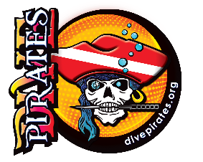
DIVE PIRATES FOUNDATION
VIRTUAL DEEP DOWN CHALLENGE - 2020 PLEDGE FORM
Speak your truth * Live your truth #divepirateswanderlust
Challenge Dates - June 16 – July 16, 2020
Virtual Diver Name:

Address: City, State, Zip:

Phone: Email:

Virtual Diver
Rally as many friends as you can to support your Virtual Dive Event! To properly credit you toward your ultimate prize booty, complete this form and submit your PLEDGES. Each check must have your name in the memo field so that you can be credited. PLEDGES are due July 16, 2020. You may be able to increase your fundraising through your employer's Matching Gift Program. Check with your HR Dept.
- Make a copy to keep, so you can collect your pledges. Collection of all money pledged is due July 31, 2020. It can be mailed to: Dive Pirates Foundation, P.O. Box 1564, Wellington, CO 80549.
- Please submit or email pledge forms to Susan (susan@divepirates.org) by July 16, 2020.
- Prizes include most pledges, most won by a team, those who earn more than $250, and yes, we are giving some “just for participating” discounts on the pirate store.
- Want to use a credit card??? Donation can be entered at Divepirates.org/xxxxxx
Donors
All donations are tax-deductible to the maximum extent allowed by law. Canceled checks are sufficient IRS proof for pledges less than $250. For pledges greater than $250, a tax receipt will be emailed to the donor. Make checks payable to the Dive Pirates Foundation and include the Virtual Diver's Name in the memo field.
COLLECTED? | PLEDGE | NAME | ADDRESS & PHONE NUMBER | EMAIL
(example) | $1 | Joe Pirate | 5432 Black Pearl, Tortuga Cove 00235  909-555-1234 | joe.pirate@yohopirates.com
 |  | TOTALS

