**October**

**October is Breast Cancer awareness month.**

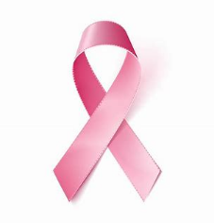

Breast cancer is the most common cancer in American women, next to skin cancer. Mammograms are the best way to find breast cancer early when it is easier to treat and before it is big enough to feel or cause symptoms. Most breast cancers are found in women who are 50 years old or older but they can affect younger women as well. Men can also get breast cancer, but they rarely do. To help lower your breast cancer risk:

* keep a healthy weight and exercise regularly;
* eliminate or limit your consumption of alcohol;
* if you are taking birth control pills or hormone replacement therapy, discuss the risks with your doctor;
* breastfeed your children, if possible.

**October is also Liver Cancer awareness month.** 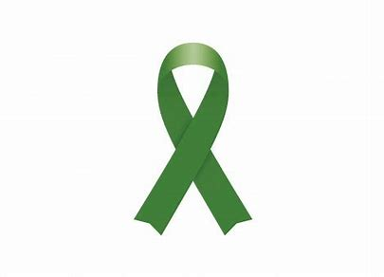

Also known as hepatic cancer, it results from the development of tumors in the liver cells. Symptoms include:

* jaundice;
* weight loss;
* stomach pain;
* fatigue;
* vomiting.

Liver cancer is relatively rare with less than 200,000 diagnosed cases per year in the U.S.