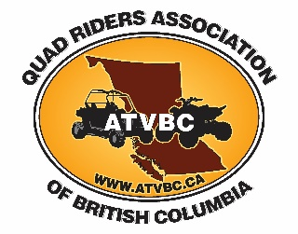

ATVBC Board of Directors Nominations 2022

Email: atvbc@atvbc.ca
Website: https://atvbc.ca

Dear ATVBC Members,

The Nominations Committee for the ATVBC Board of Directors is seeking candidates for the Board election which will be held at the next Annual General Meeting.

The 22nd Annual General Meeting (AGM) of the Quad Riders ATV Association of British Columbia, (ATVBC) will take place at 6:00 PM on Saturday August 6, 2022 at the Canoe River Campground near Valemount B.C. While it is desirable, it is not essential that candidates for the Directors positions be present at the AGM.

Please remember that in order to vote at the AGM membership is required.

Nominations should be received via email to atvbc@atvbc.ca by July 20, 2022 to be included on the ballot. Nominations received after July 20, 2022, up to and including nominations from the floor at the AGM will be accepted and treated as write-in candidates at the time of the election.

The Nomination form should be accompanied by a one-page bio outlining the nominee’s qualifications for the position of Director and reasons for running. A picture of the nominee is requested. Photo and bio will be used for publication on ATVBC’s newsletter, website and AGM package.

Please direct all inquiries to the Nominating Committee Chair: Graham Lindenbach - graham@atvbc.ca or 250-287-8368 or Greg Smith – greg@atvbc.ca or 250-565-7662

=======================================================================

Nomination Form

We hereby nominate (name) _____________________ (membership #__________for the position of Director of ATVBC. The nominee has agreed to allow his/her name to stand as shown on this nomination form.

Nominator 1 (name)_________________________ Membership #___________

Nominator 2 (name)_________________________ Membership #___________

I allow my name to be submitted (Signature of Nominee)____________________ Club affiliation (if applicable_ ____________________.

