CEO Investor Pledge Form

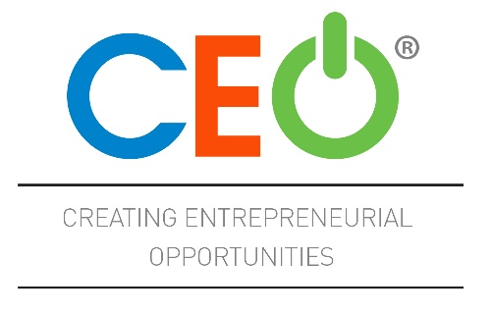

Community Stakeholder/Investor,

Streator-Area CEO and our community’s high schools Woodland and Streator High Schools are partnering together to establish a Creating Entrepreneurial Opportunities (CEO) Program for students within these districts. Community Stakeholders are the heart of CEO. Your investment provides the needed resources for facilitator salary and other expenses and ensures the sustainability of the CEO program for future participants. Your commitment of time and energy is also critical to the success of CEO.
Investors will be billed per the options listed below. Please make checks payable to Streator Area CEO/Streator High School Education Foundation by August 1, 2019.
(Insert current inaugural investors or current investor logos or names below)

Full Name: ____________________________________________________________________________________
Business: ____________________________________________________________________________________
Address: _____________________________________________________________________________________
Phone: ______________________________________________________________________________________
Email: _______________________________________________________________________________________

I wish to make a contribution to the Streator Area CEO. In consideration of the gifts of others for the same purpose, I/we hereby agree to contribute the following (Please select all that apply):
- INVESTOR: $1,000/year for 3 years.
  - Your donation will be invoiced and collected Fall 2019, Spring 2020, and Spring 2021.
  - You will receive donor recognition through the CEO Class of 2022.

- INVESTOR: $3,000 one-time payment in full.
  - You will be sent an invoice and will be asked to renew your investor status in 3 years.
  - You will receive donor recognition through the CEO Class of 2022.

- FRIEND OF CEO: (Less than $1,000/Year) Amount $_________________.

- INVESTOR and FRIEND OF CEO: $1,000 a year for 3 years AND an additional one-time payment of $5,000. You will be sent an annual invoice for payment and asked to renew your investor status in 3 years.

- INVESTOR and FRIEND OF CEO: $3,000 one-time payment in full AND an additional one-time payment of $5,000. You will be sent an invoice to renew your investor status in 3 years

- MENTOR: I would like to be paired with a student for the course of the class year so that they may call on me with questions and I may offer advice or other support as needed.

- HOST SITE: I would like to provide a meeting place for 30 people for up to 9 weeks at a time.

- BUSINESS VISIT: The class may tour my business at least one time in the course of the class year.

- GUEST SPEAKER: I would like to volunteer to speak to the class about business skills or life skills

Please note below if there are particular skills about which you would like to speak:
________________________________________________________________

*By signing this form, I agree to receive emails with pertinent information regarding Streator Area CEO.

___________________________________________ ________________________
Signature Date

The Streator High School Educational Foundation is a not-for-profit 501(c)3 corporation organized under the General Not For Profit Corporation Act of the State of Illinois.

