To Register for one or both days, please visit Five Points Theatre's Ticket page:
https://secure.ticketpro.ca/?lang=en&aff=cob#def_1328894958
To receive 50% off on the ticket price of the June 3rd and 4th events, enter the promo code below into eventbrite:
Promo code: senco50 = 50% off ($20.00 + fees)
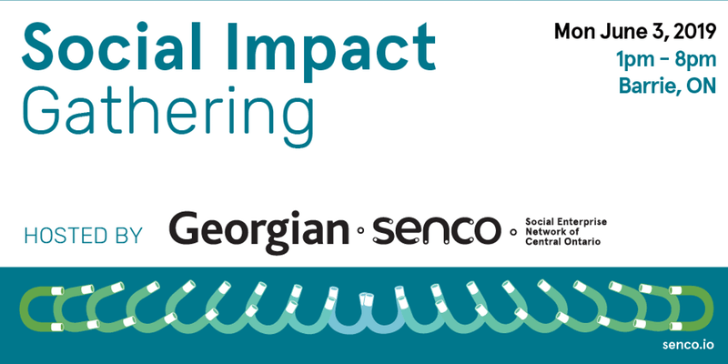
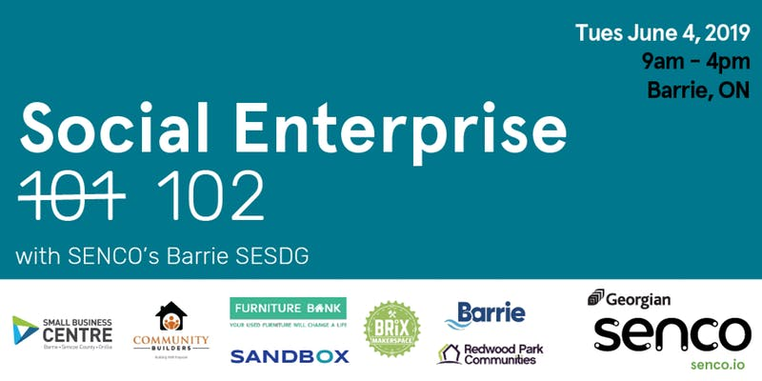

SENCO Social Impact Gathering: Monday June 3^{rd,} 2019
Join SENCO and members of the Barrie Social Enterprise Sector Development Group for a full day of insight on local social enterprise. With parts of the day taking place at both Five Points theatre and The Sandbox Centre in Barrie, this event will feature breakout sessions, discussion and a facilitated live case study with ground-breaking Canadian social entrepreneur and author, Shaun Loney. This event is ideal for individuals and organizations that want to discuss their ideas, activities and outcomes around local social enterprise development.

Social Enterprise 102 With SENCO’s Barrie SESDG: Tuesday June 4th, 2019
Join SENCO and social enterprise champions from across the region at our first annual SENCO Social Impact Gathering. This event will include panels on social enterprise, a keynote by ground-breaking Canadian social entrepreneur Shaun Loney, and a screening of the cross-Canada documentary, The Social Shift. This will be an ideal gathering for individuals and organizations from non-profit, for-profit and government organizations to connect, learn and grow their understanding of social enterprise.

SCHEDULE

JUNE 3rd |  | SENCO Social Impact Gathering | Venue
 | 1:00 PM | Welcome & Opening | Five Points
 | 1:30 PM | Growing a Social Enterprise Landscape in Central Ontario  Georgian-SENCO Panel | Five Points | Facilitator: Suzie Addison-Tor  Panelists: Elly Green, Nicole Norris, Lindsay Telfer-tbc
 | 2:30 PM | Alive to Survive to Thrive: Key Social Enterprise Resources and Tools  Provincial Panel | Five Points | Facilitator: Lindsay Telfer, Panelists: Kate Ruff, Brent Brodie, Megan O'Neil, Doug Brodhead
 | 3:30 PM | Coffee Break | Five Points
 | 4:00 PM | The Beautiful Bailout, Turning Government from a Funder into a Customer  Shaun Loney | Five Points
 | 5:00 PM | Appetizers & Cash Bar | Five Points
 | 6:00 PM | The Social Shift Screening  A Cross Canada Documentary on Business for the Common Good | Five Points
 | 7:00 PM | Screening Q & A with film makers Meg and Marie Wright  Mirror Image Media | Five Points | Facilitator: Elly Green  Videographers: Meg & Marie Wright
 | 7:30 PM | Close | Five Points
 | 8:00 PM | Join us to continue the conversations at Donaleighs  *private room reservation | Donaleighs Irish Public House | 28 Dunlop St E, Barrie, ON L4M 1A3

DATE | TIME | EVENTS DETAILS | VENUE
JUNE 4th |  | Social Enterprise 102 with SENCO's Barrie SESDG | Venue
 | 8:30 AM | Refreshments | Five Points
 | 9:00 AM | Opening Plenary | Five Points
 | 10:00 AM | Putting the Flourishing Business Model into Practice  Megan O’Neil, Lean4Flourishing | Sandbox
 | 10:00 AM | Social Enterprise: Replicating and scaling ideas that work  Shaun Loney, Emcompass Co-op  Mark Soberano, Building Up  Brandon Day, Community Builders | Five Points
 | 11:15 AM | The Flourishing Business Canvas for Policy Co-Creation and Civic Engagement in Rural Regions and Small Cities  Peter Jones, OCAD University sLab  Nicole Norris, Georgian College CCSI | Sandbox
 | 11:15 AM | Digital Storytelling  Megan & Marie Wright, Mirror Image Media | Five Points
 | 12:30 PM | Lunch, local restaurant map provided
 | 1:30 PM | Approaches to Impact measurement: getting real and getting aligned  Kate Ruff, Carleton University | Sandbox
 | 1:30 PM | Buy Social Procurement 101  Brent Brodie, Buy Social Canada | Five Points
 | 2:45 PM | The Power of a Fridge, Live Case Study  Georgian College’s Procurement Team  Redwood Furniture Bank | Five Points
 | 4:00 PM | Close & Networking | Five Points

SESSION DESCRIPTIONS & FACILITATOR BIOS
Social Enterprise: Replicating and scaling ideas that work
Starting a social enterprise can revolve around a brand new idea but it would also be learning from what’s working elsewhere, adapting to your own context and replicating it. BUILD in Winnipeg started in 2006 and Building Up in Toronto started in 2015. Community Builders started independently in Barrie but along with Purpose Construction in Winnipeg, BUILD Saskatoon, Impact Construction (St. John’s) and the Brandon Energy Efficiency Program, they are now all learning from each other. It all comes down to finding the best ways to connecting the people who most need the work with the work that most needs to be done. Also in this session, learn the importance of valuing the outcomes that non-profits provide (“stepping up from the kids’ table”) and using those lucrative values to scale the mission of your non-profit.
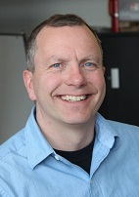
Shaun Loney- Encompass Co-op
Shaun is a widely sought-after speaker. He is an Ashoka Fellow (first on the Canadian Prairies) and Ernst and Young’s Entrepreneur of the year. Shaun has experience in government both as political staff and as a senior civil servant. He has also co-founded and mentored the establishment of 12 different social enterprises including www.buildinc.ca, www.mgrinc.ca, www.socialenterprisecentrewpg.org, and www.akienergy.com Shaun is also the author of three books including his most recent as old over 7,000 copies, is now a national best-seller. His third book, The Beautiful Bailout: How Social Innovation Will Solve Government’s Priciest Issues, is available now.
https://www.encompass.coop/
_____________________________________________________________________________________
Social Procurement 101
Are you interested in how your purchasing could make a difference in your community? Curious how you could become a Buy Social certified social enterprise or social purchaser? Join Brent Brodie from Buy Social Canada for an engaging discussion to explore the principles, policy and practice of social procurement. This session is for social enterprises and organizations alike; and together we will look at ways to leverage social value from existing purchases and introduce Community Benefit Agreements as important tools to creating healthy communities. Finally, the session will also introduce Buy Social’s national social enterprise certification for social enterprises and purchasers.

Brent Brodie- Buy Social Canada
Brent is the Regional Manager for the Greater Toronto Area for Buy Social Canada. Brent works extensively with social enterprises and organizations wanting to embark upon and improve their social procurement policies and practices. After completing his PhD at Edinburgh University, Brent went on to work with the Scottish Government in the Social Enterprise Division, working on Scotland’s Social Enterprise Strategy. After his return to Canada, Brent worked with the Learning Enrichment Foundation before taking a role with Buy Social.
https://www.buysocialcanada.com
_____________________________________________________________________________________
Approaches to Impact measurement: Getting Real and Getting Aligned

Practical, start tomorrow, tips to level up your impact measurement... And a sneak peak into future innovations in social impact data

Kate Ruff- Common Approach to Impact Measurement
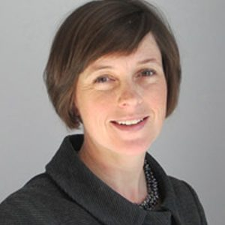
Kate Ruff is Co-Director at 3ci and an Assistant Professor of Accounting at the Sprott School of Business at Carleton University. She researches how organizations measure and report their impacts on society. Her research has won international awards. She is recognized for her work on standard setting in the social impact arena. She has a MSc from the London School of Economics and a PhD from the Schulich School of Business at York University. She served on the boards of Social Value Canada and Social Value International. She sits on the UN SDG Impact Investment Fund Research Council. At present, Kate is leading a pilot study of a Common Approach to Impact Measurement for Social Enterprises, linking flexible organizational-level indicators to the global Sustainable Development Goals (SDGs).
https://carleton.ca/commonapproach/
https://carleton.ca/3ci/
_____________________________________________________________________________________
Digital Storytelling
This session is designed to teach you the process behind telling bigger stories. Whether you are looking for guidance on how to make a video that captures an organization's philosophy, the spark of an event, or the first time you walk down the aisle, you've come to the right place.
Meg & Marie Wright- Mirror Image Media
Meg & Marie Wright are two filmmakers who created The Social Shift, a documentary where Meg & Marie, accompanied by two other filmmakers, travel across Canada in an old RV to learn more about the national social enterprise landscape. They are also the founders of Mirror Image Media.
http://www.mirrorimagemedia.ca/
_____________________________________________________________________________________
Putting the Flourishing Business Model into Practice
The concept of doing good while earning a profit may not be new, but recent interest from government, academics, and community organizations has pushed Social Enterprise into the limelight. Are you an entrepreneur? A business advisor or coach? Or someone who believes that businesses have the power to make our world a better place? Join us for this session and explore how businesses and organizations can succeed by doing good. The “Flourishing Business Canvas” is a new business tool that integrates environmental and social sustainability into a non-profit or for-profit enterprise.

This session will focus on the flourishing business model canvas - a tool used to outline, communicate, and understand your social enterprise business model. You will learn how to use this tool using a local case study.

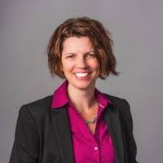
Megan O’Neil- Lean4Flourishing
Combining strong entrepreneurial skills with project management and a Master’s degree in Public Administration, Megan loves to work with social innovators to get things done. As the former Social Enterprise coach for Pillar Nonprofit, the Project Manager for Social Enterprise Southwest, and the former Executive Director of One Tomato, Megan understands the challenges that non-profits and social enterprises experience. Megan is currently focused on coaching and project managing social innovators and non-profits. Megan has scaled up and out the Food Works program, as well as Social Enterprise Southwest, expanding programs across the region.
http://lean4flourishing.biz/
_____________________________________________________________________________________
The Flourishing Business Canvas for Policy Co-Creation and Civic Engagement in Rural Regions and Small Cities

The participatory workshop session is designed specifically for policy makers, community leaders and municipal stakeholders that are looking to support social enterprise and strongly sustainable economic development. This session is part of a new research agenda through SENCO, Georgian and OCAD University to examine what civic engagement and policy modelling tools might be required at to enable 'Flourishing Social Enterprises' or Strongly Sustainable communities in our regions. Participants will be working with the Flourishing Business Canvas to explore how policy, governance and civic engagement supports Flourishing community networks within the rural Region(s) of Georgian's 7 campuses.

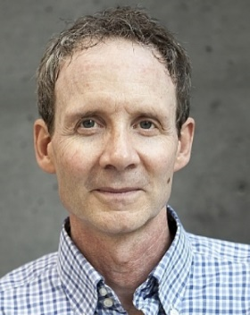
Dr. Peter Jones- OCAD University
Dr. Peter Jones is an associate professor at Toronto’s OCAD University where he teaches in the Strategic Foresight and Innovation and Design for Health graduate programs and leads innovation research and community action research. Peter studies and advises on systemic design, design for health and care, cultural sustainability, and transitions to flourishing. He is co-founder of the Strongly Sustainable Business Model Group.
https://www2.ocadu.ca/

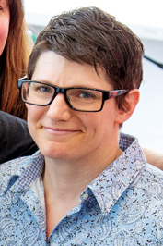
Nicole Norris- Centre for Changemaking and Social Innovation
Nicole works with SENCO (Social Enterprise Network Central Ontario) and facilitates student engagement in the Community Impact Lab at Georgian College, Orillia, to explore systemic solutions to regional socio-economic issues through Flourishing and Innovation tools. She is a design professional and a graduate student in OCAD University’s Strategic Foresight and Innovation program where she is Community Animator of the Strongly Sustainable Business Model Group.
https://senco.io/
_____________________________________________________________________________________
Follow along with updates about the events on our social media pages:
https://senco.io/

https://www.facebook.com/senco.io

Instagram: @Senco.io

Twitter: @Senco_io

