Dear Colleagues,
You asked, and the volunteers of the UCC Wellness Ministries of the National Setting have responded! We are pleased to share 3 new opportunities that will be invaluable in developing or enhancing your Wellness Ministries. If you have any questions, we are here to support you.
Please don't hesitate to contact us at WellnessMinistries@ucc.org.

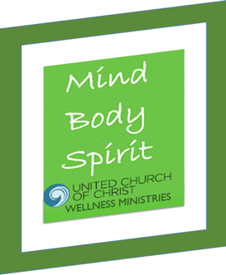
What do visitation, healing circles, meal delivery, support groups, and prayer shawls have in common?
These are some of the healing and justice activities of Wellness Ministries.

New Opportunity: A Wellness Ministries Volunteer Orientation 6-week Zoom interactive series is being offered by the UCC Wellness Ministries of the National Setting
to learn more about how you might prepare effective volunteers.

When: Tuesdays, September 3rd through October 7th at 6:30 – 8:00 pm ET
- All materials will be made available free of charge.
- Certificates of completion will be awarded at the end of the series.

Interested? Don’t miss this opportunity. Register here as soon as possible.
We limit the group size to ensure the best learning experience and that each attendee
receives the full benefit of personalized interactions and group discussions.

Have questions? E-mail Wellness Ministries or UCCWellnessMinistriesChair@gmail.com/

~~~~~~~~~~~~~~~~~~~~~~~~~~~~~~~~~~~~~~~~~~~~~~~~~~~~~~~~~~~~~~~~~~~~~~~~~~~~~~

NURTURE THE SOUL, Faith INFO Webinars

Discover Wellness Ministries in your Congregation
Thursday, October. 10th, 3:30 to 4:30 PM Eastern Time

Wellness Ministries Intergenerational Holiday Happenings
Thursday, October. 17th, 3:30 to 4:30 PM Eastern Time

More details available soon.

~~~~~~~~~~~~~~~~~~~~~~~~~~~~~~~~~~~~~~~~~~~~~~~~~~~~~~~~~~~~~~~~~~~~~~~~~~~~~~~~~~~~~~~~~

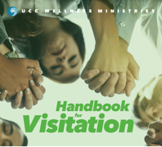
UCC Wellness Ministries Handbook for Visitation

Are you visiting a person or writing a note on behalf of
the church? Aren’t sure what to do or say to this person?

This handbook furnishes information to guide you in each encounter
and provides scripture passages, prayers, and blessings you can easily use.
This Handbook replaces the now-retired Called to Care Pocket Handbook for Caregivers.

The Handbook will be available from the UCC Resources Store by early fall.

Blessings on the ministries within your congregations and the communities you serve.
The UCC Wellness Ministries Leadership Team

