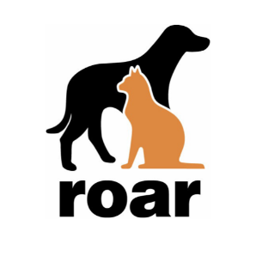
ROAR is a member of Rescue Network. Rescue Network offers a magazine, Animal Wellness, and a marketplace of pet care products. You can subscribe to the magazine at www.animalwellnessmagazine.com/subscribe or shop at www.animalwellnessmarket.com and use the code ROFAR, and ROAR will receive 25 % of the proceeds.

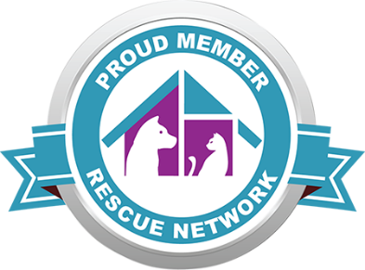
ROAR is a member of Rescue Network. Rescue Network offers a magazine, Animal Wellness, and a marketplace of pet care products. You can subscribe to the magazine at www.animalwellnessmagazine.com/subscribe or shop at www.animalwellnessmarket.com and use the code ROFAR, and ROAR will receive 25 % of the proceeds.
