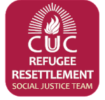

The Refugee Resettlement Social Justice Team is pleased to welcome a family of 5 from northern Afghanistan to White Plains on Wednesday, November 15. CUUC has teamed up with four other congregations in the White Plains/New Rochelle area to co-sponsor this family under the direction of HIAS, a refugee resettlement organization that is authorized by the US State Department.

An apartment in White Plains has been leased and is in the process of being furnished. This will be the third Afghani family resettled in White Plains in the past few months. We hope they get to know one another! Many members of CUUC's Refugee Resettlement Social Justice Team are on committees that are helping in one way or another now or in the coming months. We expect this will be an enriching experience for all of us!

