Praying with the Graced History of CLC Canada: 2019-present
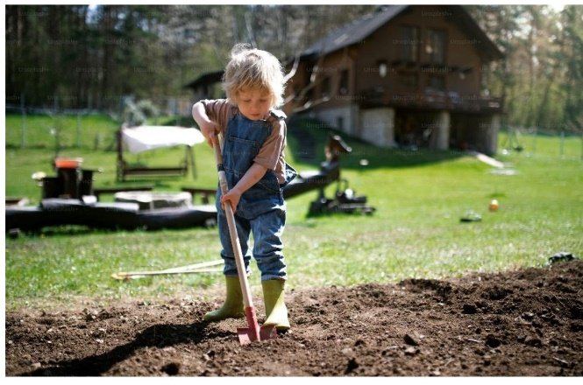
In this prayer exercise, you are invited to pray with CLC Canada’s graced history (our communal faith history) over the last five years, from our last national Assembly in Winnipeg in 2019 to the present.
We will use the three themes of Formation, Communication and Collaboration, and Sustaining CLC from our communally discerned National Priorities, along with the image of a garden as the ‘tools’ for this reflection. You may even wish to consider sitting in a garden as you pray this exercise.
Once we pray individually, we will share the fruits of this prayer in our local groups.
- INDIVIDUAL PRAYER
Scripture:
Isaiah 61:11 For as the soil makes the sprout come up and a garden causes seeds to grow, so the Sovereign LORD will make righteousness and praise spring up before all nations.
The grace desired:
We seek of God a deep awareness of how CLC Canada has grown and evolved over the last five years and the ways in which God has been with us. We also seek an awareness of how God is calling us forward for the next five years.
Points:
I prayerfully review the three themes of Formation, Collaboration and Communication, and Sustaining CLC, and the growth noted within CLC Canada in these areas in the main letter.
I then imagine myself walking with Christ through a garden. The garden represents the last 5 years in CLC Canada. The three themes are each ‘beds’ in the garden.
I look with Jesus at the three beds, in their various stages of growth. I touch the leaves, sift through the soil, and/or examine any fruit that has come forth.
I feel the love of Jesus, the master gardener, as he gazes upon the garden with me.
Examining each theme or bed in turn, what growth or fruit over the last five years do I become aware of? I take time to savour these and give thanks.
As I go through the three beds again, are there areas in which seeds have not sprung or the plants have not reached their full potential? Are there spots where the soil is dry, or the garden has been neglected or needs pruning? I take time to notice and name these areas.
Finally, I contemplate the wider world around the garden at this time (the ‘signs of the times’ or the social, political, economic and environmental context in which we live). In what ways do I sense that God desires to use this garden to nourish our world in our history now?
I reflect on all of this and pick out what is most significant to me.
Colloquy:
I speak to Christ about my new awareness, expressing my appreciation and gratitude for God’s presence in CLC in Canada and any desires/directions for us he has revealed.

- SHARING THE RESULTS OF OUR PRAYER IN OUR LOCAL GROUP
We ask each local group to plan a meeting in September, in order for members to share the fruit of their prayer experience with their community.
Each member should come prepared to share one or two insights they received under each of the three themes or beds, as well as any insights as to the purposes to which the Lord desires for the garden.
In Round One, we speak and listen to what each one has found in prayer.
In Round Two, after a 2-minute pause, we share any common themes or insights we heard or where we felt affective harmony with the others.
In Round Three, after 3 minutes to reflect, we share on one or two of the following points: What impressed me as others shared? What commonalities emerged? Were there any divergent points or outliers?
Action from the third Round, develop a sentence or two that reflects the group’s experience and insights as they relate to: Formation, Communication and Collaboration, and Sustaining CLC. Groups are invited to freely share a key observation under each theme, either in terms of where we have come in the last five years - positive or negative or perhaps identify a need that may have emerged.
If there are any questions regarding this prayer exercise, please don’t hesitate to reach out to the National Implementation Working Group. Please forward your group’s response by September 25th to
jabernethyparker@gmail.com

Individuals may also want to review our 12 Nationally Discerned Priorities which were adopted after the 2019 National Assembly and organized under these three themes: https://www.christianlifecommunity.ca/wordpress/wp-content/uploads/2020/01/Communally-Discerned-Priorities-Oct.-2019.pdf.

