

**Dear Equine Enthusiast**,

The Colorado Horse Council started working on a five year dream of realizing and developing resources that will assist our entire equine community with its growth, development and sustainability. We started a process of looking at our infrastructures, use of technologies and evaluating our community to have a better understanding of our needs.

Here are a few ways we achieved our initial goals.

* Updated our database programs and developed The Equine City Hall to start bringing a diverse equine network together utilizing cloud-base association management systems.
* Restructured our Boards with industry participants that are currently involved in today’s equine activities.
* Participate in a national Equine Economic Impact Study, collecting data specifically on our equine community in the State of Colorado.
* Taking a leadership role in the Coalition of State Horse Councils and the American Horse Council to learn and be certain of the consistent nature of our industry.

The results of our last five years has led us to the development of the

**Equine Heritage Foundation** that will:

Unite our equine community, provide the necessary educational formats to improve the welfare of equine, and provide opportunity for others to share the lifestyle of this exceptional human animal bond community.

The forming of equine foundations of this nature in other states have led to strong awareness programs, educational formats that include youth programs to professional development, result based welfare programs and a thriving equine industry.

Our goal is to have these functions accomplished by September 1, 2021 and start our campaign Fall 2021. As a stakeholder in our Colorado equine community, we invite you to become involved in our goals in the Equine Heritage Foundation. We hope that you will make an initial financial donation of support. This is an organization that has your best interests in mind as we continue to develop our future equine industry.

I hope to hear from you soon. Please call me at 720-261-0294;

Best Regards and Happy Trails!

**Bill Scebbi**

CEO/Executive Director,

Colorado Horse Council, Colorado Horse Development Authority, Rocky Mountain Horse Expo

[bill@coloradohorsecouncil.com](mailto:bill@coloradohorsecouncil.com) 720-261-0294

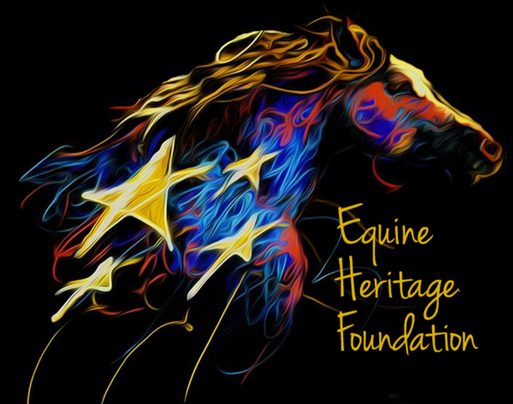

**The Equine Heritage Foundation**

**Mission and Purpose**

Promote the Heritage of the Horse, which is rich and meaningful in our state and requires continual education in the areas of welfare, training, legal responsibility and the cultural understanding.  
  
 Protect the Heritage of the Horse, which encompasses the rights of individuals to enjoy, own and actively use the natural resources and the manmade infrastructure our state has to offer for equestrian activities.   
  
Develop the future Heritage of the Horse, which has a meaningful human and financial impact in our state which includes quality of life components that is inherent in the reasons why people live, work and play in Colorado.