2019
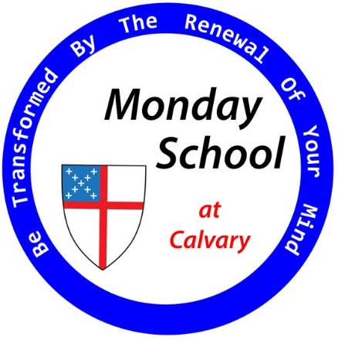
New Year
New Classes
You are invited to step into a place of learning and sharing one evening each week, leaving behind concerns about preparing a meal, watching the kids, or tasks at home. Take this time for yourself to talk with friends about things that matter, in a sacred space where everyone’s thoughts and feelings are valued.
When you love a person, you might not always agree, but you always show up, listen, respect, and relate, and you always grow. It’s the same when you love a text that’s worthy of your love. Our goal in Monday School is to come to know and love the most important texts of the Bible, but there is no homework.
Just as we get together on Sunday mornings to help each other pray and worship, some of us have also chosen to get together Monday evenings to help each other relate to the Scriptures. It took inspiration to write these texts, and it takes inspiration to read them. Inspiration comes from the gathered community and from the material we bring from our lives: our successes and failures, our hopes and fears, our blessings and hard knocks, our faith and our doubts. With our hearts and minds open, God can get a word in to tell us more.

Course Content and Schedule for 2019
First 8-week Session | No Monday School during Lent.  Stay tuned for plans regarding a special Lenten study. | Second 8-week Session
The Gospel According to Mark |  | The Gospel According to John
January 14 – March 4 |  | April 29 – June 10
Facilitated by Rick Cotner, Morgan Owen, Rose Hayden, and Josh Huber. |  | Facilitated by John Bolton, John Smith, and others TBD.

Details
6:00 p.m. Dinner (Free; donations appreciated) in Parish Hall. Bible Study 6:30 – 7:30 pm.
Discussion Format
  - Read the text in class. This may sometimes mean listening to a recording or watching a video.
  - Discuss: Facilitators might occasionally open the discussion with some background info or a personal reflection, but they won’t lecture.
  - Changing facilitators every 2 weeks will bring a diversity of viewpoints and discussion styles.
  - The facilitator’s goal will be to create a space in which everyone is heard and respected.
  - Facilitators will try to foster a love of both the text and the gathered community.

