HUMAN RELATIONS COUNCIL  Community Cultural Grant Program  - Make an impact in our Community  Who:  Valparaiso Human Relations Council seeks to fund and support initiatives to increase awareness, appreciation, and dialogue within the Valparaiso community among diverse and traditionally underrepresented groups.  What:  Receive funding to implement a program or event with a grant ranging from $500-$2000 per project. Considered programs and events are speakers, exhibitions, classes and workshops, arts and humanities initiatives, and civic/cultural programming that enhance the quality of life and strengthen our community.  Eligibility:  Individuals, incorporated nonprofit, unincorporated associations, public schools, or for-profit organizations.  Questions? Contact HRCCommunityCulturalGrant@gmail.com. | 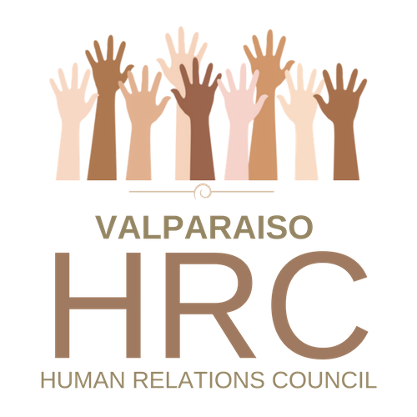  Do you have ideas to:  -BUILD BRIDGES?  -FOSTER COLLABORATION?  -TEACH TOLERANCE?  -GIVE VOICE TO OTHERS?  -CREATE ART?  Application Deadlines  Sept and March 15th  Online application:  https://ci.valparaiso.in.us/1584/HRC-Cultural-Arts-Grant  DEADLINE EXTENDED TO APRIL 15, 2019

