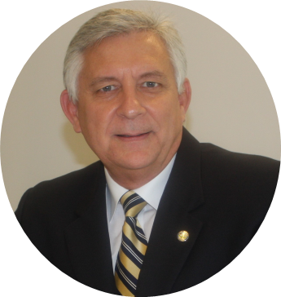
Julian H. Perez, AICP, CFM
Economic Development Director
305-460-5310
Economicdevelopment@coralgables.com
Mailing address:
2121 Ponce de Leon Boulevard, Suite 720 Coral Gables, FL 33134
Julian Perez was appointed Director of Economic Development for the City of Coral Gables in December 2019. In this capacity he leads the City’s business retention, expansion, and attraction initiatives. He is responsible for the pursuit of strategic investments and joint ventures that enhance the City’s economic competitiveness and quality of life.
Prior to joining Coral Gables, Perez held leadership roles in the City of Doral, Town of Cutler Bay, Village of Palmetto Bay, and the City of South Miami. His responsibilities included implementation of economic development programs, comprehensive plans, land development regulations, review of land development projects, interpretation of zoning and land use regulations, policy development, brownfield redevelopment, art-in-public places programs, and water resource, aviation, strategic, environmental, floodplain management and post-disaster planning.
In the private sector he provided program management consulting services to the U.S. Army Corps of Engineers, Military Munitions Response Program, and water resources projects.
Perez believes in helping existing businesses be sustainable and resilient in order for them to successfully compete in a highly competitive market. In 2020, he spearheaded Coral Gables’ COVID-19 Business Reopening Strategic Plan, Small Business Recovery and Technology grants program, Business Recovery Task Force, and participated in the development of the City’s regulatory relief programs to mitigate the impacts of the pandemic.
He holds a Master of Science in Planning (Urban and Regional Planning), Master of Arts in International Affairs and Economic Development as well as a Bachelor of Science in Economics and Policy Science from Florida State University. Perez is also a certified planner and floodplain manager in good standing with the American Institute of Certified Planners, and the Association of State Floodplain Managers.

