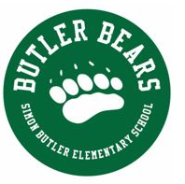
Use the riddles to find the Butler Bear Paw Print at each of the locations on the Butler property.
Take a picture of your Butler Bear next to the Paw Print. Add the pictures to this form and email the form to ButlerESPTO@gmail.com by Friday, May 14 to be included in a drawing for some prizes. You don’t have to find all of the Paw Prints to be included in the drawing. The paw prints will be waiting for you to find on Saturday, May 8 and Sunday, May 9.
Remember to stay together as a family, obey traffic laws and be respectful of property.

Student Name: _____________________________________________________
Grade: _____________ Teacher: __________________________________

Clues:
1. Where do bears hibernate in the winter?

2. Butler Welcomes everyone!

3. Where do the wheels on the bus go round and round?

4. Throw the ball, not too high, not too hard!

5. Have you ever seen a rock climb?

6. The littlest kids run and play here.

7. A popular place at Butler to visit… and maybe even have a wedding!

