Purpose

The NSHPSN’s scope and mandate is to assess perioperative services delivery provincially and to design and recommend strategy and improvement plans that will drive the achievement of targeted, measurable, and sustainable clinical and operational improvements. Specifically, this network is committed to assure that:
- Perioperative services are provided in a timely, safe, and equitable fashion to all Nova Scotians and that waitlists are measured and prioritized in a standardized fashion.
- Surgical and patient reported outcomes are measured with a validated approach and fed back to providers along with evidence informed strategies to improve outcomes based on best evidence.
- Innovation is supported and evaluated, especially where outcomes, access to care, efficiency and sustainability can be improved.
- Unwarranted variation in surgical care provision in terms of approaches, access, and outcomes is reduced.

Governance and Relationships
The NSHPSN is accountable to the Executive Leadership Team through the Quality and System Performance portfolio. Other key relationships are as follows:

- Clinical Operations Council to support the identification of network priorities and to present and recommend solutions to agreed-upon priorities (see figure 1 below)

- The VP of Quality and System Performance and VP of Research, Innovation and Discovery will be the primary sponsors of the network function. A member of the executive team may be asked to be the primary sponsor of a specific network, based on the service or issue to be addressed and the capacity of the executive team member.

- The overall functioning of the NSHPSN will be accountable to the VP of Quality and System Performance.

- The research enablement and innovation work of the Network will be led by the VP of VP of Research, Innovation and Discovery.

Figure 1

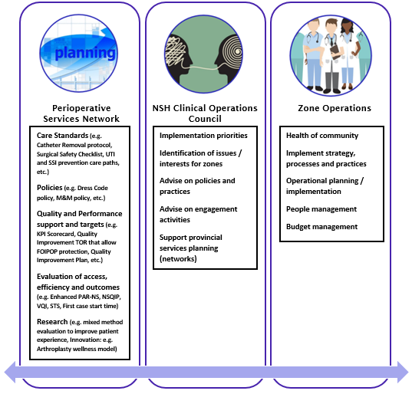

Functions
The NSHPSN will have responsibility related to Perioperative services to: 1) design and plan; 2) evaluate, report, and support implementation; and 3) engage and collaborate. The associated functions of the PSN are outlined in table 1.
Table 1
Focus | Function
Design and plan | - Ensure perioperative services planning is based on the needs of the population, research and evidence, and the lived experience of Nova Scotians  - Set strategic policy direction and priorities in keeping with the strategic direction of NSH and evidence/research/innovation  - Establish service standards, clinical standards, and performance and outcome expectations. These include a focus on people centred care; safety; accessibility; appropriateness; and integration.  - Support the prioritization of areas for health system/service change  - Align priorities between service/system and research/academia  - Support the development of an overall quality improvement program/plan  - Recommend priorities and support the best/leading practice projects and initiatives  - Recommend priorities related to resource allocations and budget alignments keeping with strategic priorities of the service; may recommend areas for investment/disinvestment to zones
Evaluate, Report, and Implement | - Evaluate and monitor performance results (process and outcome) against the established framework, standards, outcomes, risks, and expectations for the perioperative services  - Monitor and report enterprise risks for the perioperative services network  - Report results, disseminate information, and support data driven action and improvements  - Identify strategies to promote evidence-based practice  - Support implementation planning and design functions related to strategic priorities and large-scale change for the perioperative services
Engage and Collaborate | - Establish standards for patient/family engagement within the perioperative services  - Listen to and respond to the needs of operations  - Engage with clinical experts, users, patient, and community members to design perioperative service models and strategies to meet the needs of the population  - Partner with community, government, private and academic organizations to inform planning, design, and evaluation  - Champion and leverage experience(s) to develop protocols and to share good practices across NSH

Membership and Responsibilities
The NSHPSN will be co-led by a Senior Medical Director and a Director. The network consists of the Core team and a group of Operational Representatives.
- The Co-Leads drive strategic focus, champion quality improvement, and act as liaison with other networks, Programs of Care, Clinical Operations Council, and others as required.
- The Core network team meets frequently, leads and supports quality/process improvement, produces deliverables, guidelines, reports, and actions items related to operating room information systems updates and improvements. FTE allocation for core team members may vary from part-time to full time.
- The zone operational representatives are active network members and local champions for improvement initiatives. They form the communication linkage between the network and zone operations, sharing information on Network activities and bringing information, insights, and perspectives to planning, evaluation and implementation efforts. Zone/site level data is used to identify opportunities for quality improvement, track progress with implementation of initiatives, and to improve compliance with standards / best practices.
- The relationship between zone operations and the Network allows for bi-directional accountability for zonal implementation of quality improvement initiatives put forward by the network, networks are accountable for high quality data and feasible initiatives.
- PSN may also include representatives from other services that are complimentary or interconnected. Additional members may be added to the network as required (e.g., finance, quality, legal). Figure 2 illustrates the PSN Membership.

Figure 2
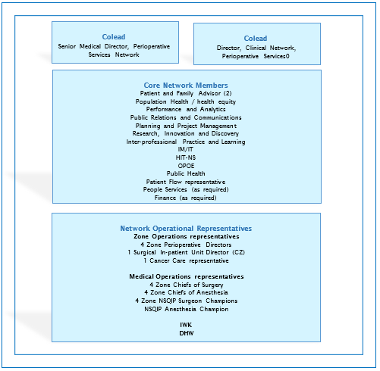

Meeting Frequency
The meetings of the Perioperative Services Network shall occur at least 10 times per year.
The Core team and co-leads will meet at a higher frequency (at least monthly) to achieve deliverables.

Approval:

Name | Position | Date
Cindy Connolly | Director, Perioperative Services Network | Jan. 7, 2022
Dr. Greg Hirsch | Senior Medical Director, Perioperative Services Network | Jan. 7, 2022
Appendix A
MEMBERSHIP (2022)
Network Co-lead
Dr. Greg Hirsch, Senior Medical Director, Perioperative Services Network
Cindy Connolly, Director, Clinical Network, Perioperative Services

Core Network Members
Lindsay Bertrand, Manager, Physician Informatics, OPOE
Kristy Bulger, Professional Practice Leader, Interprofessional Practice and Learning
Treena Campbell, Manager RNPDC, Interprofessional Practice and Learning
Sharon Forbrigger, HSM System Coordinator, Perioperative Services, IM/IT
Ryan Gainer, Health Outcomes Scientist, Research Innovation and Discovery
Lyann Hanham, Senior Business/ Systems Analyst, Perioperative Services, IM/IT
Julie Johnson, Team Lead, IM/IT
Sandra Kline, Administrative Assistant, Perioperative Services
Brittany MacKinnon, Director, Business Development, Research and Innovation
Stephanie Mailman-Crouse, Quality Improvement and Safety Advisor, Perioperative Services Network
Leanne Rankin, Clinical Informatics Lead, Health Information Technology Services (HITS-NS)
Julia Rose, Project Manager, Quality and System Performance
Margo Salmon, Manager, Clinical Specialty Services, IM/IT
Liam Shannon, Manager, Policy and Development, Perioperative Services Network
Sean Smith, Access and Wait Time Analyst, Performance and Analytics
Krista Wood, Senior Communications Advisor, Perioperative/ Surgical Services, Communications and Public Engagement

Network Operational Representatives
Dr. Andre Bernard, NSQIP Anesthesia Lead
Dr. Trevor Butler, NSQIP Surgeon Champion - Western Zone
Dr. Janice Chisholm, Zone Chief of Anesthesia – Central Zone
Dr. Neil Clifton, Zone Chief of Surgery – Eastern Zone
Dr. Peter Coady, Zone Chief of Anesthesia – Northern Zone
Dr. Gerald Corsten, Zone Chief of Surgery – IWK
Dr. Gail Darling, Department Head of Surgery – Central Zone
Dr. Robert Doyle, Zone Chief of Anesthesia – Western Zone
Joanne Dunnington, Director, Perioperative Services – Central Zone
Dr. Andrea Faryniuk, NSQIP Surgeon Champion – Northern Zone
Cathy Lynn Howley, Director, Perioperative Services – Eastern Zone
Dr. Ryan Kelly, Zone Chief of Surgery – Western Zone
Dr. David Kirkpatrick, Zone Chief of Surgery – Central Zone
LeeAnn Larocque, Director, Children’s Surgical Emergency and Rehabilitation Services – IWK
Brett MacDougall, VP Operations – Eastern Zone
Dr. Rob McGory, NSQIP Surgeon Champion – Eastern Zone
Dr. Sean Orrell, Zone Chief of Anesthesia – Eastern Zone
Aaron Prosper, Indigenous Health Consultant, Public Health
Dr. Jamie Rogers, Zone Chief of Surgery – Northern Zone
Dr. Aaron Smith, Executive Medical Director Co-lead – Northern Zone
Alana Toole, Director, Perioperative Services – Northern Zone
Dr. Mark Walsh, NSQIP Surgeon Champion – Central Zone
Tracey Watkins-Allen, Director, Perioperative Services – Western Zone
Dr. Blair Williams, Head of Surgery – Cape Breton Regional
Lisa Grandy – Department of Health and Wellness

Addendum

Perioperative Services Network

2020-22 Goals and Initiatives
- Provide safe high quality surgical care through examination of rigorously collected access and outcomes data.
Initiatives:
- PAR-NS and Novari
- NSQIP (multiple surgical specialties)
- VQI (vascular surgery)
- STS (cardiac surgery)
- CIHI and Vital Status
- Arthroplasty
- Surgical Oncology Quality Indicators
- Patient Experience
- Create evidence-based toolkits that can be used to address deficiencies in outcomes.
Initiatives:
  - CAUTI (UTI Improvement)
  - SSI improvement
  - ERAS
  - Frailty scale
  - Shared Decision Making

- Improve access to surgical care.
Initiatives:
- Revise PARNS and Novari to create standardized prioritization of cases based on procedure and relevant clinical modifiers.
- Share PARNS data with stakeholders to inform booking practices
- Explore centralized booking approaches where appropriate
- Streamline lung cancer patient triage/workup/booking
- Measure and feedback efficiency data to operations (Perioperative Scorecard)
- Renegotiate WCB - CCSP and CSSP Surgeon contracts

- Create and support the development of evidence based clinical standardization / work processes.
Initiatives:
- Clinical standards development (OPOR)
- MDR – instrument review, material review board
- Specialty Councils (provide pan-provincial forum by specialty for optimal service delivery and workforce strategy.
- Anesthesia workforce initiative
- Call coverage in rural areas
- Update and standardization of patient education materials
- Policy development (i.e., Surgical Safety Checklist)
- Pandemic Planning
  - Screening/PPE
  - Ramp down and Ramp up

- Build a strong surgical community that fosters collective learning and sharing
Initiatives:
- Review existing committee structure – including quality councils and committees
- Establish surgical specialty councils
- Develop an engagement and communication strategy - to include patients, families, and zone leadership teams
- Establish standardized approaches to surgical M and M

Perioperative Strategy 2022-2023
