Considerations for Irrigating 5 Acres or Less

Several key factors will play vital roles in selecting either overhead (sprinkler) or drip irrigation system for a small fruit or vegetable farm with 5 acres under production.
Dr. Sumon Datta says, as an irrigation engineer, I would first ask the producer the following questions related to these factors:
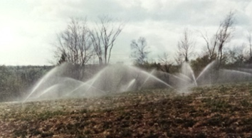
- crop type (does the crop need a large amount of water at once or needs a little bit of water more frequently?)
- soil type (Is it a heavy textured soil that can hold more water or a light soil?)
- topography of the field (Is the land flat or does it have a slope?)
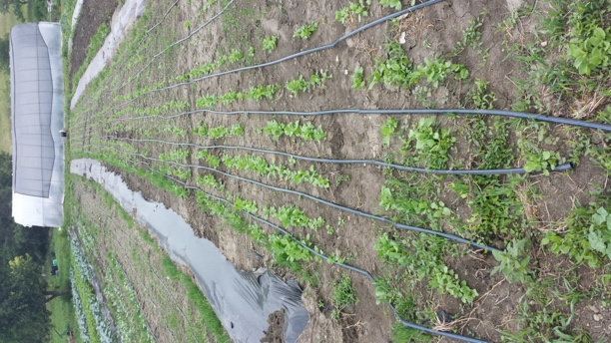
- type of water source (Is the producer drawing water from surface water reservoirs like ponds/rivers/streams or will s/he be drawing water from groundwater?)
- capacity and availability of water from the source during the most water demanding period (Is enough water available during months of June, July, and August?)
- distance from the source of water to the point of application (If the distance is longer s/he will need a larger pump to build up pressure and deliver the water to the crops)
- labor requirement (will s/he have enough labor during the busiest growing months to maintain the systems?)
- materials needed (If its open production, then a different, more rigid set of materials will be needed to survive harsh winter months compared to a closed production like greenhouse)
These all impact the cost, maintenance, and operation of an irrigation system. Generally, a basic sprinkler system (low pressure nozzles, flexible poly-tubing, manual control valve, etc. could cost you as little as $200-400/acre to set up. The costs will go up when you add pumps to build up pressures, backflow prevention, rigid steel pipes, etc.

If you want to have a movable gun system (with 1" diameter), the cost could go up significantly. I would say for a typical 5-acre field with a moving gun system (considering normal spacing between nozzles and lateral lines), the producer would be looking at 7,000 to 9,000 USD, so north of $1,000/acre.

In contrast a drip irrigation system which is more efficient than sprinkler but may cost you upwards of $1800/acre.

You can also integrate engineered smart technologies into all of these systems to optimize irrigation amounts to conserve water. So that’s kind of an overall picture on the cost of irrigation systems and the factors affecting them.

Interested in more information? Contact Dr. Sumon Datta, UMaine Extension Agriculture Engineer, at sumon.datta@maine.edu or 581-3402.

