Free
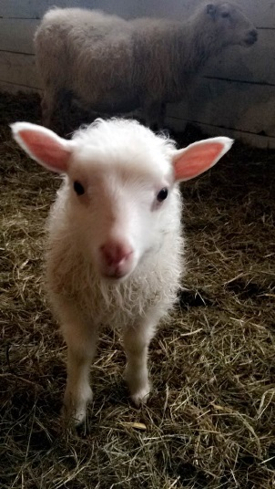
Saturday, October 22, 2016: 9 am to 3 pm
Sheep and Goat Parasitology Seminar
Kennebec Valley Community College: Carter Hall, Fairfield, ME

Want to learn more about minimizing costs of worming?
Confused about Scrapie control?
Eager to learn how to get your flock or herd a “CLean” bill of health?
Want to meet a small ruminant vet, and ask them some questions?

Please join us for an informative workshop about internal parasites of sheep and goats, especially our worst enemy, the “barberpole worm” (Haemonchus contortus). Many producers have benefited by learning whether this parasite is in their flock, and new results will help producers change their pasture strategies to reduce losses due to parasitism in their sheep and goats. We will also give a "live" parasite egg count demonstration. We’ll present guidance about the current scrapie program, and the difference between ID tags and scrapie tags. This seminar will include the “how-to” aspects of parasite management and disease prevention: please bring your questions!
Speakers:
- Jim Weber PhD DVM: SARE sheep and goat parasite project
- Anne Lichtenwalner DVM PhD: CL in sheep and goats; wildlife “crossover” diseases
- Gary Anderson PhD, Justin Bergeron DVM, Jim Weber PhD DVM: ID and scrapie issues
- Small ruminant vet panel: Dr. Tanja Ebel, Dr. Don McLean, Dr. Paul Rudenberg

Schedule: Opening remarks at 8:30 am
- 9 to noon: Sheep and goat parasite control methods for Maine, pasture management suggestions, and your questions about worming answered.
- Noon-1: lunch (bring your own) / vet panel: meet a Maine sheep and goat veterinarian
- 1:00: Dr. Paul Rudenberg, "Working with Small Ruminant Farmers in Haiti"
- 1:30-3: Sheep and goat infectious diseases update: what’s in our area? Scrapie from several perspectives (producer, regulatory vet), the use of genetic screening for prevention, and a discussion about demystifying sheep ID: eartags and scrapie tags.

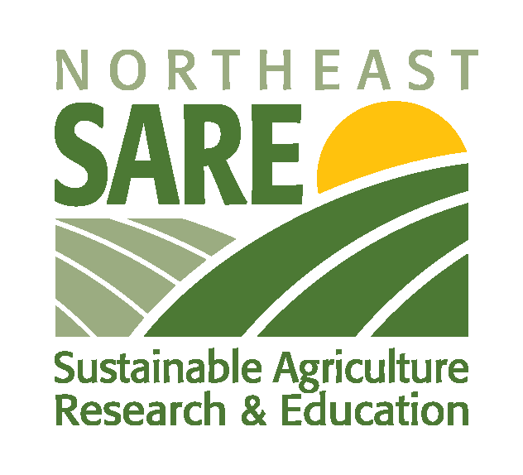
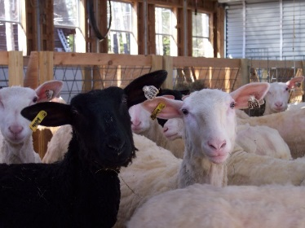
No charge; please RSVP to Melissa Libby (Melissa.libby1@maine.edu) or (207) 581-2788
“See you there!”

