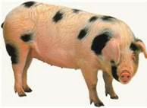
Swine Education Seminar
April 12, 2018

Viles Arboretum
153 Hospital Street, Augusta, ME
(just past Dept of Agriculture, opposite
side of street, headed toward Gardiner)

8:30am Registration

9:00am Introductions

9:15am Dr. Carolyn Hurwitz will talk on vaccinations, castrations and
Necropsies.
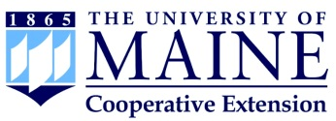
11:00am Tori Jackson, University of Maine Extension – marketing
your products using the internet.

Noon Lunch – pulled pork sandwiches, coleslaw, corn bread
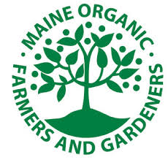
1:00pm Dr. Michele Walsh, State Veterinarian – regulations regarding
imports, exports and permits

1:20pm Gary Anderson, University of Maine Extension – reading feed
Tags. What is important.

2:15pm Diane Schivera, Livestock specialist, MOFGA, steps to getting
your swine herd certified organic
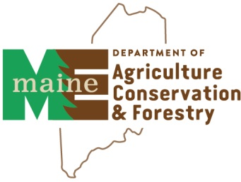
2:30pm Producer profile

3:00pm Adjourn

Questions: contact Cindy.kilgore@maine.gov 215-4968

Cost : $25.00 per person Includes lunch and hall rental; OR $20.00 for paid members of Maine Pork Producers Please make checks payable to: Maine Pork Producers Mail to: Dept of ACF, Cindy Kilgore, SHS 28, Augusta, ME 04333-0028

Name: _________________________________________________________________

Address: _______________________________________________________________

Email: __________________________________________________________________

Home phone: ______________________ Cell phone: ________________________

Member of Maine Pork Producers? Yes______ No_______

PLEASE RSVP PRIOR TO 4/10/18 FOR LUNCH COUNT…… THANK YOU !

