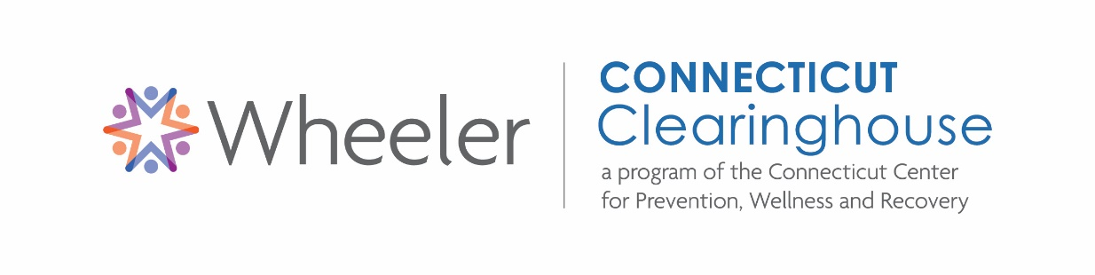
Resources to Support Health and Wellbeing in Older Adults
This document identifies books, ebooks, curricula and DVDs, as well as pamphlets and fact sheets available at Connecticut Clearinghouse about supporting the health & wellbeing of older adults and related topics. These resources may be helpful for counseling & social work professionals, healthcare professionals, educators, family members, as well as the general public.
Visit Connecticut Clearinghouse at:
334 Farmington Avenue (Route 10)
Plainville, CT 06062
For those who are unable to visit, we participate in Statewide inter-library loan.
Resources may be found using the Library Catalog: https://conn.ent.sirsi.net/

A complete list of pamphlets, as well as an online order form, may be found here:
www.ctclearinghouse.org/pamphlet-poster-directory/
For access to eBooks & streaming media, contact Connecticut Clearinghouse: info@ctclearinghouse.org

Membership is free! Join today:
www.ctclearinghouse.org/membership-form/
Contact Connecticut Clearinghouse with any questions on how to access the resources listed:
Call 860.793.9791 or 800.232.4424
Visit us online at www.ctclearinghouse.org

Last updated on 8.11.2021

Books, eBooks & Curricula
Aging and Mental Health / Daniel L. Segal
Art Therapy and Creative Coping Techniques for Older Adults / Susan I. Buchalter
Assessing Capacities of Older Adults: A Casebook to Guide Difficult Decisions / Jennifer Moye
Cognitive Behavioral Therapy with Older Adults: Innovations Across Care Settings / Kristen Hilliard Sorocco
Depressed Older Adults: Education and Screening / Jacquelin Berman
Depression and Anxiety in Later Life: What Everyone Needs to Know / Mark D. Miller
Elder Abuse and the Public’s Health / Pamela B. Teaster
Late Life Depression and Anxiety / Art Walaszek
Living Through Loss: Interventions Across the Lifespan / Nancy R. Hooyman
Making Evidence-Based Psychological Treatments Work with Older Adults / Forrest Ray Scogin
No Frontiers in Resilient Aging: Life-Strengths and Well-Being in Late Life / Prem S. Fry
Not As Prescribed: Recognizing and Facing Alcohol and Drug Misuse in Older Adults / Harry L. Haroutunian
The Older Adult Psychotherapy Treatment Planner / Deborah W. Frazer
Optimal Well-Being for Senior Adults I / Ester R.A. Leutenberg
Social Work with Older Adults: A Biopsychosocial Approach to Assessment and Intervention / Kathleen McInnis-Dittrich
Too Young To Be Old: Love, Learn, Work and Play as You Age / Nancy K. Schlossberg
Treating Late-Life Depression: A Cognitive-Behavioral Therapy Approach – Clinician Guide / Ann M. Steffen
Wisdom Mind: A Mindfulness Training Program for Cognitively Healthy Older Adults and Those with Subjective Cognitive Decline – Facilitator Guide + Participant Workbook / Colette M. Smart
Your Turn for Care: Surviving the Aging and Death of the Adults Who Harmed You / Laura S. Brown
DVDs
A Hidden Epidemic
A Hidden Epidemic is an educational documentary on the dramatic increase in alcohol and prescription drug abuse in our older population.
Gen Silent
Gay, Lesbian, Bisexual and Transgender older people who fought the first battles for equality now face so much fear of discrimination, bullying and abuse in the care setting that many are hiding their lives to survive. Thousands are dying earlier than their straight counterparts because they are isolated and afraid to ask for help. But a growing number of people are fighting to keep their elders from being silenced.
Mental Health Issues in Late Life
For older adults with mental health issues, problem-solving skills can weaken as a result of cognitive decline in late life. Problem-solving therapy is especially suited for work with older adults because it encourages the client to define his or her problems concretely in terms of the stimuli, responses, and consequences. In this video, Dr. Patricia Areán demonstrates the effective use of problem-solving therapy with a 62 year old retired woman who is the sole caregiver of her grandchild, as well as both of her parents. The client has been struggling with depression, severe mood swings, and sleeplessness for about five years.
Rewarding Challenges: Social Work with Older Adults
Portraying encounters between social work interns and older adults, this program illustrates fundamental social work knowledge, values, and skills in engagement, assessment, intervention, evaluation, and termination.

