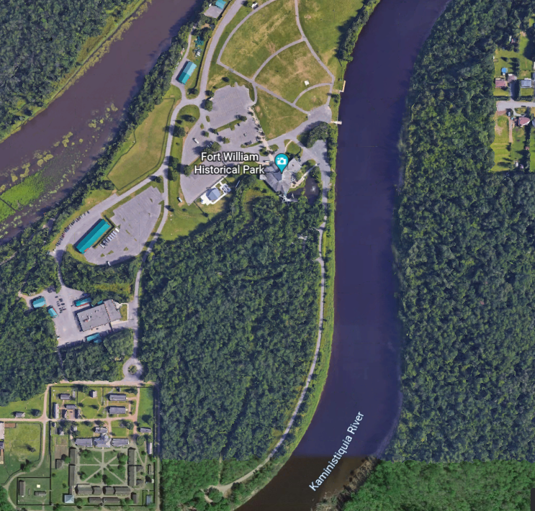
Middle Parking Lot Please Park Here
Administration Parking
Canot du Nord
North Gate
PARKING
Visitor Centre

PARKING
Figure 1Administration Parking Lot

