Alpha Beta’s Recruitment Embraces Sisterhood
Lambda Kappa Sigma Alpha Beta Chapter
University of Connecticut School of Pharmacy

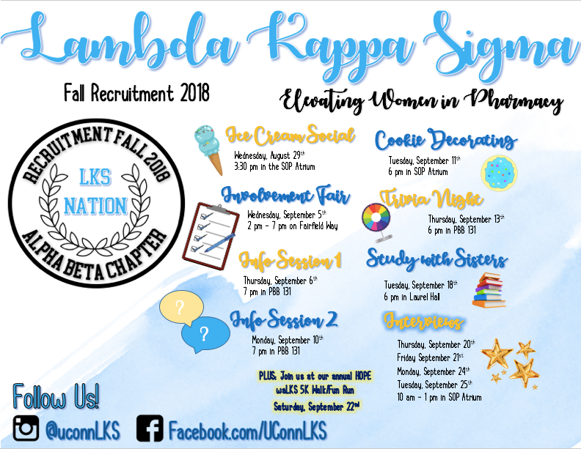
Fall 2018 was the start of a new motto for AlphaBeta chapter - “why not?” This year at Convention, the Collegiate Conference, we paid close attention to every point GVPC Amanda Higgins had to make - from how to do a SWOT analysis, to ensuring our values and mission were portrayed throughout the recruitment process. There was one thing, however, that really stuck with us and ultimately became the framework for our entire fall recruitment process: “When it comes to change, give me a reason why we shouldn’t.” There was room for improvements within our chapter’s recruitment process, and this inspired us to actually take action towards making those improvements. As much as we valued the foundation laid down before us by previous New Member Educators, we felt that it would be better to work with a clean slate when it came to how we would conduct recruitment in the fall.
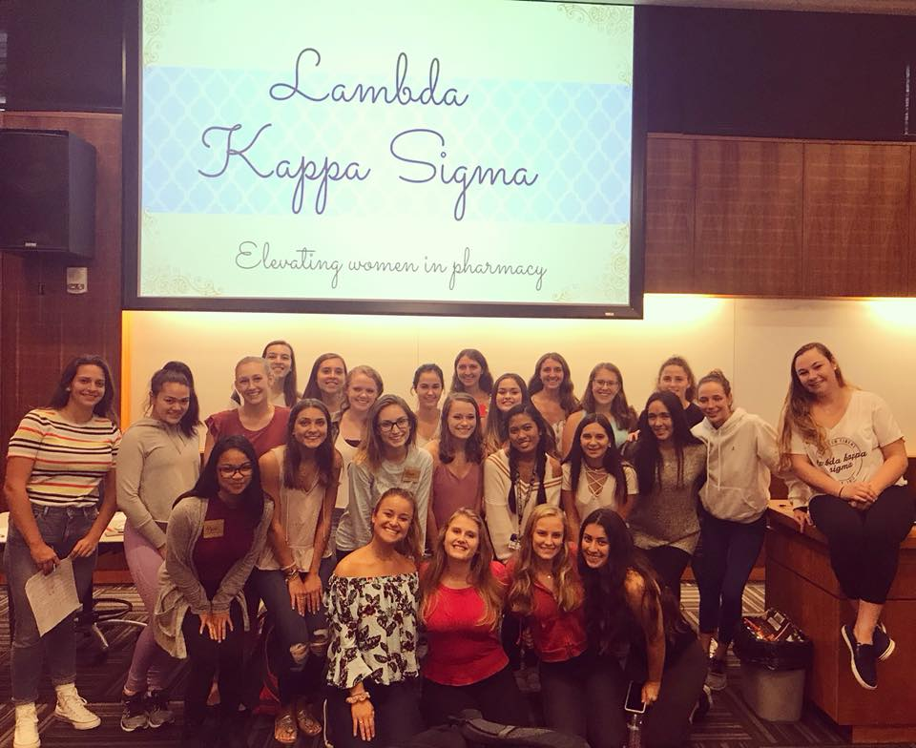
We started by creating a recruitment committee, as recommended to us in Recruitment Bootcamp. It was comprised of 10 members, with two designated committee heads, Cara Rotatori and Becca Vales, to help us with planning and executing all of our events. We made a new poster board for recruitment that focused on how we, as a chapter, promote our core values, and we also created a separate poster showcasing our national awards such as Chapter of the Year and Region of the Year! We wanted to emphasize the essence of LKS, the importance of connections you will make all across the country, as well as the national presence that our chapter has. As a recruitment committee, we brainstormed ideas for new events we hadn’t tried before, and decided on doing informational sessions to help PNMs learn more about us, cookie decorating with a sisterhood bonding activity, trivia night with teams comprised of current members and PNMs, and a final Bid Night event for new inductees to really get to know each other and current members.
We also decided during recruitment to create a Facebook page to reach more pre-pharmacy women at UConn, and also share our ideas and events with other chapters (and thank you to all the sisters who liked and followed us on Facebook and Instagram)! We posted about events we hosted, pictures of current sisters, and other information that we felt was important for potential new members to know about our chapter. We got a lot of engagement on social media and found it to be a great communication tool throughout the whole process.
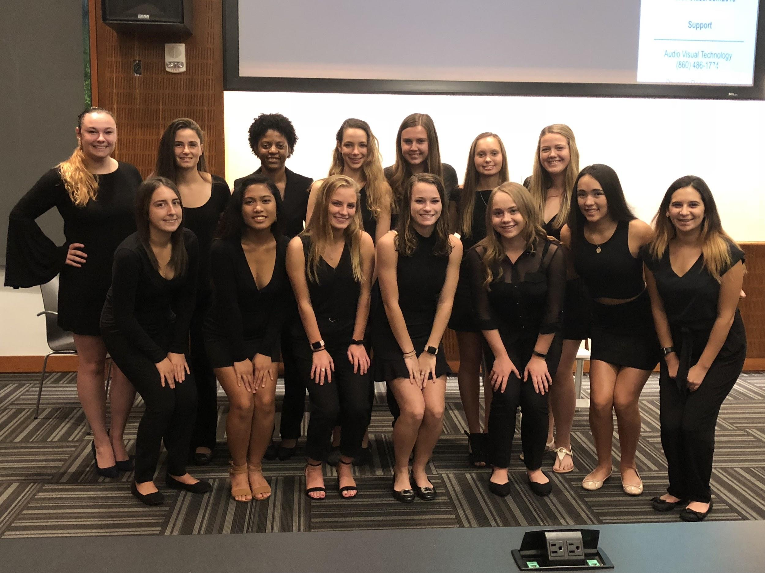
We just inducted 14 new members to Alpha Beta chapter, and we believe that our changes to recruitment and our new attitude toward change are what helped us recruit quality girls who would represent LKS in an exceptional way and live the core values of our organization. We continue to make changes to our recruitment during our new member meetings by focusing more time on having current sisters visit and talk to the new members. We also are improving the Big/Little process by giving everyone even more events where they can get to know each other better before being paired together.

Change is scary. The unknown is daunting, and taking the path less traveled will often be out of your comfort zone. When you want to make change happen, be the change. Whether you hold a position or not, everyone’s goal should be to ensure betterment of your chapter and the organization as a whole, and it’s up to you to take action and achieve that goal. Recruitment can be a lot of hard work, long hours, lots of organizing, and sometimes a little hectic, but at the end of the day you’re giving potential new members the opportunity to fall in love with LKS the way you did when you first joined. We hope that every chapter had a successful recruitment this fall, and from now on, just remember: “When it comes to change, give me a reason why we shouldn’t.”

