LKS/Medicare Health Fair
Mary Train, Alpha Xi Chapter

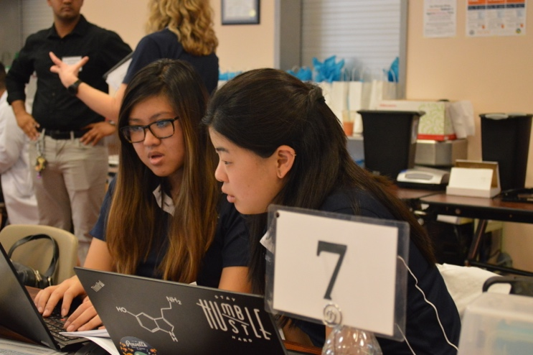
This Medicare Open Enrollment season starting October 15 to December 7, Alpha Xi chapter will be partnering with Medicare Part D students at the University of the Pacific (UOP) to hold our very first LKS/Medicare Health Fair in San Francisco on November 5th. The Medicare health fairs have been well established at UOP for over 10 years. Since 2011, the Medicare committee held over 112 outreach events in 20 different cities, served over 30,000 patients and saved beneficiaries a total estimate of over 5 million dollars. When we were approached with the offer to partner up with the Medicare class to host a health fair in San Francisco, we were very thrilled and honored to be a part of something that has such a significant impact on the community.

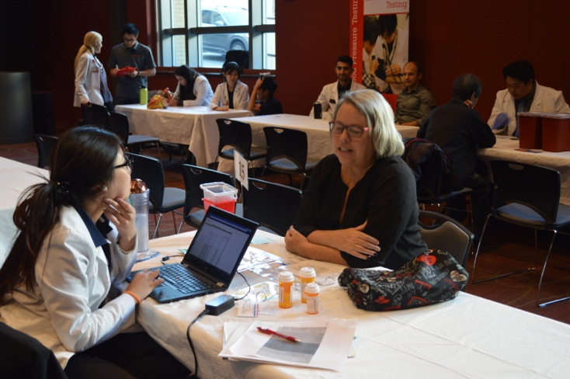
This fall season Alpha Xi has been working hard to help plan and advertise the health fair to the San Francisco community. Our members have been calling doctor’s offices to ask them to advertise the health fair to their patients, making weekend trips to San Francisco to hang up flyers at various community centers and restaurants, and calling past beneficiaries to set up appointments with them. This year we are hoping to assist around 80 beneficiaries with their Medicare Part D plan as well as provide over hundreds of free health screenings.

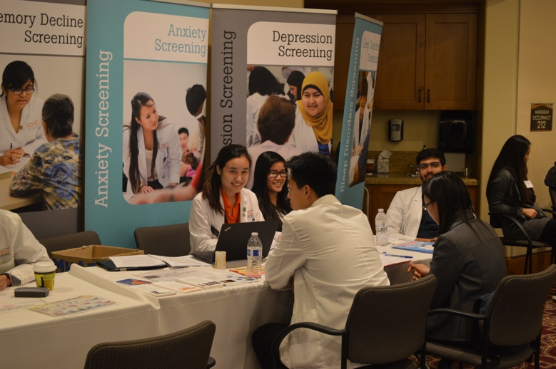
On the day of the health fair, our whole fraternity will be volunteering to help make sure the health fair runs smoothly. This year, we have four of our very own members who will be participating in the Part D and Medication Therapy Management (MTM) interventions. During the Part D interventions, we will be sitting down with the beneficiaries to help them enroll in the lowest cost plan based on their current medications, identify if they qualify for additional governmental assistance to lower their out-of-pocket prescription medication costs and determine if any of their medications qualify for Pharmaceutical Assistance Programs. For the Medication Therapy Management intervention, we will be reviewing all of the beneficiaries’ medications to make sure they are safe to take together and answering any questions or addressing any concerns they may have about their medications. If necessary, we will also contact their primary care provider and/or pharmacist to provide our recommendations.

Our graduate pharmacy students will be volunteering at one of the following screening stations that will be offered at the health fair:
Free Services Offered at the Health Fair
- Anemia testing  - Anxiety testing  - Asthma/COPD Screening  - Blood pressure testing  - Bone Density testing  - Cholesterol testing | - Collection of expired medications  - Depression Assessment  - Diabetes screening  - Falls Risk screening  - Memory decline screening  - Sleep disorder screening

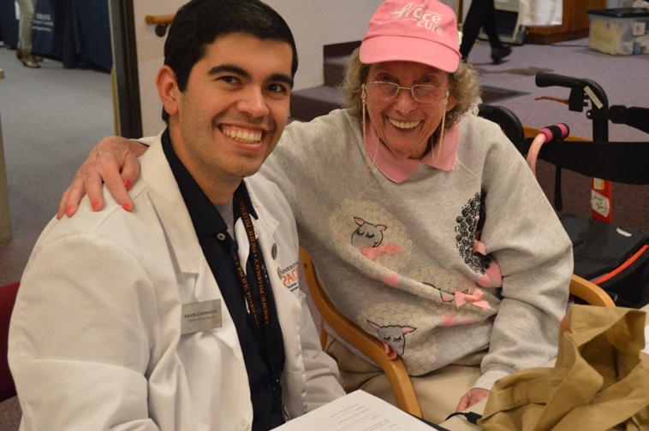
Our undergraduate pre-pharmacy students will also be volunteering at the health fair where they will help usher beneficiaries to the Part D/MTM interventions or the screening stations. They will also be provided with the opportunity to sit down with a Medicare student and observe a Part D/MTM intervention as well as shadow a screening station. This will give them the opportunity to experience first-hand what happens at a health fair before they enter pharmacy school.
Alpha Xi has grown immensely since I was initiated in 2014, and this is mainly because we are constantly striving to improve and expand upon ourselves. We are beyond excited to see the turn out of this health fair and what we will accomplish this school year!
