Project Guatemala
Erika Zarfoss
Wilkes University Pharm.D. Candidate 2019

“It is better to see something once than to hear about it a thousand times.”
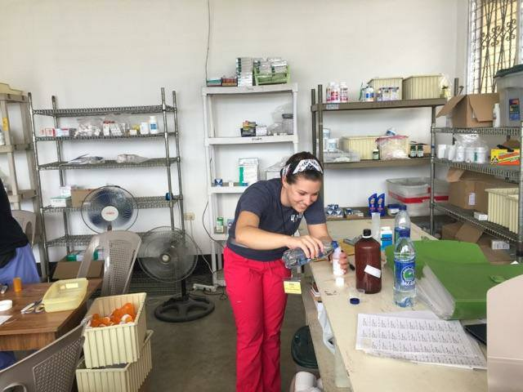
I had heard stories about mission trips. I had listened to incredible experiences of providing care for the people most in need. I was told that you will never meet more positive and grateful people than those living in the worst conditions. However, I never truly understood these things until I experienced them for myself.
In April 2017, I had the incredible opportunity to participate in the Glens Falls Medical Mission Trip: Project Guatemala. My involvement in this mission was a culmination of several factors. At Wilkes University, I have been privileged to pursue not only a Spanish minor, but also the nation’s only Spanish language concentration for pharmacy students. This concentration requires patient care hours in a Spanish-speaking community, and the founding Dean of the Nesbitt School of Pharmacy has been promoting service through this mission trip for many years.
This experience was the greatest example of multidisciplinary teamwork that I have seen. The small but mighty team of 37 volunteers assembled a working clinic in an empty church courtyard. Practitioners including doctors, PAs, nurses, pharmacists, dentists, and various students truly functioned as a unit. We relied on one another for help and advice with diagnoses, treatment plans, and language translations. Limited resources, especially for medications, required deviating from traditional guidelines and brainstorming alternatives. I was able to utilize skills I had just learned in class, making recommendations for various antibiotics, and developing a treatment plan for H.pylori infection using a limited group of medications.
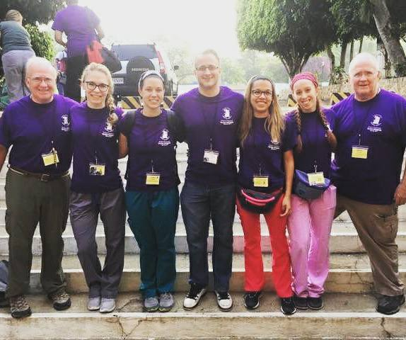
Despite the excitement of utilizing my knowledge from school, the most rewarding part of the mission was interacting with the incredible people of Guatemala. As a Type-A pharmacy student with minimal experience speaking Spanish in healthcare settings, interacting with patients in a foreign country was far beyond my comfort zone. After successfully counseling my first patient on her medications, I was eager to help more. These patients truly were the most kind and grateful people I have ever met. Most of them rely on this mission, which returns to the town every 6 months, as their sole source of healthcare and medications. Many of them walk for miles and wait in line for hours to be seen at the clinic, all with smiles on their faces. These people make you forget how tired, hot, and hungry you may feel, and remind you to find hope and positivity in every situation. I cannot wait to return to serve the people of Guatemala again and to learn even more from them.
While this may be the thousandth story of a mission trip that you have heard, I encourage you to see and experience these things for yourself at least once. It truly is better to see something once than to hear about it a thousand times, and words will never truly explain the impact of this mission on my life.

