Convention Elevates the Women of Omicron Chapter
Natalie Brikho
Leanne Olney
Sara Denton
Najifa Choudhury

The 2018 Lambda Kappa Sigma National Convention had many moments that were truly inspirational, educational, and touching beyond words. Who doesn’t like a road trip where you can have quality time with your sisters and bond in an exciting new city?! From the opening ceremony to the final dinner, time seemed to go by too fast. The convention was a perfect balance between information that helped each attendee on their individual journey to becoming a better sister and pharmacist with just the right amount of leisure time to get to know other chapter members and explore what Buffalo, NY had to offer. From the Core Values Poster presentations to the amazing speakers, new information was not in short supply. Lambs were turned into lions, skin cancer awareness was of top priority, sisters were learning how to crush the dreaded student loans, and as always, leaders were emerging and improving.
During the award ceremony, each recipient was given a brief introduction followed by her speech. Dr. Justine Dickson discussed a sensitive topic, imposter syndrome, which is very prevalent in women. Imposter syndrome is something that most people secretly deal with each and every day. Imposter syndrome is a psychological pattern in which an individual doubts their accomplishments and has a persistent fear of one day being exposed as a “fraud”. Thanks to Justine who bravely shared her personal experiences with this condition, which helps all of us address the condition instead of being intimidated. This presentation empowered other women to speak openly about this syndrome without fear of judgement and with growth to understand their own excellence amongst others and the world.
Another notable award recipient speech was given by Dr. Sharon Brown, past LKS National President, who spoke about the topic of what it means to be a servant leader. She said, “I am a servant before I am a leader”. And I thought to myself, when I grow up, I want to be like Sharon, a selfless leader whose purpose is to leverage the talent of young women. All of the Omicron convention attendees thought about what servant leadership means to their upcoming chapter responsibilities this academic year. This reflection would be a worthwhile exercise for all sisters. There was wisdom and inspiration to be gained from all the award winners speeches and we were honored to be among such accomplished women.
It was truly inspirational to see how dedicated the grand council is to our beloved fraternity. These women graciously give their talents, time and energy to advance the careers of other women and men in pharmacy and the fraternity. When we spoke to many of the sisters on grand council, they told us how they have served on the grand council for 3 to even 16 years. The past presidents dedicated 8 years in their position as active and past president with many having varying times on the board in other positions prior. Witnessing this all in person made us realize that Lambda Kappa Sigma is not over after the 4 years of pharmacy school. Lambda Kappa Sigma exists far beyond that with active sisterhood as an alumna. Chris Grass, incoming president, and Sandy Mullen, outgoing president, gave the most heartwarming speeches at the conference. Not only were their speeches moving and inspiring, but just the tone in their voices showed their depth of passion, dedication and love for this organization. Both these women are role models and it was a true privilege to speak to them both.
The positive energy, uplifting environment, and loving atmosphere provided the best place to recharge your love for Lambda Kappa Sigma and all the sisters. We went back home with so many new ideas, enthusiasm to recruit more sisters than ever before, and a renewed love for our three greek letters. During convention, everyone wore her/his letters with the proudest smile. The familiar blue and gold outfits were so exciting to see, especially in formal attire during the final banquet.
At Lambda Kappa Sigma, we are all about sisters and brothers supporting each other. During convention, the Ewe Can Shop was a great example of how we can provide for one another. While we ate lunch on that Friday afternoon, tables were set up all around the edge of the ballroom for the chapters that wanted to sell LKS merchandise to their fellow lambs. There were LKS hats, totes, bumper stickers, sweatshirts, t-shirts, water bottles… basically any and all things a lamb could want to proudly show off our lamb love! The Ewe Can Shop was a great success to all who participated.
Convention is another reminder that joining LKS was one of the greatest professional decisions we made. As we prepared to head back to our hometowns, the memories made in the past few days flashed through our minds and an indescribable feeling washed over us. From having the honor of witnessing our incredibly devoted Faculty Advisor, Dr. Mary Beth O’Connell, accept her award as LKS Faculty Advisor of the Year, to the speeches of the remaining award winners who moved us to tears of joy. Because of interacting with new and old sisters, we left convention with a better version of ourselves. A perfect example was when some of the sisters encouraged our president Natalie to face her fear of heights when she ziplined alongside the Niagara Falls with her very own faculty advisor and fellow sister Leanne!
Thus, attending convention is highly encouraged for both professional and personal growth. The inspiration and learning gained will help with making the upcoming fraternity year more successful. Meeting new and old fraternity members increased each member’s professional network, to help with personal and chapter success both now and in the future. Attending convention is a once in a lifetime experience and not worth missing. Each convention only happens once and is completely unique each year. We highly encourage chapters to start saving now and conduct those chapter fundraisers so you can go to the next convention in 2019 in Milwaukee, WI. We have already started planning for more convention fundraising, and cannot wait for the next road trip, hopefully with even more sisters this time around. From the sisters of Omicron chapter, we wish you a great 2018-2019 academic and fraternity year. See you next July!

(Description: Omicron Chapter Faculty Advisor, Dr. Mary Beth O’Connell received Faculty Advisor the year award! Pictured from left to right: Sara Denton, Najifa Choudhury, Aisha Rahman, Dr. Mary Beth O’Connell, Natalie Brikho, Dr. Debbie Bourquin and Leanne Olney)

(Description: Gala Reception with Omicron Chapter President (Natalie Brikho) and Vice President (Leanne Olney))
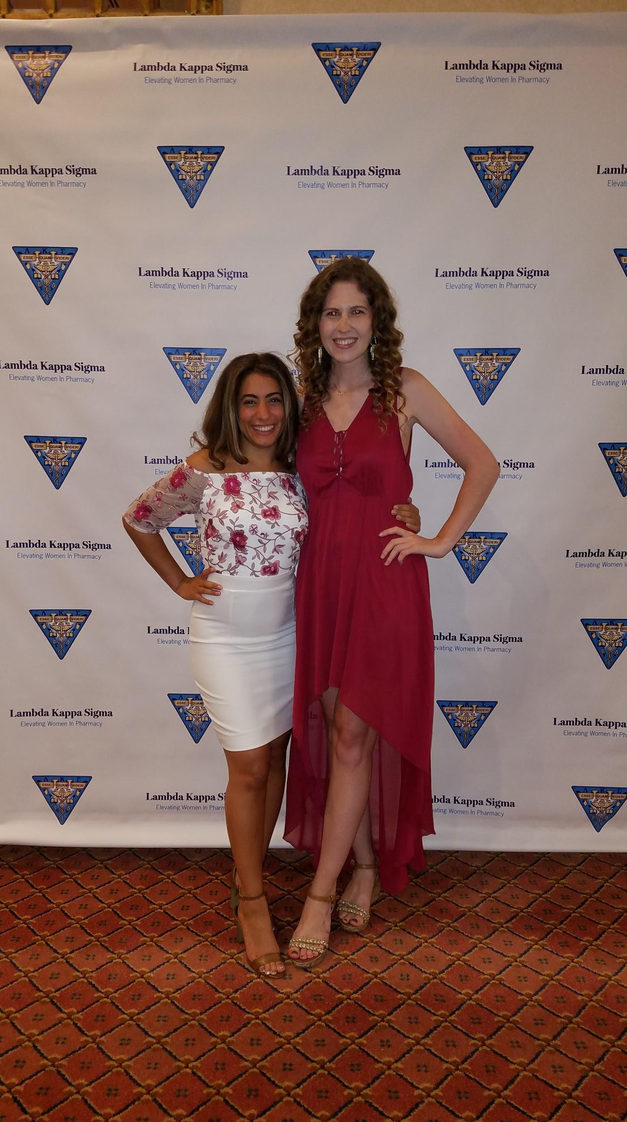
(Description: Omicron Chapter’s Core Values poster presentation: Spotlighting Melanoma Skin Cancer Prevention During Hygeia Day)
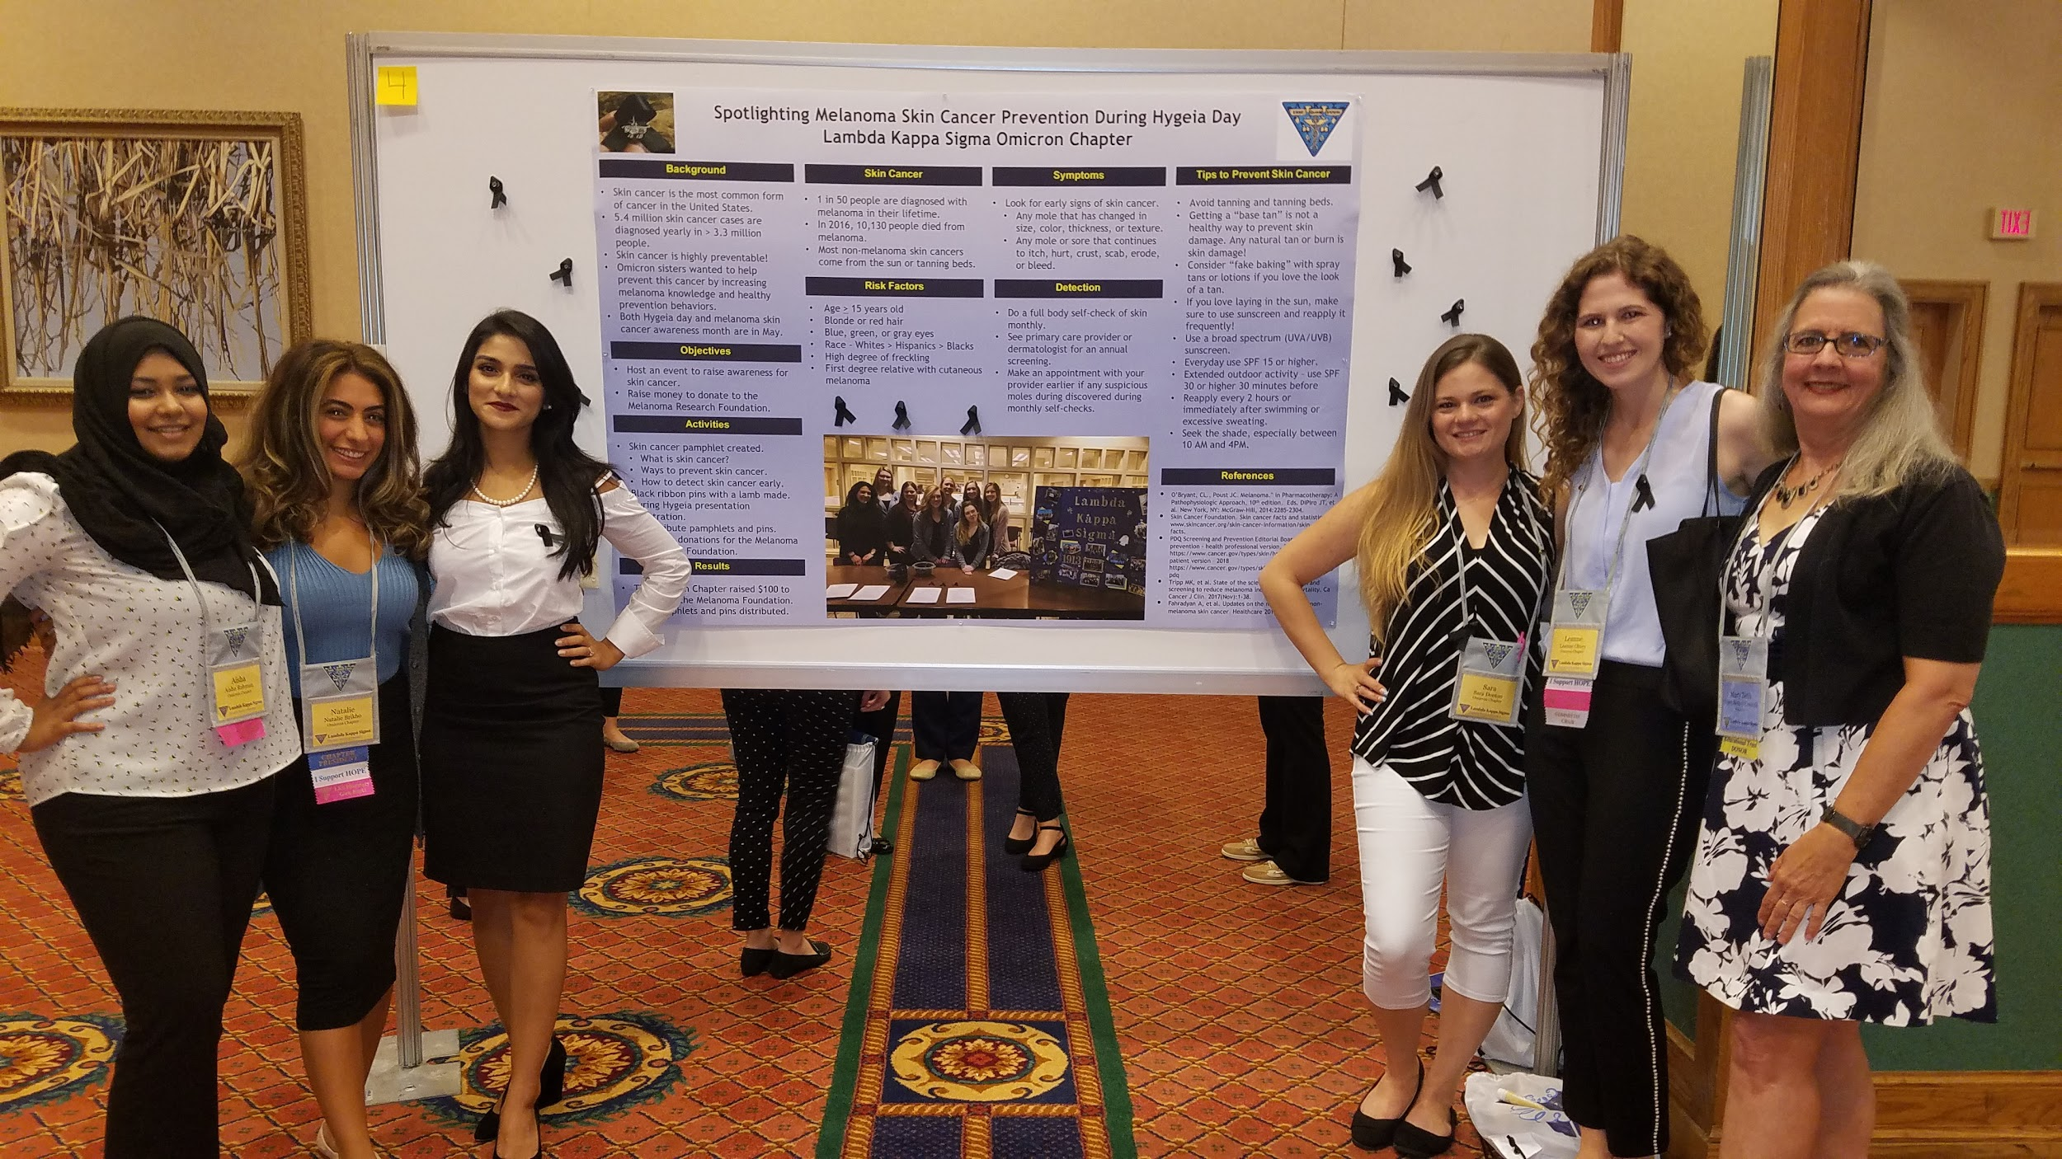
(Description: Omicron Chapter President (Natalie Brikho) and Vice President (Leanne Olney) showing sisterly love!) 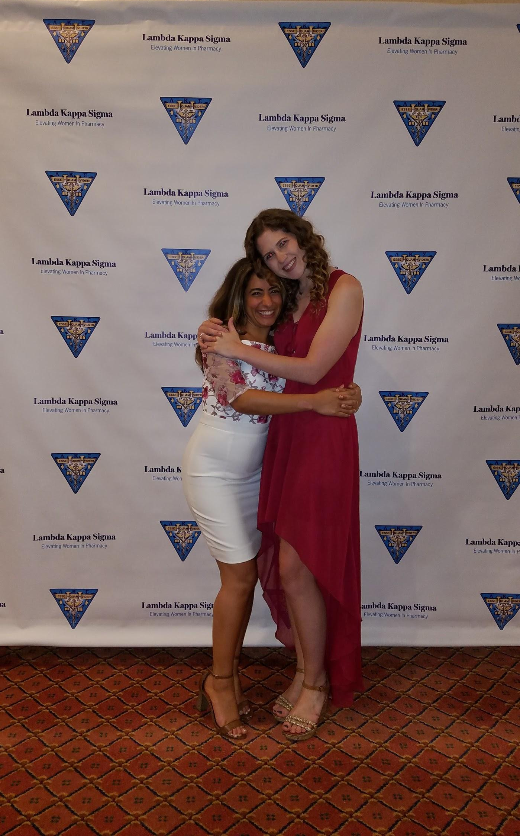

(Description: Making lasting memories with our sisters from Delta Chapter!)
