Think Before You Speak Ideas

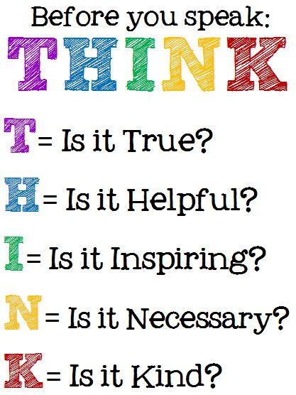

Consider Consequences
Help your student understand the potential consequences of what they want to communicate.
If it seems good to them, like they think they’ll make people laugh, ask them to pause and consider if the consequences are all good. For example, they may make people laugh with their comment, but who might they hurt in the process? While no one can predict everything and some people get offended at the oddest things, at least teach them to do the best they can in this respect.

Role Play
Model and practice responses to different situations with role play. Use examples of situations that may happen or already have happened. Practicing difficult situations when we are calm provides the opportunity to discuss options and consequences. Have children demonstrate the words and actions that are good responses to the situations. Example scenarios include: Someone cutting in line; being called a name; someone bumping the child; a friend making a joke; someone saying something about the child’s art work or how they play sports; a classmate taking something the child owns.

Ask Why
If you hear your student say something inappropriate or gossip-like, ask them to share with you why they said it. Ask them to imagine what it would make them feel if someone said the same thing about them. Often, when we think about what it’s like to walk in another person’s shoes, it helps us empathize and think. Hopefully the discussion will help them think before repeating this behavior.
Learning to ask themselves, “Why do I want to say this?” before actually saying it may save many a relationship in the future.
Heart prints

Objective: To help students realize that hurtful, mean things said and done can stay with a person for a long time.

Materials:
- A paper heart
- Crayons or markers

Activity directions:
- Have your student color their heart.
- Ask them, “What kinds of things are sometimes said that hurt people’s feelings?” Tell them that each time we think of something that is hurtful or mean they are to make a fold on their paper heart.
- List of hurtful words and actions to get the discussion started:
- Saying – You can’t sit here.
- Doing – Pushing someone out of line.
- Saying – You’re not my friend.
- Doing – Knocking books out of someone’s hands.
- Saying – I don’t want to play with you.
- Saying – You can’t be on our team.
- Doing – Tripping someone as they walk out the door.
- Saying – You can’t play the game with us.
- Saying – Your clothes aren’t cool.
- Now ask what kinds of things others say and do to help someone feel better?” Tell them that each time we think of something that is kind they are to unfold one of the folds in their hearts. List kind words and actions until all folds in their heart have been unfolded.
- Saying – Would you like to sit by me during lunch?
- Doing – Take someone by the hand and invite them to stand next to you in line.
- Saying – I would really like it if you were my friend.
- Doing – Helping someone pick up their books that have been knocked onto the floor.
- Saying – Will you play with me at recess?
- Saying – Would you like to join our team?
- Doing – Helping someone up off the ground that has just been tripped.
- Saying - Please play the game with us.
- Saying – You look really nice today.
- Have your student smooth out their heart as much as possible. Ask them what they still see. They should observe that even though the heart isn’t all folded up, the marks from the folds are still there.
- Explain that even though the hurtful things that happened didn’t last forever, and some nice things even happened to help them feel better, whenever something hurtful is done or said to someone that bad feeling sticks around for a longer time and is still remembered inside.
- We can never completely undo a hurtful action or word, so the best thing is to keep it from happening in the first place.

