Step by Step:
Applying to College/Universities on Naviance

Step 1: On the home screen click on colleges I’m applying to.
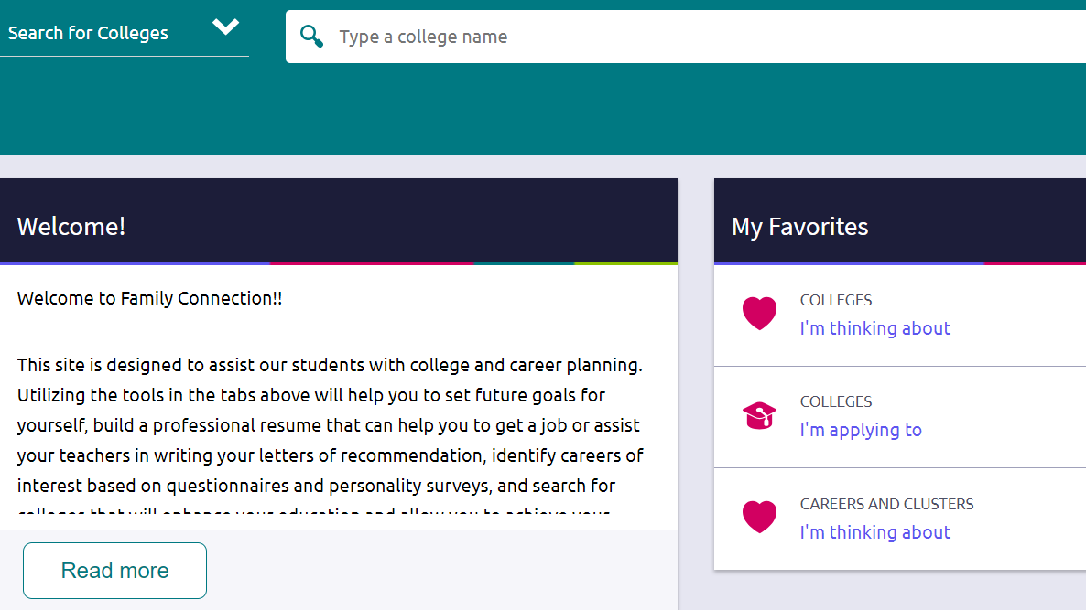

Step 2: Click on the + sign to add the college that you will be applying to.
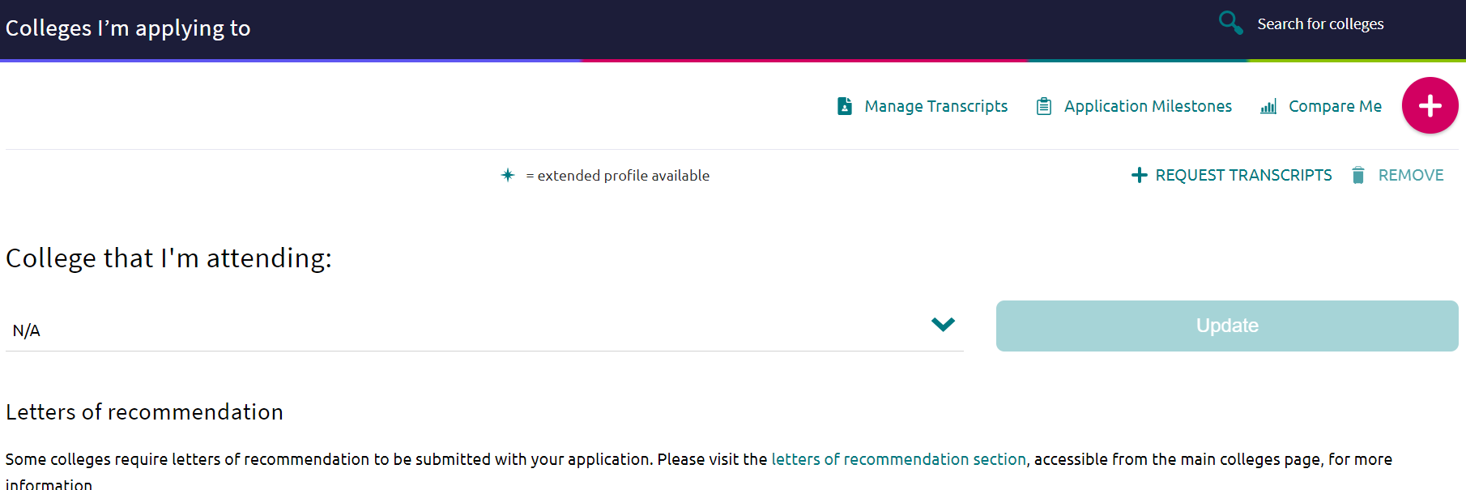

Step 3: Type in the college you are applying to. Make sure to click on both drop down menus.
Only request the transcript if you have submitted your application to the institution!!!

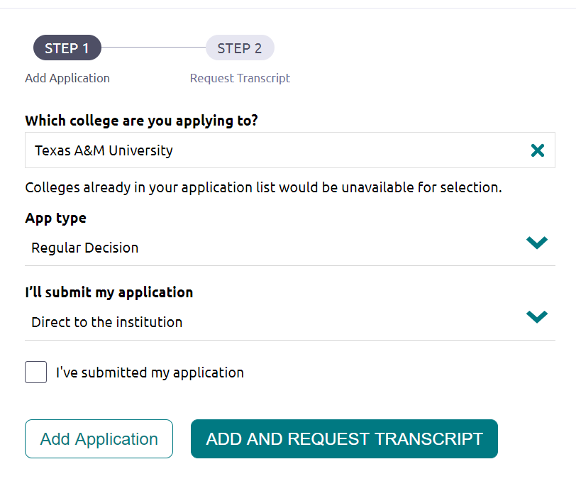
Click- I’ve submitted my application and Add and request transcript
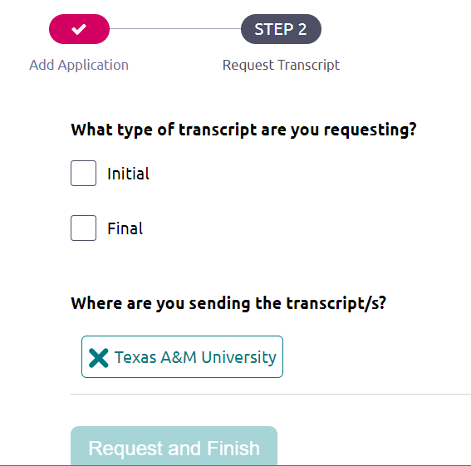
Final step is to click on Initial transcript. Submit your request by selecting Request and Finish.

*You must mark that you have applied and request the transcript for us to send it!

