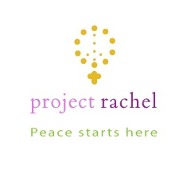

**Diocese of Rockville Centre**

***Healing after Abortion***

**Project Rachel retreats offer the opportunity to experience the loving mercy of God in a safe and sacred space. The retreats are directed by specially trained compassionate caregivers, including counselors and clergy, who have a sensitivity and a heart for those who suffer.**

**2019 Retreat Dates**

**Day of Prayer and Healing for Women--Saturday, November 9th**

**Evening of Prayer for Men--Wednesday, November 13th  7pm-9pm**

**For more information and to register please visit** www.respectlife.drvc.org

**or contact Project Rachel at** 1(888) 456-HOPE (4673), 1(516) 766-2538 or

[projectrachel@drvc.org](mailto:projectrachel@drvc.org). *All information will remain confidential.*