Nexis Uni Guide
Part 1: Accessing Nexis Uni
Step 1: Access Nexis Uni here: http://guides.lib.unc.edu/go.php?c=46108264. You will be taken to the home screen automatically.
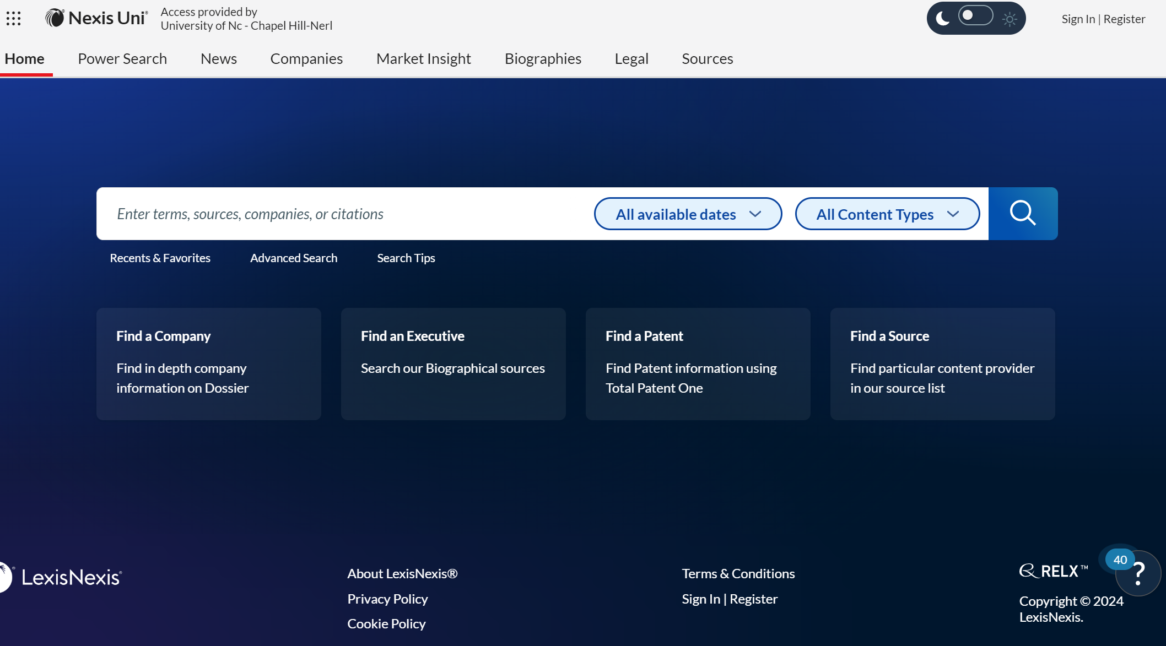
Step 2: From the home screen, navigate to the “Legal” Tab
This will take you to the Legal Explore page. This narrows the Content Types down from everything within Nexis Uni to specific legal content types like cases, statutes, administrative codes, and law review articles.
Part 2: Important Parts of the Nexis Legal Search Page
The tips button will launch Nexis Help.
You can search from this toolbar using terms, but that does not narrow your search to a particular content type, jurisdiction, practice area, or industry.
Click here to start an advanced search of cases.
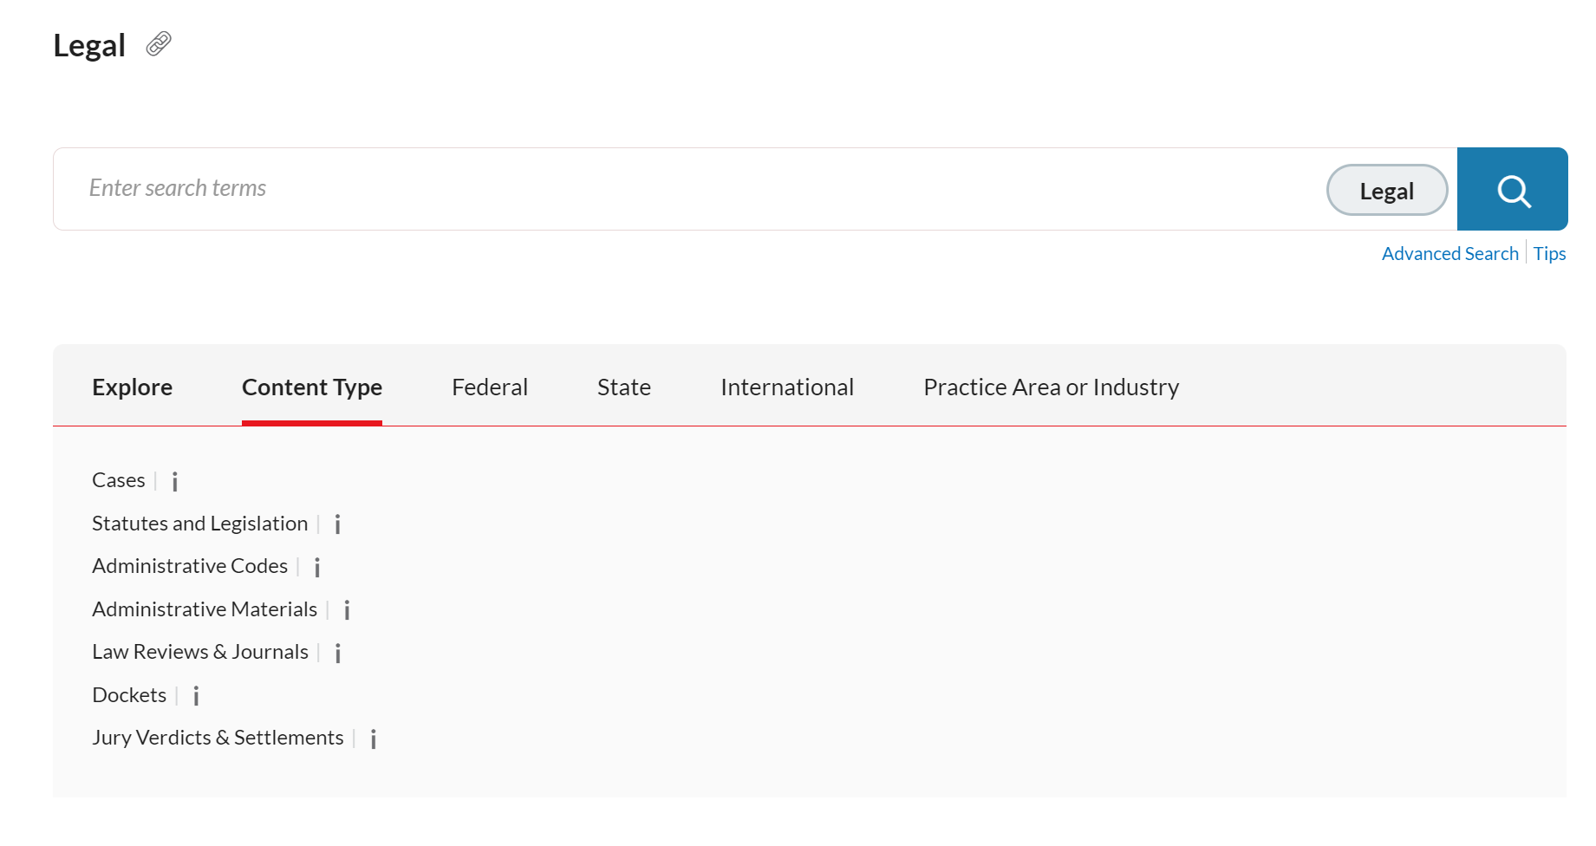Part 3: The Advanced Search
If you move to any of these tabs and select one of the options within the tab, it will begin an advanced search narrowed to that selection.
For example, in the “Content Type” tab here, if you select “Cases” an advanced search opens and is narrowed to case law results only. See in Part 3 below.
The Advanced Search Page in the Legal tab defaults to search ONLY cases.
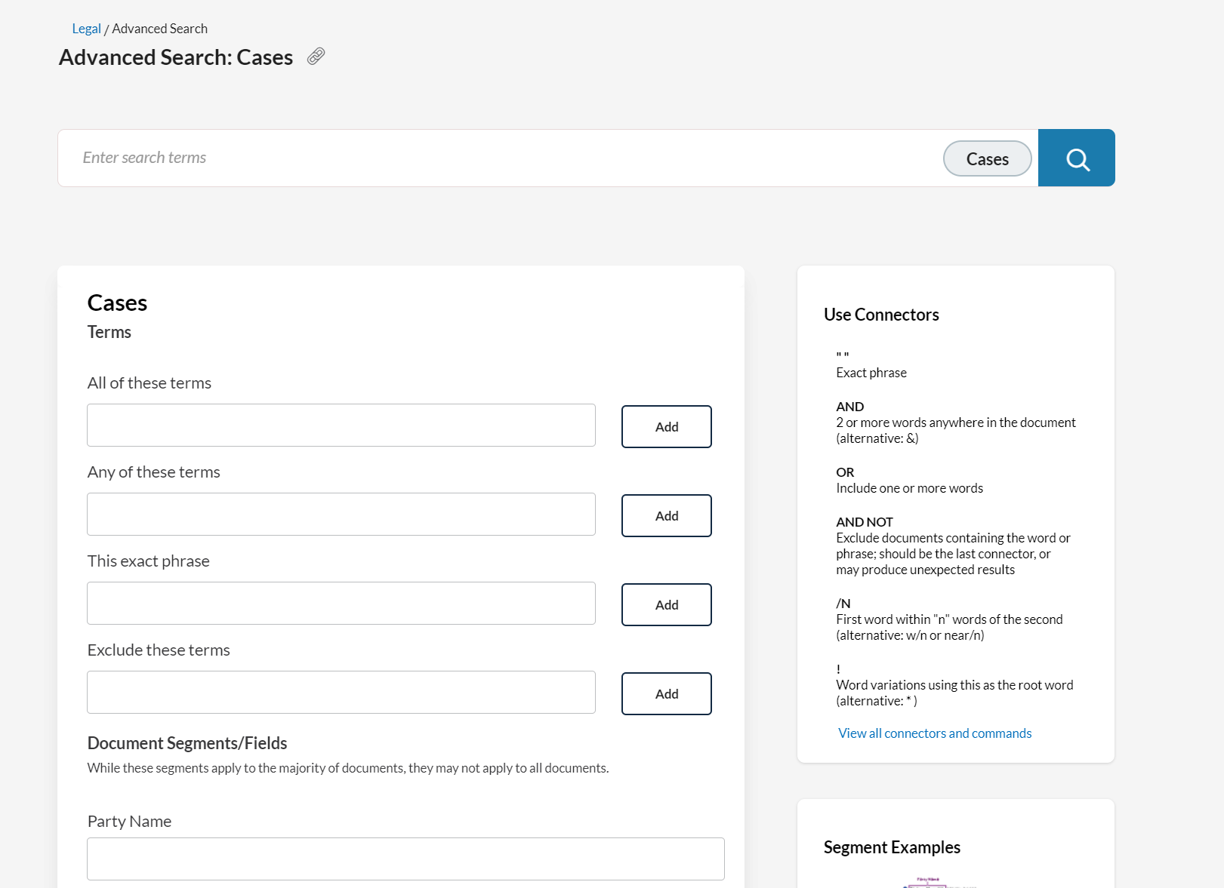
The Document Segment Fields (not all shown) are going to be more helpful if you either: (1) know the case you are searching for or (2) are narrowing your search to particular court(s) or dates.
Using terms to search can be a helpful way to narrow your search when you have an idea of the topic or issue you are searching for, but do not know what case you are looking for.
To start an advanced search of another content type, within a particular jurisdiction, or in a particular practice area or industry return to the Legal Search Page and select what you would like to begin an advanced search in.
Selecting a “Content Type” from the Legal Search Page will allow you to search all sources of that type. For example, selecting “Statutes and Legislation” will allow you to search all statutory and legislative law. You can search by citation to the section number within that field and narrow that to the jurisdiction you are looking for. For example, you can search for a specific statutory section you are looking for in the North Carolina General Statutes using the Citation section. You would type the section of the code that you are trying to locate in the search box of that section and Nexis Uni will auto populate a search into the main legal search box. You will click search beside that main search box at the top of the page, then narrow the Jurisdiction in the column that will appear to the left if needed.

Selecting “Federal” will allow you to choose between an advanced search of some top sources or an advanced search of case law within a particular federal circuit (or all federal case law).

Selecting “State” or “International” will allow you to select a state or country, respectively, and begin an advanced search of that state or country’s case law.

Finally, selecting “Practice Area or Industry” will allow you to begin an advanced search of all content types, narrowed to the selected area type.
Alternatively, you can return to the home screen and select the Advanced Search button to start an advanced search of everything there. However, this will search all content within Nexis Uni, not just legal content. For more on using the advanced search form from this main home page, please see the following video: https://vimeo.com/642403644.

You can also use the “All available dates” and “All Content Types” selections on the home screen search bar to narrow searches here. You can choose any date range you would like to narrow to – even a custom range. You can narrow to Legal content including cases, legislation, law review articles, administrative materials, and more. Some of these can be further narrowed. For example, Administrative Codes and Regulations can be narrowed to certain state(s) & territories.
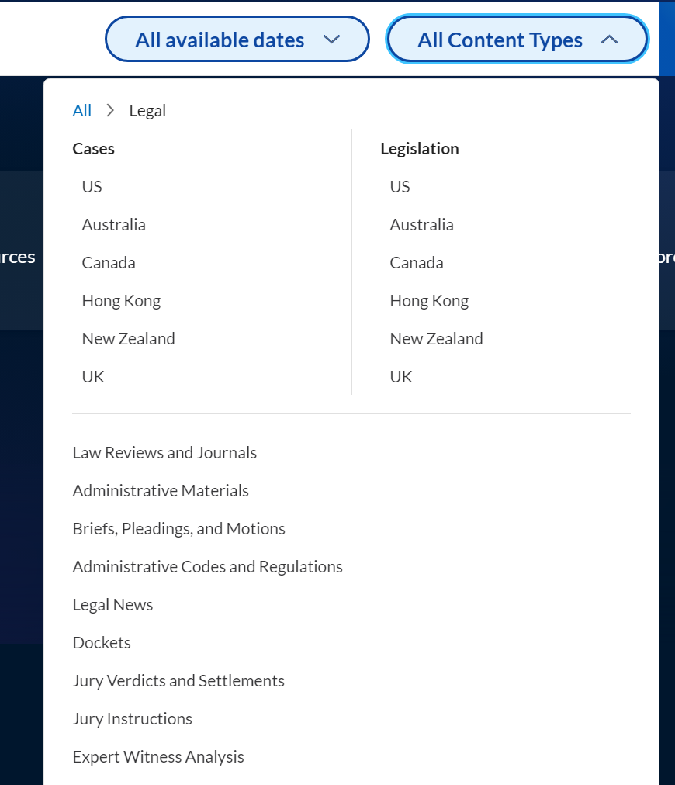
Here is one example of conducting a search from the home page using the North Carolina General Statutes – when you know the statute you are looking for.
Step 1: Type the postal abbreviation of the state – NC
Step 2: Type the word “code”
Step 3: Type the section number you are looking for.
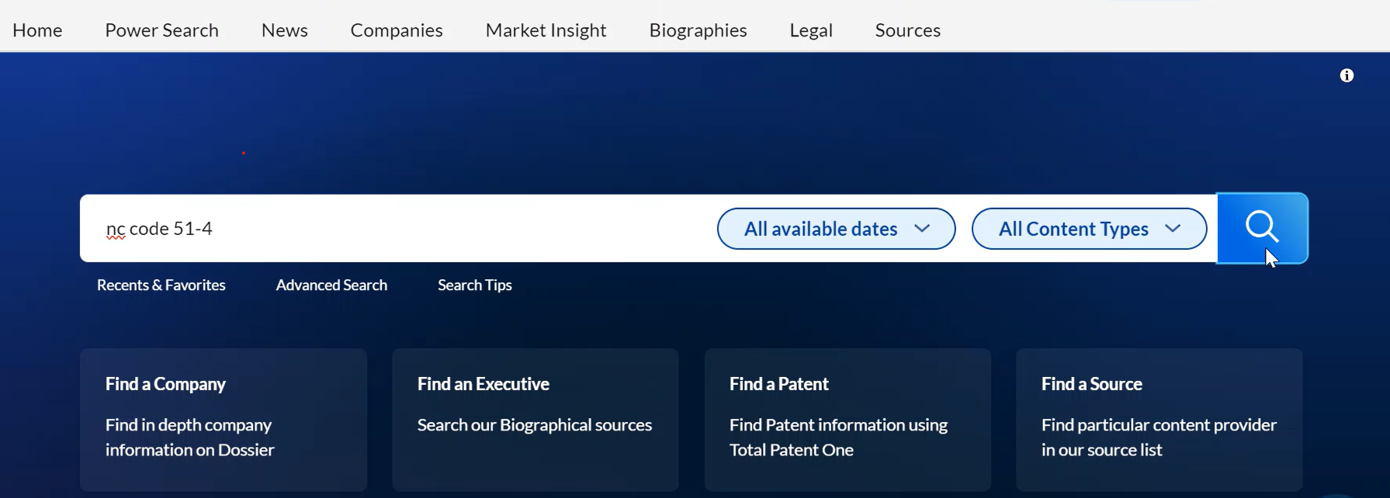

Part 4: Shepardize Your Findings
You can use Shepard’s as a citator to learn the history of how the document has been cited in other legal documents. It is a way to validate your source to determine if it is good law. For instance, it will tell you if a court case was reversed or overruled making it bad law. In Nexis, using Shepard’s validation tool is called Shepardizing the document.
When you find a source, there will be a symbol to the left of the title. This symbol indicates if the decision is good law.
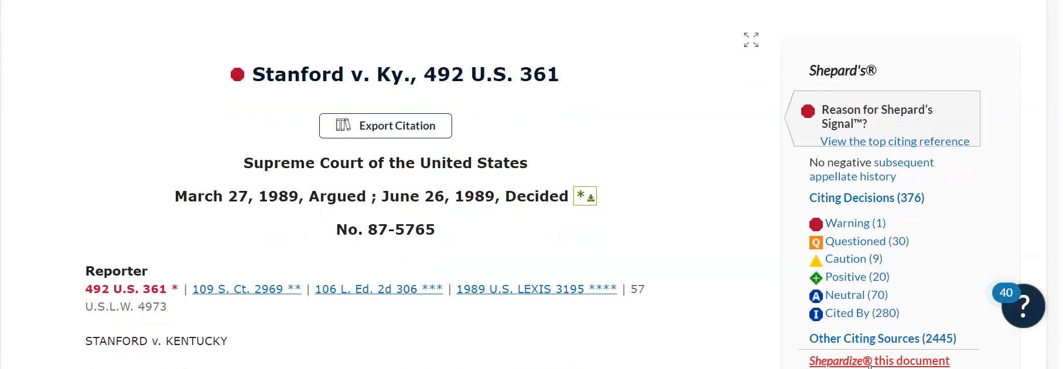
To Shepardize you can click on the symbol or click on “Shepardize this document” in the column to the right. This generates the Shepard’s report, which gives you the analysis of each citing decision and shows you the citation history as described above. If you have additional questions about using Shepard’s there are helpful videos at the following link: https://www.lexisnexis.com/lnumedia/GNS/Uni_LegalABC/index.html#/ (When you click on the link, scroll down and click on the title “Shepard’s®: What Is It and Its Critical Role in Legal Research.” You do not need to take the Knowledge Check below the video).

Part 5: Citation Assistance
There are 2 citation management tools that can help you cite the sources you find using proper Bluebook style.
The first is the “Export Citation” button found just below the title of the source that you find. You will select the Bluebook citation format when prompted.

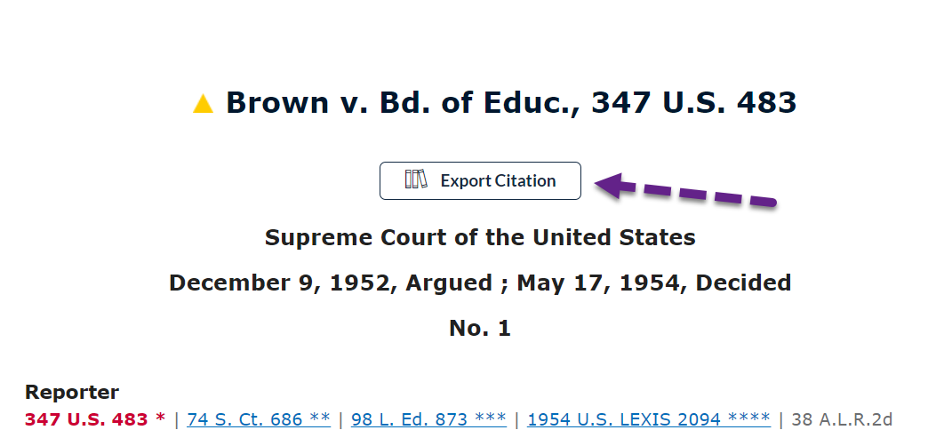

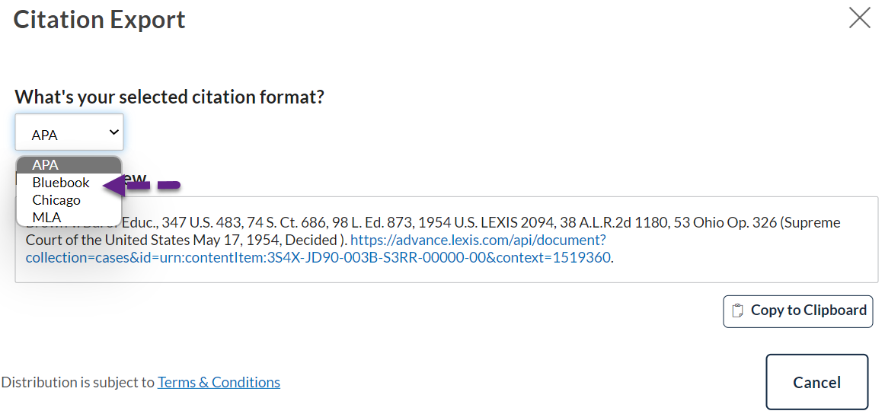

The second is using the books symbol on the search results page. You will first select the sources you would like to cite by checking the box next to each desired document so that a check mark appears. Once you have all the sources selected, you will click the books icon. This will load the “Citation Export” and allow you to select what type of citations you need. You will select the Common citation formats, how you would like to receive your citations, and again select Bluebook for the citation format.

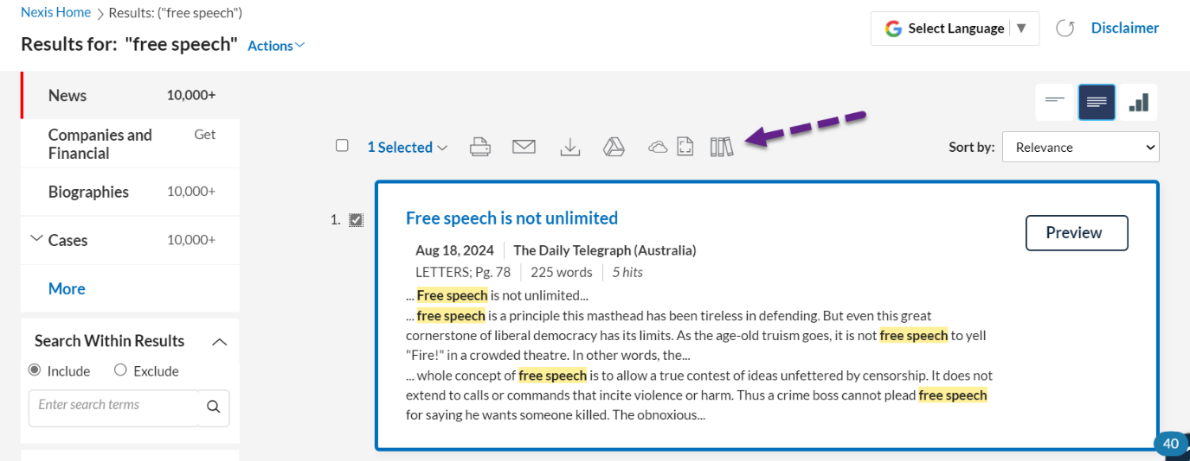

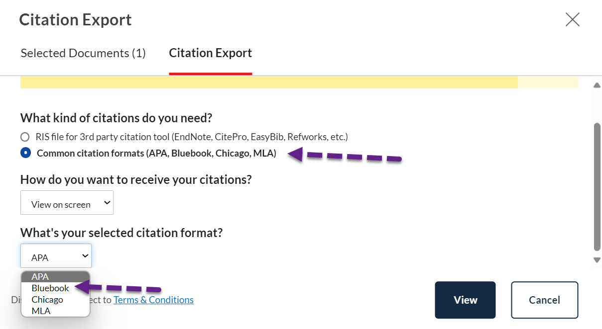

Part 6: Tips Page
Clicking on the tips button on the Legal Search Page (shown above) will automatically direct you to a guide to help with Searching for Legislation. However, you can use the sidebar within the Nexis Help that launches. This sidebar will allow you to find tips and links for many other things like Nexis Uni basics, help with searching on Nexis Uni, including help with crafting searches and working through your search results.
Click any arrow in this sidebar to see links to more tips for using Nexis Uni.

